|  |  |
| --- | --- |
| UAE Public Prosecution |  |
| Web Portal and eServices |
|  | |

**Web Portal user guide**

**Prepared By**



TACME Business Process Management Department

**Confidential**

**Version 0.1**

**Sunday, May 24, 2016**

# Contents

Contents 28

Document Management 32

Change Record 32

Who's Who 33

1 Knowledge Worker 33

2 Application Specialist 34

3 Web Developer 29

4 Developer 29

5 SystemAdministrator 30

Part I 1

1 Introduction to WebCenter Portal 1

1.1 WebCenter Portal Concepts 1

2 Exploring WebCenter Portal 1

2.1 Working In the Home Portal 2

2.2 Setting Preferences 2

3 Working with Your Profile 2

3.1 Setting Your Personal Preferences 3

3.2 Managing Your Profile 1

Part II 1

2 Working In the Home Portal 1

2.1 About the Home Portal 1

2.2 Accessing the Home Portal 2

2.3 Pages inthe Home Portal 3

2.4 What You Can Do Inthe Home Portal 4

3 Creating and Managing Personal Pages 5

3.1 About Personal Pages 2

3.2 Opening a Page inthe Home Portal 2

3.3 Creating a Personal Page inthe Home Portal 3

3.4 Managing Your Personal Pages 6

3.5 Editing a Personal Page 7

3.6 Setting Security for a Personal Page 7

3.7 Showing or Hiding Pages in Your Viewof the Home Portal 13

3.8 Rearranging Page Order inthe Home Portal 14

3.9 Customizing Your Viewof a Page inthe Home Portal 15

3.10 Resetting All of Your User Customizations froma Personal Page 18

3.11 Copying a Personal Page 19

3.12 Renaming a Personal Page 19

3.13 Sending Mail witha Link toa Personal Page 20

3.14 Viewing Information About a Personal Page 20

3.15 Deleting a Personal Page 20

4 Exploring Portals 1

4.1 About Portals 1

4.2 What Does a Portal Look Like? 2

4.3 Interacting with Portals Before Logging In(Public User) 3

4.4 Viewingand Accessing Available Portals 4

4.5 Sending Mail to Portal Members or Moderators 7

4.6 Viewing Information About a Portal 8

4.7 Viewing Portals Similar tothe Current Portal 10

4.8 Publishing the Link toa Portal 12

4.9 Searching for a Portal 14

4.10 Joining a Portal 15

4.11 Searching ina Portal 18

4.12 Working with Pages ina Portal 18

4.13 Changing Your Role ina Portal 24

4.14 Cancelling Your Portal Membership 26

Part III 1

5 Managing Your Contacts 1

5.1 About Connections 1

5.2 Setting Connections Preferences 4

5.3 Viewing Another User's Profile 5

5.4 Viewing Connections 5

5.5 Adding Contacts 6

5.6 Removing Contacts 10

5.7 Creating and Managing Groups of Contacts 11

6 Working with Feedback and the Message 1

6.1 About Feedback 1

6.2 Setting Feedback Preferences 3

6.3 Viewing Feedback 4

6.4 Posting Feedback 8

6.5 Deleting Feedback 9

6.6 About Messages 10

6.7 Setting Message Preferences 13

6.8 Viewing Messages 14

6.9 Posting Messages 18

6.10 Editing Messages 21

6.11 Deleting Messages 22

6.12 Enabling Other Users to Post Feedback and Messages for You 22

7 Liking, Commenting On, and Sharing Items in 1

7.1 About Liking Items in WebCenter Portal 1

7.2 Liking Items 2

7.3 About Commenting on Items in WebCenter Portal 3

7.4 Commenting on Items 3

7.5 About Sharing Items in WebCenter Portal 5

7.6 Sharing Streamed Items witha Wider Audience 5

7.7 Sharing Messages, Files, and URLs 8

Part IV 1

8 Creating and Managing Documents 1

8.1 About Creating and Managing Documents in WebCenter Portal 2

8.2 Actions for Working with Folders and Files 7

8.3 Personalizing Your Viewof Documents 13

8.4 Creating a Folder 16

8.5 Creating a File 17

8.6 Opening a Folder or File 23

8.7 Using the Rich Text Editor (RTE) 28

8.8 Editing or Updating a File 42

8.9 Renaming a Folder or File 49

8.10 Copying and Pasting Folders and Files 50

8.11 Moving Folders and Files 51

8.12 Deleting Folders and Files 52

8.13 Refreshing Folder Contents 53

8.14 Hiding and Showing Folders 53

8.15 Managing Tags on Files 54

8.16 Viewing and Deleting File Version History 55

8.17 Working with Folder and File Properties 57

8.18 Managing Document Links 62

8.19 Viewing Document Recommendations 64

8.20 Openingor Saving PDFFiles 65

8.21 Sharing the URL for a Folder or File 66

8.22 Setting Security Options on a Folder or File 70

8.23 Subscribing toa File 73

8.24 Liking a File 73

8.25 Adding a Folder or File to Your Favorites 73

8.26 Searching for Documents 73

8.27 Working with Workflow-Enabled Content 78

9 Collaborating on Documents 1

9.1 Collaborating on Documents Using the Documents Page and Documents Viewers 1

9.2 Collaborating on Documents through Workflows 1

Part V 1

10 Getting Notified When Things Change 1

10.1 About Subscriptions and Notifications 2

10.2 Establishing and Managing Your Messaging Channels and Filters 7

10.3 Subscribing tothe Application, to Portals, and to Objects 15

10.4 Viewing and Cancelling Your Subscriptions 19

11 Tracking Portal Activities 1

11.1 Comparison of Activity Stream and Recent Activities 1

11.2 About the Activity Stream 1

11.3 Setting Activity StreamPreferences 9

11.4 Working withthe Activity Stream 11

11.5 Hiding and Showing the Activities of a Selected User 13

11.6 Hiding and Showing the Activities of a Selected Portal 14

11.7 About Recent Activities 16

11.8 Working with Recent Activities 18

# Document Management

|  |  |
| --- | --- |
| Document Title | Web Portal User guide |
| Prepared for | UAE Public Prosecution |
| Revision | V0.1 |
| Date | 24.05.2016 |
| Version Date | 24.05.2016 |
| Author | Mohamed Mitkees, TACME |
| Classification | Confidential |

# Change Record

|  |  |  |  |
| --- | --- | --- | --- |
| Date | Author | Revision | Change Reference |
| 24.05.2016 | Mohamed Mitkees | 0.1 | Document Creation |
|  |  |  |  |
|  |  |  |  |
|  |  |  |  |
|  |  |  |  |

# Who's Who

The WebCenter Portal documentation is organized so that the tasks in a particular guide address a specific user *persona*. Each persona is associated with a set of skills required to work with WebCenter Portal, from basic to advanced. For example, this guide is aimed at the *Knowledge Worker* persona.

This preface introduces you to the WebCenter Portal personas and describes the ways in which they might interact with WebCenter Portal. Each persona is assigned a default role provided out-of-the-box with WebCenter Portal. The default roles are given a unique set of permissions appropriate for the work that each persona will typically do. Note that you can modify these default roles or configure new roles to meet the unique needs of your organization.

The people who interact with WebCenter Portal typically work together as a team that is comprised of the following personas:

* Knowledge Worker
* Application Specialist
* Web Developer
* Developer
* System Administrator

## Knowledge Worker



Karen is a *knowledge worker* who typically uses WebCenter Portal to contribute and review content, participate in social interactions, and leverage the Home portal to manage her own documents and profile.

At the application level, Karen has permissions such as those granted to the default Authenticated-User role, which may be customized for the specific needs of the organization. At the portal level, the portal Moderator will likely assign Karen the Viewer or Participant role, or a custom role that offers a similar set of permissions.

For more information about roles and permissions, see the "About Roles and Permissions for a Portal" section in *Building Portals with Oracle WebCenter Portal*.

##### Knowledge Worker Tasks in WebCenter Portal

Tasks that are typical of a knowledge worker like Karen include:

* Connecting to and collaborating with other WebCenter Portal users by sharing information, files, and links; and by interacting through instant messaging, mail, message boards, discussions, wikis, and blogs
* Uploading, sharing, and managing documents stored in Content Server
* Joining a team or project portal
* Keeping up with changes in WebCenter Portal by receiving notifications when content is updated, exploring recommendations from other users, viewing the activities of the portals she is a member of and users she's connected to, viewing announcements, taking polls, and monitoring WebCenter Portal RSS feeds
* Staying organized through the use of favorites, notes, calendars, lists, links to portal objects, and tags
* Viewing and responding to worklist items

As Karen becomes more familiar with the functionality available in WebCenter Portal, she may begin to perform more advanced tasks, such as creating portals. As a more advanced knowledge worker, her role may evolve to overlap with application specialist tasks.

Information targeted for knowledge workers like Karen is in *Using Oracle WebCenter Portal*. Advanced tasks that overlap with those of an application specialist are covered in *Building Portals with Oracle WebCenter Portal*.

## Application Specialist



Ari is an *application specialist* who works in Portal Builder to create and administer portals, their structure (hierarchy of pages, navigation, security), and their content (components on a page, layout, behavior, and so on). In a typical project, Ari coordinates the efforts of Karen (knowledge worker), Wendy (web developer), and Dave (developer).

At the application level, Ari has permissions such as those granted to the default Application Specialist role, which may be customized for the specific needs of the organization. In a portal that Ari creates, he performs actions available to the Moderator role to manage the portal.

For more information about roles and permissions, see the "About Roles and Permissions for a Portal" section in *Building Portals with Oracle WebCenter Portal*.

##### Application Specialist Tasks in WebCenter Portal

Tasks that are typical of an application specialist like Ari include:

* Planning and creating new portals
* Editing and administering the portals he owns
* Creating and building portal pages using the page editor (Composer) and the resource catalog to add and configure page components
* Creating and managing portal assets, tools, and services
* Managing shared assets and portal templates across all portals

Information targeted for application specialists like Ari is in *Building Portals with Oracle WebCenter Portal*. To work with his personal view of the Home portal, Ari will also refer to *Using Oracle WebCenter Portal*.

## Web Developer



Wendy is a *web developer* who focuses on delivering a consistent, branded look and feel to all portals. Wendy provides graphics designs and HTML markup from which Ari (application specialist in Portal Builder) or Dave (developer in JDeveloper) can create content or page style templates, skins, and so on. Once these assets are created, Ari can leverage them to create portal pages. Wendy typically does not interact with WebCenter Portal directly.

##### Web Developer Tasks in WebCenter Portal

Tasks that are typical of a web developer like Wendy include:

* Developing a corporate portal look and feel
* Designing new portal page templates

Information targeted for web developers like Wendy is in the "Creating a Look and Feel for Portals" chapter in *Building Portals with Oracle WebCenter Portal*.

## Developer



Dave is a *developer* who provides support for both portals and WebCenter Portal Framework applications:

##### Portals (Portal Builder)

Dave is primarily responsible for developing components (such as task flows, page templates, and content templates), which are published and leveraged by Ari (the application specialist). Dave primarily works with JDeveloper and leverages the WebCenter Portal Extension/WebCenter Portal Service Extension projects.

##### Framework Applications

Dave primarily works with JDeveloper to develop WebCenter Portal Framework applications. Once he has developed the application, he can package it as an EAR file and deploy it on the application server. In a typical environment, Dave would have JDeveloper configured with a SCM system and be working within a team with automated build and deploy processes.

##### Developer Tasks

Tasks that are typical of a developer like Dave include:

* Building and maintaining WebCenter Portal Framework applications
* Developing custom assets, like page templates and navigation components for portals in WebCenter Portal
* Developing Java portlets
* Developing and deploying task flows, managed beans, and other custom components
* Developing custom personalization components
* Maintaining the source control system
* Maintaining a build system

Information targeted for developers like Dave is in *Developing Portals with Oracle WebCenter Portal and Oracle JDeveloper*.

## SystemAdministrator



Syed is a *system administrator* who fields requests from IT employees and business users to set up new machines; clone or back up existing applications systems and databases; install patches, packages, and applications; and perform other administration-related tasks. As the system administrator, Syed works with other tools such as Fusion Middleware Control and command line tools. He leverages Enterprise Manager to configure portal settings, and also configures integrations such as WebCenter Content and other Fusion Middleware products and Oracle applications.

In WebCenter Portal's Portal Builder, he has permissions such as those granted to the default Administrator role, which provides exclusive access to administer and set global options for all portals (including the Home portal).

For more information about application level roles and permissions, see the "About Application Roles and Permissions" section in *Administering Oracle WebCenter Portal*.

##### System Administrator Tasks

Tasks that are typical of a system administrator like Syed include:

* Uses Portal Builder administration to administer all portals (including import and export of portals) and security site-wide
* Uses Portal Builder administration to manage site-wide system pages, business role pages, and personal pages
* Uses Portal Framework application administration console to manage application-wide preferences, manage users and roles, manage assets, configure the content repository, create polls, register producers and external applications
* Leads security, taxonomy, metadata, workflow, governance
* Uses the management console for administrative functions
* Executes command line utilities for administrative functions
* Installs and configures production versions of developers' efforts
* Performs patching of the production versions and the operating system
* Creates clones and backups of the production versions
* Performs restores of production versions
* Monitors the operating system for issues with the production version
* Deploys and redeploys applications

Information targeted for system administrators like Syed is in *Administering Oracle WebCenter Portal* and *WebLogic Scripting Tool Command Reference*.

# Part I

## Introduction to WebCenter Portal

This chapter describes WebCenter Portal, defines useful terms, and provides an overview of this guide.

This chapter includes the following topics:

* Section 1.1, "WebCenter Portal Concepts"
* Section 1.2, "Basic WebCenter Portal Tasks"

### WebCenter Portal Concepts

This section contains the following topics:

* + - Section 1.1.1, "What Is a Portal?"
    - Section 1.1.2, "What Is the Home Portal?"
    - Section 1.1.3, "What Are Pages?"
    - Section 1.1.4, "What Are Portal Components?"
    - Section 1.1.5, "What Are Portal Tools and Services?"

#### What Is a Portal?

A *portal* is an online gateway to a wide variety of tools, services, and applications. A portal can provide networking tools within an organization, easing the way towards building connections, posting content, and sharing files across teams. It can provide external users with a clear pathway to company services and information. It can provide support networks for small and large internal teams as well as thousands of partners, suppliers, and customers.

A portal presents information and resources that are diverse in location, technology, and derivation, through a single point of entry. Content and technology that originate

From widespread sources appear as a cohesive set of information and services that are easily available from one location.

For example, in a portal, a user can look at all the Worklist items coming from their organization's eBusiness Suite, the detailed customer information coming from a CRM suite, and the latest sales figure charts coming from a Business Intelligence tool.

Despite these multiple sources, all of this content is available in one place and appears to be coming from a single source.

Portals also deliver personalization capabilities. With personalization, you can leverage the information in a user's Profile to tailor his or her experience of the portal. For example, Mary the manager logs in and sees reports on department-wide results and links to reporting applications, while Sal the salesman logs in and sees reports on his own results and links to leads.

#### What Is the Home Portal?

The Home portal is your portal landing page. It's where you have access to your profile, preferences, and all the portals that are available to you, and where you can customize certain elements of your own view. You can create your own *personal pages* in the Home portal, and system administrators can expose *system pages* and *business role pages* to selected audiences.

For more information, see Chapter 2, "Exploring WebCenter Portal."

#### What Are Pages?

WebCenter Portal offers several types of *pages*. These may be out-of-the-box or user-created.

##### Out-of-the-Box Pages

* + - * *System pages*, such as the **Login** page and the **Documents** page, are prepopulated with relevant input fields and boilerplate text. System pages are managed by portal moderators and system administrators.
      * *Business role pages* are populated with information of relevance to a particular business role, such as salesperson, accountant, or marketing associate, and pushed into the Home portals of anyone who is assigned that role. Business role pages are managed by the system administrator.

##### User-Created Pages

You and other WebCenter Portal users can create new pages to meet your needs:

* + - * *Personal pages* are pages you can create for your own exclusive use in the Home portal. By default, personal pages can be seen in the Home portal only by you (the person who created them), but you can also allow others to see your personal pages. For more information, see Chapter 9, "Creating and Managing Personal Pages."

While you are primarily responsible for managing the content of your personal pages, a system administrator has the authority to administer all personal pages in WebCenter Portal administration.

* + - * *Portal pages* are pages that can be created by anyone with permissions to create pages in a portal. Portal pages may serve different purposes:
        + Portal pages may be created by the portal moderator, designed to contribute to the knowledge base of the portal, and made available to all members of the portal.
        + Portal pages may be created by a portal member and exposed in the portal either for personal use or for the use of other selected portal members. While this type of portal page may not be exposed to all portal members, a portal moderator nonetheless has the authority to administer them along with all other portal pages.

Portal pages can have any number of *subpages*, as well as *page variants*, which are optimized for display on other devices, such as tablets or mobile phones.

You can customize your own view of a page by rearranging items, expanding or collapsing content viewers, and resizing areas, visible only to you.

##### What Are Portal Components?

As you use WebCenter Portal to build a portal, you will work with elements on the portal pages. These elements are many and varied, and are collectively referred to as *portal components*. Portal components include views/viewers, portlets, content containers, and other types of resources such as images and links.

##### What Are Portal Tools and Services?

Portal tools and services are provided by WebCenter Portal and available once WebCenter Portal is installed and configured and your system administrator has set up valid connections to the required external back-end servers, tools, and services. They provide such features as activity streaming, connections, scheduling, lists, notifications, and the like.

Tools and services can be exposed on their own page in a portal with a separately addressable URL, or as one of many components on a page. Tools and services include: announcements, discussions, documents, events, lists, search, tags, instant messaging and presence, links, mail, polls, activity graph, notes, and notifications.

## Exploring WebCenter Portal

This chapter describes how to get started in WebCenter Portal. It provides information about registering yourself (if necessary) and links to more detailed sections that cover, working in the Home portal, searching, saving favorites, and setting preferences.

There is also a brief section about how to access help. This chapter includes the following topics:

* + - * Section 2.2, "Working In the Home Portal"
      * Section 2.3, "Setting Preferences"
      * Section 2.4, "Working with Your Profile"

**Permissions:** The tasks described in this chapter are available to any WebCenter Portal user minimally assigned the role

Authenticated-User; that is, any user who is logged in.

**Notes:**

* + - * + If you are using Internet Explorer, turn off Compatibility Mode before trying to access WebCenter Portal. In Internet Explorer, from the **Tools** menu, select **Compatibility View Settings**. In the Compatibility View Settings dialog, deselect all the options, and click **Close**.
        + WebCenter Portal supports only single browser tab or window viewing. It will not function properly if you try to view WebCenter Portal in multiple browser tabs or windows simultaneously.

### Working In the Home Portal

When you log in to WebCenter Portal, the default landing page is the *Home portal* (Figure 2–3). Your system administrator may have changed the landing page to a different portal or page.

For more information, see Chapter 8, "Working In the Home Portal."

***Figure 2–3 The Home Portal***

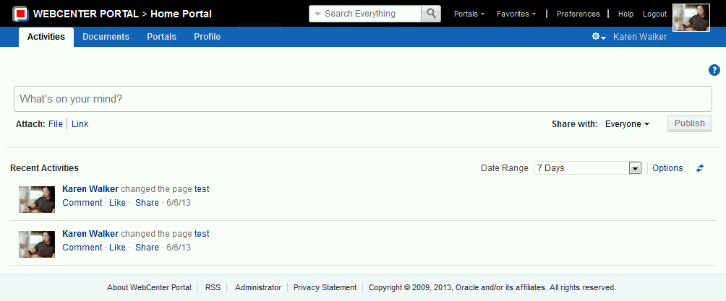

### Setting Preferences

Your personal preferences, accessed through the Preferences link (Figure 2–6), provide easy configuration settings for tailoring the application to your particular working style. These include settings for your preferred application display language; your preferred application look and feel; your WebCenter Portal password; and the like.

Additionally, WebCenter Portal preferences provide an accessibility setting to optimize the application user interface for use with a screen reader, such as JAWS. For information, see Chapter 5, "Setting Your Personal Preferences."

***Figure 2–6 Preferences Link***



## Working with Your Profile

Your profile is a collection of useful data about you. It can include contact information, a photo, your location within the company hierarchy, and so on. The social networking capabilities in WebCenter Portal enable you to view and manage your own profile and to view the profiles of others if they have made them available to you. For information about how to view and manage your profile

### Setting Your Personal Preferences

**Permissions:** The tasks described in this chapter are available to any logged in WebCenter Portal user.

#### Accessing the Preferences Page

Click the **Preferences** link (Figure 5–1) to open the **Preferences** page (Figure 5–2).

***Figure 5–1 Preferences Link***



**Note:** The availability of navigational links, such as the **Preferences** link, is determined by the people who design and build your portal. This being so, you may not see a **Preferences** link. In such a case, ask your system administrator to make the **Preferences** link available.

***Figure 5–2 Preferences Page***

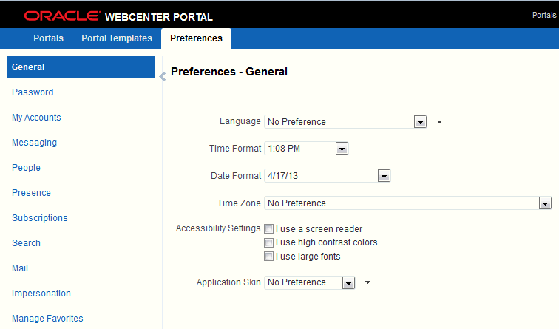

#### Setting Your Preferred Display Language

The display language preference controls the language that user interface (UI) elements are rendered in your browser. UI elements include button and field labels, application links, screen text, and so on. Display language also provides options for reflecting the current locale. Locale controls the appearance of symbols, such as monetary symbols, and the reading direction in which UI text is rendered.

To set your display language:

* + 1. Open the **Preferences** page (see Section 5.1, "Accessing the Preferences Page").
    2. Click **General** in the left navigation pane to access general preferences (Figure 5–2).
    3. From the **Language** drop-down list, select your preferred display language locale.

Alternatively, select **No Preference** to accept the application-level default set by your system administrator.

Your change is applied immediately, and the page refreshes in the selected language.

**Note:** You can set your display language before you log in to WebCenter Portal by selecting a language in the language switcher on the Login page (Figure 5–3).

***Figure 5–3 Language Switcher on Login Page***

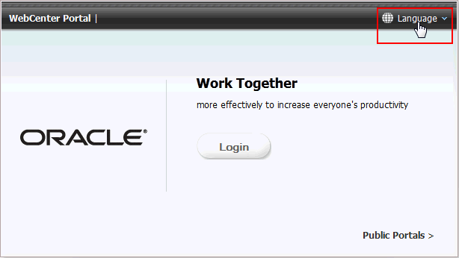

#### Setting Date and Time Preferences

Use date and time preferences to specify your preferred date and time formats and your current locale's time zone:

**Note:** Some content may be developed with an intrinsic time display format. Such content is not affected by your date and time preference.

To set your preferred time format, date format, and time zone:

* + 1. Open the **Preferences** page .
    2. Click **General** in the left navigation pane to access general preferences (Figure 5–2).
    3. Set your date and time preferences.

Table 5–1 describes the available date and time options.

***Table 5–1 Date and Time Preference Settings***

|  |  |
| --- | --- |
| **Preference** | **Description** |
| Time Format | Select your preferred time format. The example formats show the current time.  **Note:** The available time formats depend on the locale you selected from the  **Language** list or the locale set for your browser. For example, if you select  English-United Kingdom [en-GB], the AM/PM is not included in the time format.   * **No Preference**—The default Time Format established by your system administrator * **H:M AM/PM**—Shows hour, minutes, and AM or PM, such as 4:47 PM * **H:M:S AM/PM**—Shows hour, minutes, seconds, and AM or PM, such as 4:47:52 PM * **H:M:S AM/PM Time Zone**—Shows hour, minutes, seconds, AM or PM, and the abbreviation of the specified time zone, such as 4:47:52 PM PDT * **H:M:S o'clock Time Zone**—(Not available for all locales.) Shows hour, minutes, seconds, "o'clock", and the abbreviation of the specified time zone, such as 4:47:52 o'clock PDT |
| Date Format | Select your preferred date format. The example formats show the current date.  **Note:** The available date formats depend on the locale you selected from the **Language** list or the locale set for your browser. For example, if you select English-United Kingdom [en-GB], the dates are listed in day, month, year order.   * **No Preference**—The default date format set by your system administrator * **M/D/YY**—A number format, such as 4/21/09 * **MON D, YYYY**—An abbreviation format and the full year, such as Apr 21, 2009 * **MONTH D, YYYY**—The full month name and the full year, such as Apr 21, 2009 * **DAY, MONTH D, YYYY**—The full month name, the full year, and include the day of the week, such as Tuesday, April 21, 2009 |
| Time Zone | Select your preferred time zone, or select **No Preference** to accept the application-level default set by your system administrator. |

Your change is applied immediately.

#### Setting Your Accessibility Options

Use accessibility options to optimize the application user interface (UI) for use with a screen reader, such as JAWS; to enable support of high-contrast colors; and to enable support for large fonts.

This section includes the following subsections:

* Section 3.1.4.1, "About Application Accessibility Options"
* Section 3.1.4.2, "Applying Accessibility Options"

##### About Application Accessibility Options

Although WebCenter Portal provides accessibility options to assist users in navigating the application user interface, these tips can assist in using them successfully.

Submenu Items

Normally, screen readers announce links associated with menu selections. With the **Actions** menu, screen readers do not announce submenu items. For example, they do not read the submenu items under **Manage**. The workaround is to select a menu item

using direct keyboard navigation. That is, instead of using your screen reader's Links Chooser, navigate to the **Manage** submenu of the **Actions** menu using the Tab key on your keyboard.

Unlabeled UI Objects

Not all drop-down menus, fields, and radio buttons on WebCenter Portal administration pages are labeled. As a result, screen readers render a pound sign (#) instead of a label when an Insert-F7 command is invoked. The problem occurs in the following areas:

* + - * Drop-down menus in portal administration pages
      * Radio buttons on portal administration pages
      * Fields on the **Documents** page

The workaround is to use the Tab and arrow keys to navigate to each individual form field in order to hear each form field read.

Add Resources

When you add resources from the resource catalog, your screen reader announces all resource catalog items as *Add*. This makes it difficult to identify the selected resource. To work around this issue, press the Tab key to get to the Add link for the resource, then press the Down Arrow key. Your screen reader then reads the description of the resource.

##### Applying Accessibility Options

To apply accessibility options to the application UI:

1. Open the **Preferences** page (see Section 5.1, "Accessing the Preferences Page").
2. Click **General** in the left navigation pane to access general preferences (Figure 5–2).
3. Next to **Accessibility Settings**, select your preferred accessibility settings:
   * **I use a screen reader**—Specifically for visually impaired users, enables the use of screen reader software.
   * **I use high contrast colors**—Makes the WebCenter Portal user interface compatible with operating systems or browsers that have high-contrast features enabled. For example, WebCenter Portal changes its use of background images and CSS styles in high-contrast mode to prevent the loss of visual information.

**Note:** High-contrast mode is more beneficial if used in conjunction with your browser's or operating system's high-contrast mode. Also, some users might find it beneficial to use large-font mode along with high-contrast mode.

* + **I use large fonts**—Provides zoom-friendly content. In default mode, most text and many containers have a fixed font size for a defined look. In large-font mode, text and containers are more scalable. This allows WebCenter Portal to be compatible with browsers that are set to larger font sizes and to work with browser-zoom capabilities.

**Note:** If you are not using large-font mode or browser-zoom capabilities, you should disable large-font mode. Also, some users might find it beneficial to use high-contrast mode along with the large-font mode.

Your changes are applied immediately.

#### Changing the Look and Feel of Your View

Use application skins to change the look and feel of your view of the Home portal. Application skins specify the application background color, screen fonts, and, with some skins, the shapes and images used for application buttons and icons.

The skin you select through the Preferences page affects only the look and feel of your view of the Home portal. No other users' views and no other areas of the application are affected.

To change the look and feel of your view:

* + 1. Open the **Preferences** page
    2. Click **General** in the left navigation pane to access general preferences (Figure 5–2).
    3. In the **Application Skin** list, select your preferred application skin:
       - **No Preference**—To defer to the application's configured skin setting
       - ***Skin_Name***—To select a predefined application skin from the list of skins available to you

**Note:** Your system administrator makes skins available.

Your change is applied immediately. Go to the Home portal to see the selected skin.

#### Providing Login Information for External Applications

The **My Accounts** page is available for providing login credentials for all external applications that are configured to be accessed through WebCenter Portal. After you have provided your credentials, every time you access an external application within WebCenter Portal, the login credentials are provided automatically. This gives you a single-sign-on type of experience where one login (to WebCenter Portal) provides access to multiple applications.

**Note:** If you change the login credentials for an application, you must enter them again into the **My Accounts** page as described in this section.

To provide login credentials for external applications:

* + 1. Open the **Preferences** page .
    2. Click **My Accounts** in the left navigation pane to open the **My Accounts** page (Figure 5–5).

***Figure 5–5 Preferences My Accounts Panel***

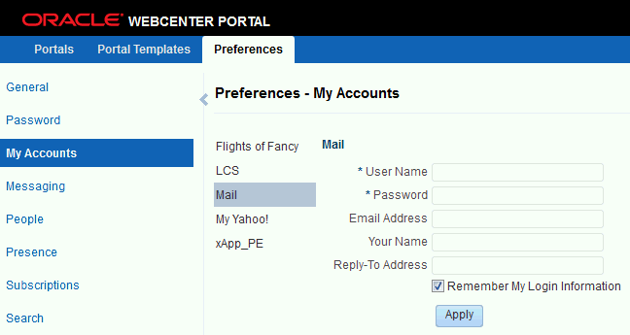

* + 1. Enter login credentials as required for the selected application.

Login credential fields and check boxes for the selected application are shown in the right pane. Fields requiring values are marked with an asterisk (*).

**Tip:** The applications you see on the **My Accounts** page are those that were configured by your system administrator. Contact your system administrator to request additional applications.

**Note:** Login credentials vary from one application to another. For example, some applications may require user name and password, while others may require those values along with additional values, such as your mail address.

* + 1. Select **Remember My Login Information** to enable automatic authentication to the selected application every time you log in to WebCenter Portal.

**Note:** If you do not select **Remember My Login Information**, the login information that you enter is used only for the current user session. This means the next time you log in to WebCenter Portal, you must also log in to this application.

* + 1. Click **Apply** to save your change.

### Managing Your Profile

This chapter describes how to view and manage your profile in WebCenter Portal. Your profile is a collection of useful data about you that can include contact information, a profile photo, your position relative to others in your organization, and so on. The social networking capabilities in WebCenter Portal enable you to view and manage your own profile and to view the profiles of others if they have made them available to you.

This chapter includes the following topics:

* Section 3.2.1, "About Profiles"
* Section 3.2.2, "Viewing a Profile"
* Section 3.2.3, "Editing Your Profile"
* Section 3.2.4, "Setting Profile Preferences"

**Permissions:** To perform the tasks in this chapter, you need the application-level permission People Connections: Update People Connections Data.

#### About Profiles

When you connect with other users, you give them access to your profile, and gain access to theirs. Your profile can include contact information, portal activity for your connections, a list of your connections, a view of your personal document library, a view of your location in your organization's hierarchy, recommended connections, and a list of your top contributions.

You can control how much of your profile a connection can view through profile preferences. For information about setting your profile preferences, see Section 6.4, "Setting Profile Preferences."

Your system administrator can set global defaults that affect what all users may see and do in profiles. Some profile information is pulled from the user database that WebCenter Portal uses. Depending on how your system administrator configured the user database, your profile may not show all the information discussed in this chapter and some profile information may not be editable. Because your system administrator can customize how profile information is rendered in WebCenter Portal, the

screenshots embedded with this information may not match what you see in your organization's version of WebCenter Portal.

**Notes:**

* + - The Profile user interface was updated in 11*g* Release 1 (11.1.1.9.0). Depending on how your system administrator configured your installation of WebCenter Portal, you might see the legacy Profile user interface. For information on the legacy Profile user interface, see the "Managing Your Profile" chapter in the *User's Guide for Oracle WebCenter Portal: Spaces* for 11*g* Release 1 (11.1.1.7.0).
    - Fields without any content do not appear in some profile views.

#### Viewing a Profile

You can view a profile, including your own, by clicking a user name wherever you see it in WebCenter Portal. Depending on where you click in the portal, you either see a popup view or a full profile view.

In some application contexts, such as in a Document Library or an announcement, a context menu opens in lieu of a profile popup (Figure 6–1). Select **View Profile** to view the user's profile.

***Figure 6–1 View Profile Option on the Documents Page***

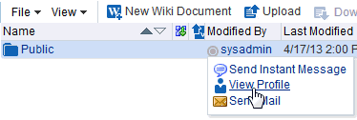

For more information, see:

* + - Section 6.2.1, "Profile Popup"
    - Section 6.2.2, "Profile Page"

You can also see profile information in one of these views that can be added to a portal page:

* + - Section 6.2.3, "Organization View"
    - Section 6.2.4, "Profile"
    - Section 6.2.5, "Profile Gallery"
    - Section 6.2.6, "Profile Snapshot"

##### Profile Popup

Click a user name wherever it appears in the application to view your own profile in a popup or the profiles of your connections or fellow portal members.

***Figure 6–2 Profile Popup***

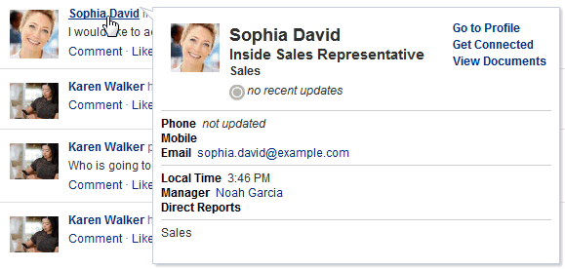

In the popup, click **Go to Profile** to view additional profile details on the WebCenter Portal **Profile** page (described next).

##### Profile Page

You can view the full details of a profile on the WebCenter Portal **Profile** page by clicking **Go to Profile** in the profile popup or by clicking your own name at the top of the application.

***Figure 6–3 Profile Page***

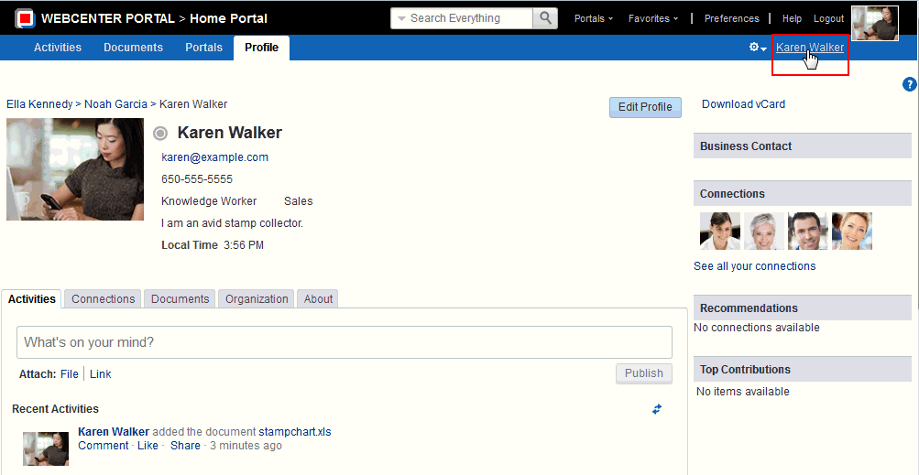

**Note:** The **Profile** page is a business role page included in the Home portal of all users who are logged in to WebCenter Portal.

By default, the **Profile** page presents the following information:

* + - * Your contact information, such as photo, email address, position, business phone number and address, and so on.
      * A view of your activities and those of your connections on the **Activities** tab. For more information, see Chapter 24, "Tracking Portal Activities."
      * A brief list of your connections on the main **Profile** page, and a detailed view of your connections on the **Connections** tab. For more information, see Chapter 11, "Managing Your Contacts."
      * A view of the documents and folders in the Public folder of your personal document library on the **Documents** tab. For more information, see Part IV, "Working with Documents".

**Note:** You must access the **Documents** page in the Home portal at least once before accessing the **Documents** tab in your profile.

Accessing the **Documents** page in the Home portal initializes the Documents feature. If you do not first access the **Documents** page in the Home portal, you will see the following message: "The user does not currently have any public documents."

* + - * A chart view of your location within the organization on the **Organization** tab.
      * A view of additional profile details on the **About** tab (Figure 6–4).

***Figure 6–4 About Tab on Profile Page***

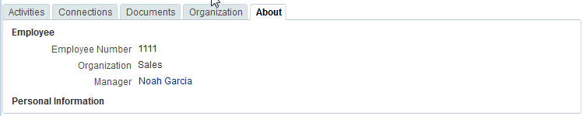

* + - * A list of recommended connections.
      * A list of your top contributions (your personal documents that you access most).

**Note:** The type of information and number of items displayed in under Top Contributions can be customized by selecting the Edit (pencil) icon.

Your system administrator can revise the default **Profile** business role pages to include additional components, remove existing components, and revise the page look and feel. Consequently, the page described in this guide may be different than the **Profile** page that you see. However, the basic profile functionality should remain about the same.

**Note:** Fields without any content do not appear on the Profile page.

##### Organization View

The Organization View (Figure 6–5) can be added to a portal page to present a graphical depiction of the user's position within the company—that is, a detail of the overall organization chart. In Organization View, you can click through three views of the user's profile information, including contact information; the user's address and current time in the user's locale; and a summary About Me statement. You can also expand the Organization View to show the user's reports or managers.

***Figure 6–5 Organization View***

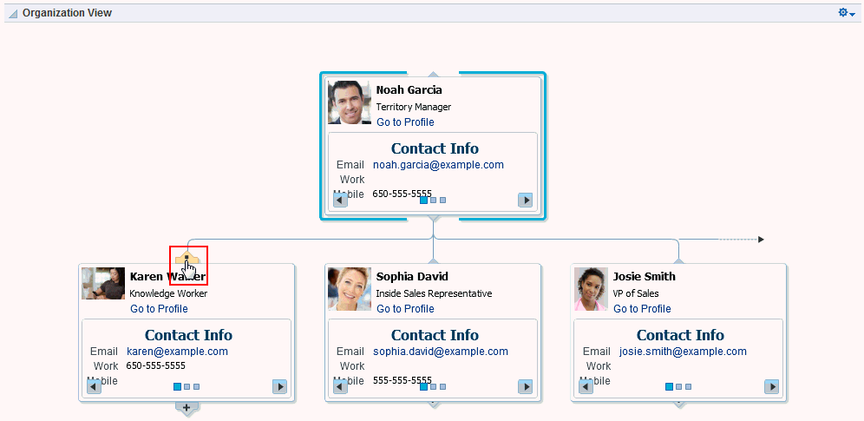

##### Profile

The Profile viewer (Figure 6–6) can be added to a portal page to display a user's profile details. If you are viewing your own profile, the Profile viewer allows you to upload a profile photo and (if enabled) allows you to edit your profile details.

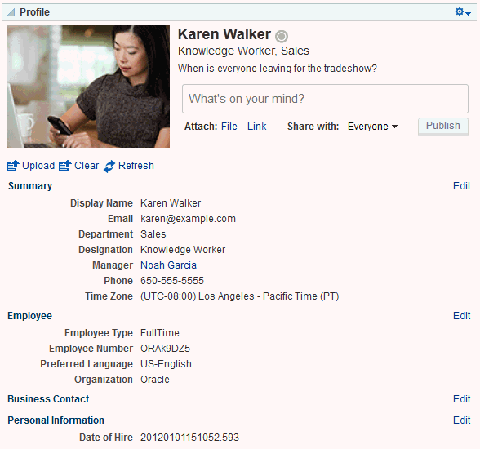***Figure 6–6 Profile***

**Note:** Fields without any content do not appear in the Profile view.

##### Profile Gallery

The Profile Gallery (Figure 6–7) can be added to a portal page to provide access to all of your social networking information.

***Figure 6–7 Profile Gallery***

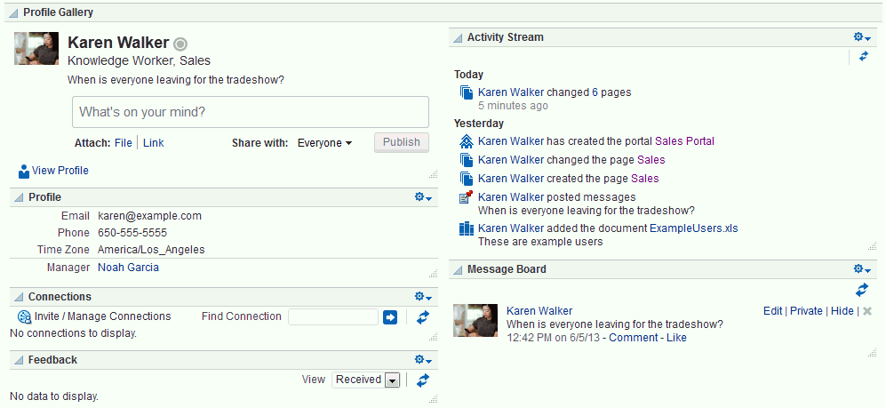

**Note:** Empty fields (fields without any content) do not appear in the Profile Gallery views.

##### Profile Snapshot

The Profile - Snapshot viewer (Figure 6–8) can be added to a portal page to display a user's photo and status message.

***Figure 6–8 Profile - Snapshot***

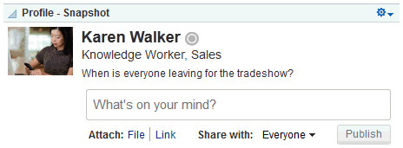

#### Editing Your Profile

Your system administrator determines how much of your personal profile you may edit. When you have permission to edit your profile, an **Edit Profile** button appears on the **Profile** page (Figure 6–9). In addition, when you place your cursor over information that is editable, a gray box appears around editable information.

***Figure 6–9 Edit Profile Button and Editable Information on a Profile***

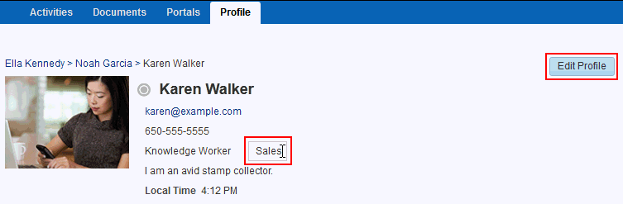

Click the **Edit Profile** button or an editable piece of information to open an edit view of your personal profile.

**Notes:**

* + - Even if your system administrator has enabled the editing of a particular profile section, it is possible that some fields in that section are read-only. For example, you should generally not be able to change the value for your manager.
    - Some web browsers lack the support to show text box labels. However, if you click a text box a tooltip appears that describes the text box.

To edit your personal profile:

1. Open your **Profile** page (as described in Section 6.2.2, "Profile Page").
2. Click **Edit Profile** or one of the editable pieces of information to open your profile in edit mode (Figure 6–10).

***Figure 6–10 Profile in Edit Mode***

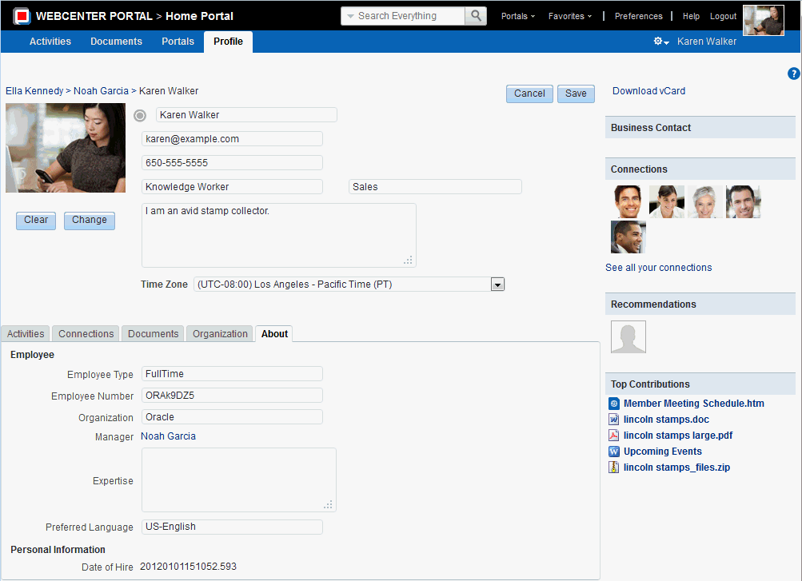

1. Make your changes, and click **Save**.

##### Uploading and Updating a Personal Profile Picture

Provided the profile viewer is configured to allow it, users with a personal profile can upload or update their profile image.

**Note:** The file must have the mime-type *image*, and cannot have the extension *.ico. For best results, your photo should be 150x150 pixels.

To upload or update your profile image:

* + - 1. Open your **Profile** page (as described in Section 6.2.2, "Profile Page").
      2. Click **Edit Profile**.
      3. Upload, change, or remove your photo: To upload or change your photo:
         1. Click **Change** to open the Upload Photo dialog (Figure 6–11).

***Figure 6–11 Upload Photo Dialog***

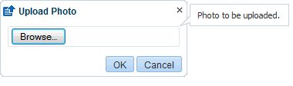

* + - * 1. Click **Browse** to locate and select a photo.
        2. Click **OK** to complete the upload. To remove your photo, click **Clear**.

**Note:** You do not need to click **Save** on the Profile page to save your photo.

#### Setting Profile Preferences

The profile details that are affected by your preferences settings appear in your full profile view, for example, in the Profile viewer and on the **About** tab of the default **Profile** business role page (Figure 6–12).

***Figure 6–12 About Tab on Profile Page***



Full profiles are presented in four sections: **Summary**, **Employee**, **Business Contact**, **Personal Information**. Each section provides information related to the section heading. For example, **Summary** includes a collection of basic details, such as your user name, mail address, and office location.

**Note:** Your system administrator can control every user's access to the user's own profile information. For example, the system administrator can control whether a profile section is shown, whether a given section is editable, and who can see what profile information. Consequently, the control you can exercise over your own profile preferences is determined by the actions of your system administrator.

Use profile preferences to specify who can view different types of information associated with your personal profile.

To set profile preferences:

* + 1. Click **Preferences**.
    2. Click **People** to display People Connections preferences.
    3. Click the **Profile** tab (Figure 6–13).

***Figure 6–13 Profile Preferences***

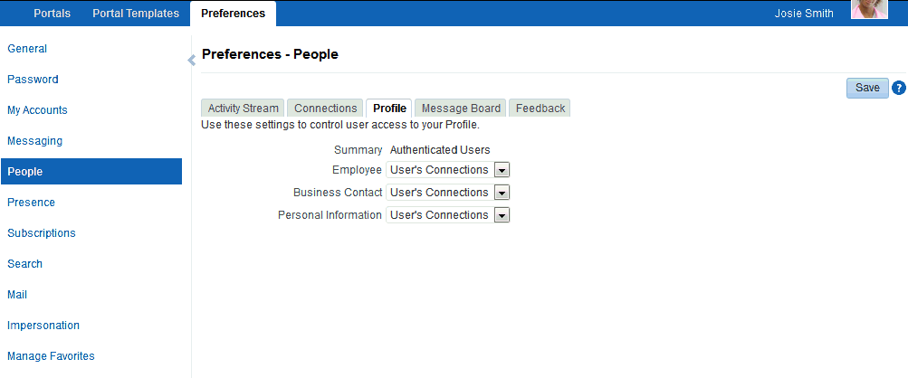

For each section of your personal profile, specify the users who can view it:

* + - * **Everyone**—All users, including users who are not logged in, can view the associated section of your profile.
      * **Authenticated Users**—Only users who are logged in can view the associated section of your profile.
      * **User's Connections**—Only you and your connections can view the associated section of your profile.
      * **User Only**—Only you can view the associated section of your profile.
    1. When you are done, click **Save**.

# Part II

## Working In the Home Portal

This chapter describes the Home portal, where you have access to WebCenter Portal activities, your personal documents, the portal browser, your profile, and your personal pages.

This chapter includes the following sections:

* + - * Section 8.1, "About the Home Portal"
      * Section 8.2, "Accessing the Home Portal"
      * Section 8.3, "Pages in the Home Portal"
      * Section 8.4, "What You Can Do In the Home Portal"

**Permissions:** The tasks described in this chapter are available to any WebCenter Portal user minimally assigned the role

Authenticated-User; that is, any user who is logged in.

### About the Home Portal

The *Home portal* (Figure 8–1) is the area where you have access to WebCenter Portal activities, your personal documents, the portal browser, and your profile. You can also create your own *personal pages* in the Home portal, and system administrators can expose *system pages* and *business role pages* to selected audiences.

**Note:** Your system administrator may choose to prohibit the creation of personal pages.

***Figure 8–1 The Home Portal***



### Accessing the Home Portal

When you log in to WebCenter Portal, the default landing page is the *Home portal*. Your system administrator may have changed the landing page to a different portal or page.

Depending on the navigation model, you may have a number of ways to access the Home portal. For example:

* + - Use the following URL:

http://*host*:*port*/webcenter/portal/home

* + - Click your user name where it appears as a link in the menu bar, as shown in Figure 8–2.

***Figure 8–2 Example of a User Name as a Link***

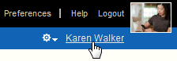

This takes you to the **My Profile** page in the Home portal.

* + - Click the **Portals** menu, and select **Home Portal** (Figure 8–3).

Pages in the Home Portal

***Figure 8–3 Home Portal Option on the Portals Switcher Menu***

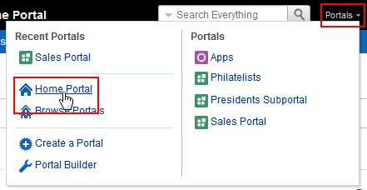

### Pages inthe Home Portal

By default, the Home portal includes the following pages:

* + - **Activities**: Includes Publisher, which you can use to make statements about your personal status and provide links to external or internal objects; and Recent Activities, which streams information about activities WebCenter Portal. For more information, see Section 15.7, "Sharing Messages, Files, and URLs" and Chapter 24, "Tracking Portal Activities."
    - **Documents**: Provides a view of your personal document library, where you can create, view, and manage your documents. For more information, see Part IV, "Working with Documents."
    - **Portals**: Provides access to available portals, including managing your portal memberships. For information, see Chapter 10, "Exploring Portals."
    - **Profile**: Displays information about you, such as contact information, a photo, your location within the company hierarchy, and so on. It also provides access to your *connections*, other WebCenter Portal users with whom you communicate or collaborate. For information on your profile, see Chapter 6, "Managing Your Profile." For information on your connections, see Chapter 11, "Managing Your Contacts."

Additionally, any personal pages you create are available in the Home portal. See Chapter 9, "Creating and Managing Personal Pages."

Some pages are hidden by default:

* + - **Portal Templates**: This page is intended for advanced users who build portals and custom portal templates. For more information, see the "Working with Portal Templates" chapter in *Building Portals with Oracle WebCenter Portal*.
    - **Tag Center**: Allows you to view and manage tags on WebCenter Portal objects. Tags provide a means of applying your own meaningful terms to and bookmarker application objects, making them easy to locate the next time you go looking for them. For more information, see Chapter 33, "Working with Tags."
    - **WebCenter Portal Impersonation**: Lets you assign the right for someone else to impersonate you and lets you impersonate a user for whom you have been given impersonation rights. For example, impersonation might be useful if a customer support representative needs to perform actions on your behalf to understand

issues you are experiencing, a system administrator might need to perform operations on your behalf, or you might be delegated someone else's responsibilities while they are away. For more information, see Chapter 7, "Using WebCenter Portal Impersonation."

For instructions on how to show these pages in the Home portal, see Section 9.7, "Showing or Hiding Pages in Your View of the Home Portal."

### What You Can Do Inthe Home Portal

You can perform the following actions in the Home portal:

* + - Create personal pages. For information, see Chapter 9, "Creating and Managing Personal Pages."
    - Manage your contacts, connect with them through instant messaging and email, and collaborate with other WebCenter Portal users. For more information, see the chapters in Part III, "Connecting and Collaborating with Other Users."
    - Create and manage documents, collaborate with others on documents, and publish content. For more information, see the chapters in Part IV, "Working with Documents."
    - Use tools and services to notify you when things change, track activities, participate in polls, monitor RSS feeds, and view your worklists. For more information, see the chapters in Part V, "Staying Informed."
    - Use tools and services to manage your schedule and work environment through calendars, notes, links, tags, and bookmarks. For more information, see the chapters in Part VI, "Staying Organized."

**Tip:** Some tools and services are active only in portals other than the Home portal, such as discussions, events, announcements, and lists.

## Creating and Managing Personal Pages

This chapter describes how to create, secure, edit, copy, and delete your own personal pages, which are available in the Home portal to you and to other users to whom you grant access.

This chapter includes the following topics:

* + - Section 3.1, "About Personal Pages"
    - Section 3.2, "Opening a Page in the Home Portal"
    - Section 3.3, "Creating a Personal Page in the Home Portal"
    - Section 3.4, "Managing Your Personal Pages"
    - Section 3.5, "Editing a Personal Page"
    - Section 3.6, "Setting Security for a Personal Page"
    - Section 3.7, "Showing or Hiding Pages in Your View of the Home Portal"
    - Section 3.8, "Rearranging Page Order in the Home Portal"
    - Section 3.9, "Customizing Your View of a Page in the Home Portal"
    - Section 3.10, "Resetting All of Your User Customizations from a Personal Page"
    - Section 3.11, "Copying a Personal Page"
    - Section 3.12, "Renaming a Personal Page"
    - Section 3.13, "Sending Mail with a Link to a Personal Page"
    - Section 3.14, "Viewing Information About a Personal Page"
    - Section 3.15, "Deleting a Personal Page"

**Permissions:** To perform the tasks in this chapter, you need the application-level permission Pages: Create, Edit, and Delete Pages. Users with this permission can create and manage their personal pages in the Home portal.

### About Personal Pages

**Note:** The system administrator may choose to prohibit the creation of personal pages in the Home portal, allowing only the display of business role pages and system pages, over which you have less control.

With appropriate permissions, you can create, secure, edit, copy, and delete your own *personal pages* in the Home portal, and populate them with components and content such as Message Board, Events, Discussions, portlets, and documents.

By default, personal pages can be seen in the Home portal only by the user who created them, but users can also allow other users to see their personal pages (see Section 9.6, "Setting Security for a Personal Page"). While individuals are primarily responsible for managing the content of their personal pages, a system administrator has the authority to administer all personal pages in WebCenter Portal administration, as described in the "Managing Personal Pages" chapter in *Administering Oracle WebCenter Portal*.

Personal pages are functionally similar to *portal pages*, but their purpose is different: personal pages are for an individual user's use in the Home portal, whereas portal pages are created by a portal moderator for use by all members of a portal. For more information about the different types of *pages* in WebCenter Portal, see Section 1.2.3, "What Are Pages?"

### Opening a Page inthe Home Portal

In the Home portal, you have access to your personal pages, system pages, and other pages to which you have been granted access.

The way that you access pages in the Home portal depends on the page template that is defined for the Home portal, the controls that the application specialist has made available, and the navigation model in use. In all configurations, however, you can open pages using a *pretty URL*.

To open a page in the Home portal:

* + - Click the page name in the Home portal navigation, such as tabs along the top.
    - Enter the following URL in your browser:

http://*host:port*/webcenter/portal/profile/*userName*/page/*pageName*

**See Also:** "WebCenter Portal Pretty URLs" appendix in *Building Portals with Oracle WebCenter Portal*.

* + - Open the **Personalize Pages** page, and click the name of the page you want to open (Figure 9–1).

**Tip:** The way you access this page depends on the page template in use. For example, you may access it through an **Actions** menu.

***Figure 9–1 Personalize Pages: Opening a Page***

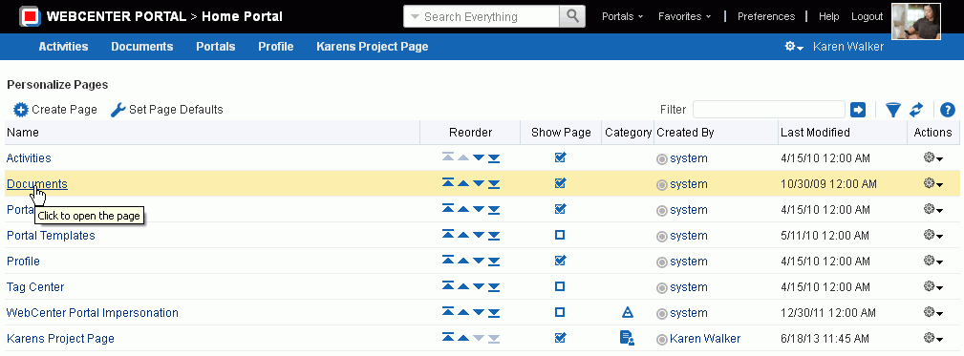

### Creating a Personal Page inthe Home Portal

After setting page creation defaults, you can create a personal page in the Home portal:

* + - Section 9.3.1, "Setting Page Creation Defaults for Personal Pages"
    - Section 9.3.2, "Creating a Personal Page"

#### Setting Page Creation Defaults for Personal Pages

If your system administrator has made the option available, you can set page creation defaults to reduce the number of steps required to create a personal page in the Home portal. That is, you can specify the page style that is selected by default when you open the Create Page dialog. You can also select to bypass the Create Page dialog, which enforces the default page style.

The settings you establish for yourself override any page-creation settings set by the system administrator.

To set personal page creation defaults:

* + - 1. In the Home portal (see Section 8.2, "Accessing the Home Portal"), open the

**Personalize Pages** page.

**Tip:** The way you access this page depends on the page template in use. For example, you may access it through an **Actions** menu.

* + - 1. On the **Personalize Pages** page, click **Set Page Defaults** to open the Set Page Defaults dialog (Figure 9–2).

***Figure 9–2 Set Page Defaults Dialog***

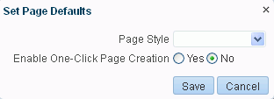

* + - 1. To set page creation defaults:
         1. Select a page layout from the **Page Style** dropdown list.

For detailed information about the seeded page styles, click the Help icon. Note, however, that your system administrator may provide additional custom page styles or restrict page styles to a shorter list.

* + - * 1. Select an option next to **Enable One-Click Page Creation**:

**Yes**—Bypass the Create Page dialog, and create all of your personal pages using the specified **Page Style**. This enforces a common look and feel across your personal pages.

**Tip:** When you bypass the Create Page dialog, your result is a page with a generic name. For information about renaming pages, see Section 9.12, "Renaming a Personal Page."

**No**—Display the Create Page dialog, with the specified **Page Style** selected as the default in the Create Page dialog for all of your personal pages. You can select a different style for your new personal pages.

* + - 1. Click **Save** to save your changes and exit the dialog.

#### Creating a Personal Page

Depending on how your portal navigation is implemented and the page template design in use, there may be several ways to create a personal page in your view on the Home portal.

To create a personal page in the Home portal:

* + - 1. In the Home portal (see Section 8.2, "Accessing the Home Portal"), click **Create Page**.

**Tip:** The location of the **Create Page** link depends on the page template in use. For example, in a side navigation template, you may access it through an **Actions** menu. You can also find it on the **Personalize Pages** page.

WebCenter Portal will either:

* Open the Create Page dialog (Figure 9–3).
* Immediately create a new page with a default style, if specified in the Set Page Defaults dialog (see Section 9.3.1, "Setting Page Creation Defaults for Personal Pages").

***Figure 9–3 Create Page Dialog***

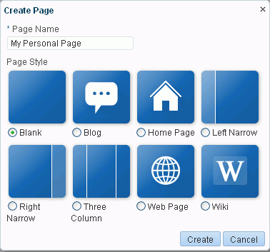

**Note:** Your system administrator can control the options that appear in the Create Page dialog. So, your view may differ from that depicted in Figure 9–3. Additionally, the system administrator can set an attribute on a custom page style that determines whether a newly created page that is based on that style opens in page edit mode or page view mode.

* + - 1. If the Create Page dialog opens, provide a name for the page.

There are no restrictions on the characters you can use in page names. You cannot give a page the same name as an existing page or certain system pages (Activities, Documents, Tag Center, Analytics, WebCenter Portal Impersonation). However, the names of the following system pages are allowable as personal page names: Portals, Portal Templates, Profile.

**Note about wiki page names:** While there are restrictions on naming files (including wiki documents), there are no naming restrictions for page names. Thus, while any of the following characters can be used to name a wiki *page*, the page title will include the character(s) but the associated wiki *document* will replace the illegal character with _.

? # & \ / * " | < > : ^

For example, if you create a wiki page named "What's In a Name?", the page will have this title, but the associated wiki document will be named _What's In a Name .

* + - 1. Select a page style to define the page structure.

For detailed information about the seeded page styles, click the Help icon. Note, however, that your system administrator may provide additional custom page styles or restrict page styles to a shorter list.

* + - 1. Click **Create**.

The new page opens in page edit mode (Composer), where you can add content.

**See Also:** For information about editing personal pages in the Home portal, see Section 9.5, "Editing a Personal Page."

### Managing Your Personal Pages

To manage a personal page, or a page you have permission to manage:

* + 1. In the Home portal (see Section 8.2, "Accessing the Home Portal"Section 8.2, "Accessing the Home Portal"), open the **Personalize Pages** page (Figure 9–4).

**Tip:** The way you access this page depends on the page template in use. For example, you may access it through an **Actions** menu.

***Figure 9–4 Personalize Pages Page***

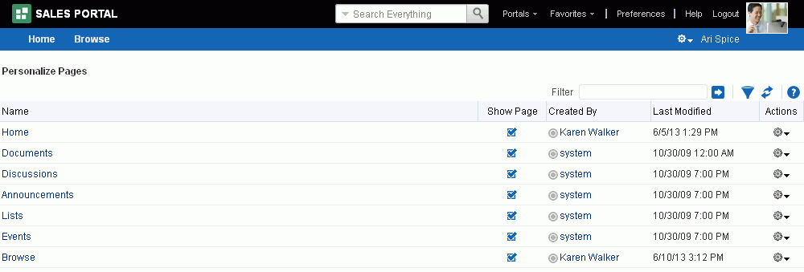

* + 1. On the **Personalize Pages** page, select a page, then choose any of the actions available to you on the **Actions** menu for the page (Figure 9–5):

***Figure 9–5 Personalize Pages: Page Actions Menu***

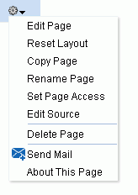

* + - * **Edit Page**. Open a page that you own or have privileges to edit in the page editor, Composer. See Section 9.5, "Editing a Personal Page."
      * **Reset Layout**. Remove all of your user customizations from a selected page. This action removes such personal changes as rearrangement, resizing, or collapsing of components in only your view of the page. See Section 9.10, "Resetting All of Your User Customizations from a Personal Page."
      * **Copy Page**. Make a personal copy of a page. See Section 9.11, "Copying a Personal Page."
      * **Rename Page**. Rename a page that you own or have privileges to manage. See Section 9.12, "Renaming a Personal Page."
      * **Set Page Access**. Add or remove access to a page by user name or role. See Section 9.6, "Setting Security for a Personal Page."
      * **Delete Page**. Delete a page that you own or have privileges to manage. See Section 9.15, "Deleting a Personal Page."
      * **Send Mail**. Send a link to a page that you own or have privileges to manage. See Section 9.13, "Sending Mail with a Link to a Personal Page."
      * **About This Page**. View information about a page. See Section 9.14, "Viewing Information About a Personal Page."

### Editing a Personal Page

When you edit a personal page, you can add or remove content, set properties on content and on the page itself, and perform additional customizations that affect the view of everyone who has access to the page.

To edit a personal page:

* + 1. In the Home portal (see Section 8.2, "Accessing the Home Portal"), open the page in edit mode.

**Note:** Depending on how the Home portal is designed, you can enter page edit mode from a page **Actions** menu or an **Actions** menu next to a page on the **Personalize Pages** page. Or, the page template used for the page may provide an **Edit Page** link.

* + 1. Edit the page as desired.

**See Also:** Editing a personal page is no different than editing a page in a portal. This is an advanced task, described in the "Editing a Page" section in *Building Portals with Oracle WebCenter Portal*.

* + 1. Click the **Save** icon to save your changes.

### Setting Security for a Personal Page

By default, the personal pages you create in the Home portal are accessible only to you and the system administrator. You can set page access settings to allow other users to view and work with your personal pages and to remove that access.

When you grant access to one of your personal pages to another user, the other user must deliberately show the page in their view of the Home portal. The user must take this step for each session because shared pages are not automatically shown on login.

**See Also:** For information about how to show a hidden page, see Section 9.7, "Showing or Hiding Pages in Your View of the Home Portal."

You may want to open a personal page to many users, but limit the exposure of a particular page component to a specific user, a user group, or to users who are assigned a specific application role. This is an advanced task requiring the use of EL expressions, described in the "Setting Security on a Page Component" section in *Building Portals with Oracle WebCenter Portal*.

You can grant or revoke access to your personal pages as described in the following sections:

* Section 9.6.1, "Accessing Personal Page Security Using the Page Properties Dialog"
* Section 9.6.2, "Accessing Personal Page Security Using the Set Page Access Dialog"
* Section 9.6.3, "Setting Personal Page Security"

#### Accessing Personal Page Security Using the Page Properties Dialog

To access security settings for a personal page using the Page Properties dialog:

* + - 1. In the Home portal (see Section 8.2, "Accessing the Home Portal"), open the page in edit mode.

**Note:** Depending on how the Home portal is designed, you can enter page edit mode from a page **Actions** menu or an **Actions** menu next to a page on the **Personalize Pages** page. Or, the page template used for the page may provide an **Edit Page** link.

* + - 1. Click the **Page Properties** icon (Figure 9–6).

***Figure 9–6 Page Properties Button in Page Edit Mode***

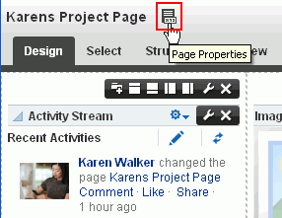

* + - 1. In the Page Properties dialog, click the **Security** tab (Figure 9–7).

***Figure 9–7 Personal Page: Security Tab in Page Properties Dialog***

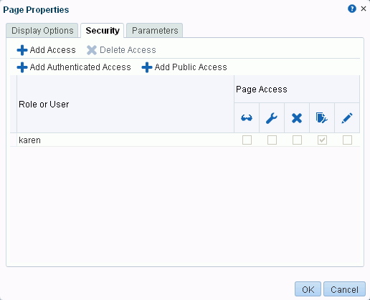

* + - 1. Follow the general steps for setting page access in Section 9.6.3, "Setting Personal Page Security."

#### Accessing Personal Page Security Using the Set Page Access Dialog

To access security settings for a personal page using the Set Page Access dialog:

* + - 1. In the Home portal (see Section 8.2, "Accessing the Home Portal"), open the

**Personalize Pages** page.

**Tip:** The way you access this page depends on the page template in use. For example, you may access it through an **Actions** menu.

* + - 1. On the **Personalize Pages** page, click the **Actions** icon for the page, and choose **Set Page Access** to open the Set Page Access dialog (Figure 9–8).

***Figure 9–8 Set Page Access Dialog: Personal Page***

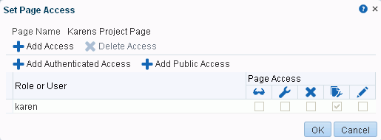

* + - 1. Follow the general steps for setting page access in Section 9.6.3, "Setting Personal Page Security."

#### Setting Personal Page Security

To set security on your personal page in either the Page Properties dialog or the Set Page Access dialog:

* + - 1. To grant page access permissions to all authenticated users (that is, to users who are logged in to WebCenter Portal), click **Add Authenticated Access**.

The role authenticated-role is added under **Role or User** with default **View**

access to the page.

* + - 1. To grant page access permissions to all public users (that is, users who have not logged in to WebCenter Portal) click **Add Public Access**.

The role anonymous-role is added under **Role or User** with default **View** access to the page (Figure 9–9).

***Figure 9–9 Authenticated and Public User Read Access to a Page***

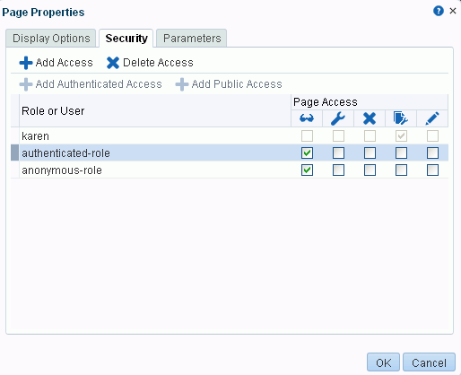

* + - 1. To grant page access permissions to selected users and roles, click **Add Access** to open the Add Access dialog (Figure 9–10).

***Figure 9–10 The Add Access Dialog***

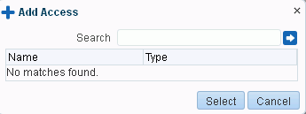

* + - 1. In the **Search** field, enter a search term or the name of the user or role for whom you want to enable access, and click the **Search** icon. For tips on searching for a user in the identity store, see the "Searching for a User or Group in the Identity Store" section in *Building Portals with Oracle WebCenter Portal*.
      2. Select a user or role by clicking in its row.

**Note:** When you select a user name, the permissions you set are granted to that specific user. When you select a group or application role, the permissions you set are granted to all users who are members of that group or who are assigned that role.

To make multiple selections:

* + - * + Ctrl+click to select multiple rows.
        + Shift+click to select a range of rows.
      1. Click **Select** to close the Add Access dialog, and populate the **Role or User** list with the selected users, group, or roles (Figure 9–11).

***Figure 9–11 Set Page Access Dialog***

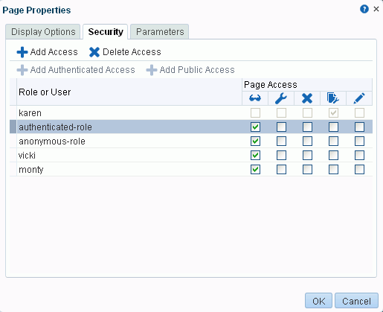

* + - 1. In the Set Page Access dialog, set the **Page Access** permissions as desired for each user or role (Table 9–1).

***Table 9–1 Page Access Privileges in the Set Page Access Dialog***

|  |  |
| --- | --- |
| **Page Access** | **Role or User Permissions** |
| View Page | Access the page for viewing, but cannot perform any other actions on the page. Other permissions do not implicitly include this privilege |
| Edit Page | Edit the page using the page editor, Composer. This includes adding, rearranging, and deleting content; renaming the page; and changing page properties. This permission additionally requires the **View Page** permission. |

***Table 9–1 (Cont.) Page Access Privileges in the Set Page Access Dialog***

|  |  |
| --- | --- |
| **Page Access** | **Role or User Permissions** |
| Delete Page | Delete the page. This permission additionally requires the **View Page**  permission. |
| Perform All Page Actions | Perform all actions on the page. |
| Personalize Page | Adjust a user's own view of a page. This includes rearranging page content, collapsing and restoring page content, and removing page content. This permission additionally requires the **View Page** permission. |

**Tip:** By default, all authenticated users and user roles that you add are granted page view access. The other access privileges must be explicitly granted.

* + - 1. To prevent access to the page, select the user or role from which to revoke page access, and click **Delete Access**.
      2. Click **OK** to save your changes.

### Showing or Hiding Pages in Your Viewof the Home Portal

By default, the Home portal exposes your personal pages and selected system pages as tabs. You may want to hide some pages, or expose system pages that are hidden by default, such as the **Portal Templates** page.

To show or hide pages in your view of the Home portal:

* + 1. In the Home portal (see Section 8.2, "Accessing the Home Portal"), open the

**Personalize Pages** page.

**Tip:** The way you access this page depends on the page template in use. For example, you may access it through an **Actions** menu.

* + 1. On the **Personalize Pages** page, select or deselect the **Show Page** check box for the pages you want to show or hide (Figure 9–12).

**Note:** If you deselect the **Show Page** check box for the current page, the **Personalize Pages** page closes and the current page is hidden.

Within the Home portal, one page must always be shown; therefore, you cannot hide all pages.

***Figure 9–12 Personalize Pages: Show Page***

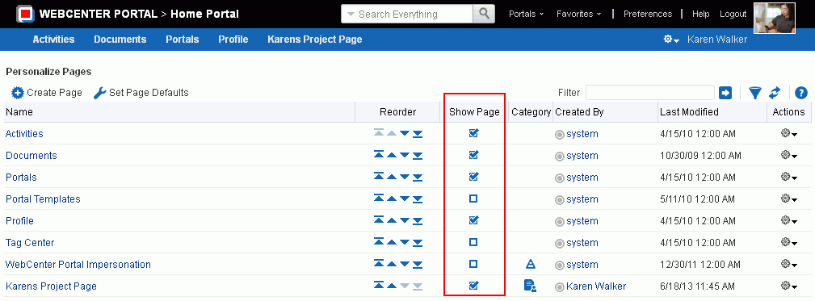

### Rearranging Page Order inthe Home Portal

On the **Personalize Pages** page, you can change the order in which pages are listed or arranged in your view the Home portal. This affects the order of the tabs exposed in the Home portal.

To rearrange page order in the Home portal:

* + 1. In the Home portal (see Section 8.2, "Accessing the Home Portal"), open the

**Personalize Pages** page.

**Tip:** The way you access this page depends on the page template in use. For example, you may access it through an **Actions** menu.

* + 1. Use the icons in the **Reorder** column to rearrange page order (Figure 9–13).

**Note:** You can also reorder pages by dragging and dropping the page names

***Figure 9–13 Personalize Pages: Reorder***

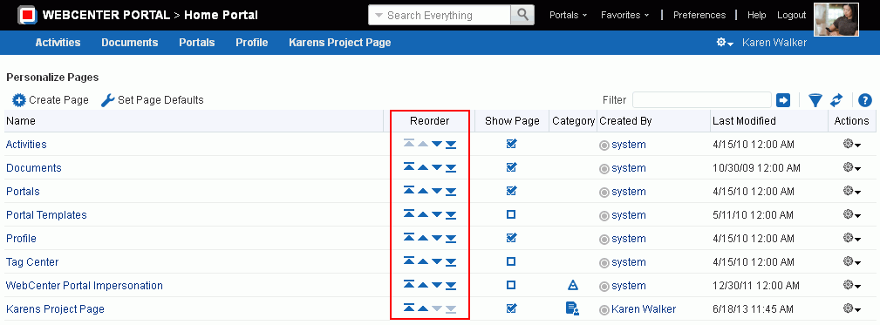

### Customizing Your Viewof a Page inthe Home Portal

You can change your view of a given page in the Home portal in many ways, including rearranging your view of page content, hiding components, changing your page layout, and so on. All of these options are *user customizations*, which affect only your view. The views of all other users who have access to the page remain unchanged.

This section describes the user customizations you can perform on a page:

* Section 9.9.1, "About User Customizations on a Page"
* Section 9.9.2, "Rearranging Page Content"
* Section 9.9.3, "Removing Components from Your View of a Page"
* Section 9.9.4, "Resizing Components"
* Section 9.9.5, "Collapsing and Expanding Components"

#### About User Customizations on a Page

You can customize the way pages appear in many ways without opening the page editor (Composer). For example, you can reposition, remove, resize, and collapse components, all within just your view of a page.

User customizations are yours and yours alone. That is, the changes you make through the procedures described in the following sections affect only your view of the page. No other users are affected by your changes.

**Note:** When you revise a component in page view mode while another user deletes the same component in page edit mode, an error page opens. Simply navigate back to the original page. The deleted component does not appear, and you can continue working on other components.

Whether you can customize a page depends on permissions granted to you or your application role and on how user customizations are configured. You can tell if you have such permission by the presence or absence of the controls discussed in this section. If you do not see these controls, contact your system administrator to ask for a higher-level of access or for a configuration change.

#### Rearranging Page Content

Use drag-and-drop to rearrange the position of a component on a page. Components moved by drag-and-drop can be moved into any open position on a page.

To rearrange components by dragging and dropping on a page:

* + - * Click and hold the header of the component you want rearrange, drag it to its target position, and drop it onto the page.

A shadow indicates where the component is placed when you drop it (Figure 9–14).

***Figure 9–14 Dragging an Issues List Above an Events Viewer***

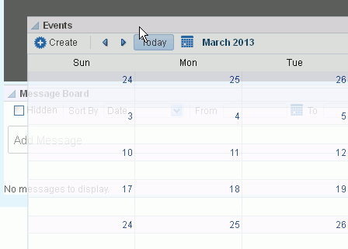

#### Removing Components fromYour Viewof a Page

If you find that a component, such as a document viewer or portlet, is not useful to you and the component displays a **Remove** icon, you can remove it from your view of the page.

Keep in mind that you can restore a removed component only by editing the page and adding a new component instance.

To remove a component from your view of a page:

* + - * Click the **Remove** icon on the component header (see Figure 9–15).

***Figure 9–15 Remove Icon on a Component***

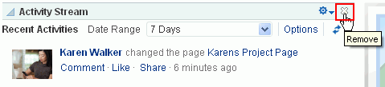

The component is removed from your view of the page.

#### Resizing Components

The border and header surrounding a component is also known as *chrome*. Chrome can clarify the boundaries of the component and provide an access point for component actions, such as those on the **Actions** menu and those embedded in the chrome itself. In the latter case, the chrome may include a **Resize** handle that you can use to increase or decrease the height of the component (Figure 9–16).

***Figure 9–16 Resize Handle on a Component***

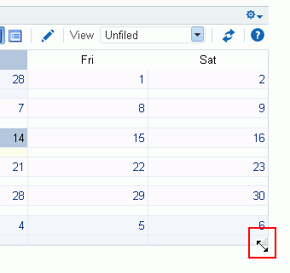

**Note:** The position of the resize handle differs for bidirectionally displayed components. Those components displayed in a right-to-left orientation display the resize handle on the left side.

To use this feature, click and hold the **Resize** handle and drag it up to decrease the height of the component or down to increase the height of the component.

#### Collapsing and Expanding Components

With one click, you can collapse some components so that they roll up like a window shade, useful for removing the visual noise of an unused component from your application view. Collapse is available when a component shows a header. With another click, you can expand a collapsed component.

To collapse and expand components on a page:

1. Click the **Collapse** icon on the component header to roll the component up like a window shade (Figure 9–17).

***Figure 9–17 Collapse/Expand Icon on a Component***

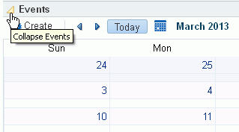

1. Click the **Expand** icon on the component header to restore the full component to view (Figure 9–18).

***Figure 9–18 Collapsed Component***

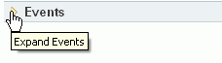

### Resetting All of Your User Customizations froma Personal Page

You can change your view of a page in many ways, including rearranging your view of page content, hiding components, and changing your page layout, as described in Section 9.9, "Customizing Your View of a Page in the Home Portal."

To reset all of your personal customizations of a page in the Home portal:

* + 1. In the Home portal (see Section 8.2, "Accessing the Home Portal"), open the

**Personalize Pages** page.

**Tip:** The way you access this page depends on the page template in use. For example, you may access it through an **Actions** menu.

* + 1. On the **Personalize Pages** page, click the **Actions** icon for the page, and choose

**Reset Layout** (Figure 9–19) to open the Reset Layout dialog.

***Figure 9–19 Page Actions: Reset Layout***

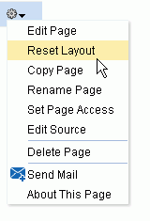

* + 1. To confirm your intent to remove all of your user customizations from the page, click **Reset**.

### Copying a Personal Page

When you copy a page, all content from the original page is also copied. The copy opens in page edit mode (Composer) so that you can start immediately making adjustments to the copy.

Note that a copy does *not* also include the original page's access settings. You must set access on the copy as a new page (see Section 9.6, "Setting Security for a Personal Page").

To copy a personal page:

* + 1. In the Home portal (see Section 8.2, "Accessing the Home Portal"), open the

**Personalize Pages** page.

**Tip:** The way you access this page depends on the page template in use. For example, you may access it through an **Actions** menu.

* + 1. On the **Personalize Pages** page, click the **Actions** icon for the page, and choose

**Copy Page** to open the Copy Page dialog.

* + 1. Enter a name for the page copy in the **Page Name** field, and click **OK**. The copied page opens in page edit mode (Composer).
    2. Edit the copy as desired than click the **Save** icon to exit Composer.

### Renaming a Personal Page

When you rename a page, any pretty URLs that use the old name will be broken. Also note that system pages, such as the **Announcements**, **Lists**, and **Events** pages, cannot be renamed.

To copy a personal page, or a page you have permission to manage:

* + 1. In the Home portal (see Section 8.2, "Accessing the Home Portal"), open the

**Personalize Pages** page.

**Tip:** The way you access this page depends on the page template in use. For example, you may access it through an **Actions** menu.

* + 1. On the **Personalize Pages** page, click the **Actions** icon for the page, and choose

**Rename Page** to open the Rename Page dialog.

* + 1. Enter a new name for the page, and click the **Save** icon.

### Sending Mail witha Link toa Personal Page

If you own or have manage permissions on a page in the Home portal, you can send other users a link to the page.

To send mail to other users populated with a link to a personal page:

* + 1. In the Home portal (see Section 8.2, "Accessing the Home Portal"), open the

**Personalize Pages** page.

**Tip:** The way you access this page depends on the page template in use. For example, you may access it through an **Actions** menu.

* + 1. On the **Personalize Pages** page, click the **Actions** icon for the page, and choose **Send Mail** to open your mail application compose window, showing a URL link to the page.

### Viewing Information About a Personal Page

To view information about a personal page:

* + 1. In the Home portal (see Section 8.2, "Accessing the Home Portal"), open the

**Personalize Pages** page.

**Tip:** The way you access this page depends on the page template in use. For example, you may access it through an **Actions** menu.

* + 1. On the **Personalize Pages** page, click the **Actions** icon for the page, and choose **About This Page** to open the Page Information dialog, which shows Name, Created By, Date Created, Last Modified, and Direct URL.

### Deleting a Personal Page

To delete a personal page:

* + 1. In the Home portal (see Section 8.2, "Accessing the Home Portal"), open the

**Personalize Pages** page.

**Tip:** The way you access this page depends on the page template in use. For example, you may access it through an **Actions** menu.

* + 1. On the **Personalize Pages** page, click the **Actions** icon for the page, and choose

**Delete Page** to display the Delete Page dialog.

* + 1. In the Delete Page confirmation dialog, click **Delete**.

## Exploring Portals

This chapter describes what a portal is and how to perform the tasks available to any knowledge worker in an existing portal.

This chapter includes the following topics:

* Section 4.1, "About Portals"
* Section 4.2, "What Does a Portal Look Like?"
* Section 4.3, "Interacting with Portals Before Logging In (Public User)"
* Section 4.4, "Viewing and Accessing Available Portals"
* Section 4.5, "Sending Mail to Portal Members or Moderators"
* Section 4.6, "Viewing Information About a Portal"
* Section 4.7, "Viewing Portals Similar to the Current Portal"
* Section 4.8, "Publishing the Link to a Portal"
* Section 4.9, "Searching for a Portal"
* Section 4.10, "Joining a Portal"
* Section 4.11, "Searching in a Portal"
* Section 4.12, "Working with Pages in a Portal"
* Section 4.13, "Changing Your Role in a Portal"
* Section 4.14, "Cancelling Your Portal Membership"

**Permissions:** To perform the tasks in this chapter, you need the application-level permissions granted by default to the application Authenticated-User role, and the portal-level permissions granted by default to the portal Participant role.

### About Portals

A portal provides a dedicated and readily accessible area for relevant tools, pages, and content and supports the inclusion of specified members, each of whom have defined roles associated with permissions in the portal. As you explore, you will learn more about the portals available to you, their purpose, and how to manage your role in a portal. Your experience in a particular portal depends on the purpose of the portal and your membership role.

Many features and tools to facilitate teamwork are built into the portal framework, instantly allowing portal members to share documents, discuss issues, schedule meetings, exchange messages, create lists, and much more.

### What Does a Portal Look Like?

A newly created portal may look similar to Figure 10–1 (side navigation) or Figure 10–2 (top tabbed navigation). It is important to realize, however, that your

system administrator or the portal moderator has most likely created and applied a custom page template to expose or hide tabs, features, and display a unique look and feel for your organization. A new portal that you create may look nothing like these examples.

***Figure 10–1 Home Page of a New Portal Using a Side Navigation Page Template***

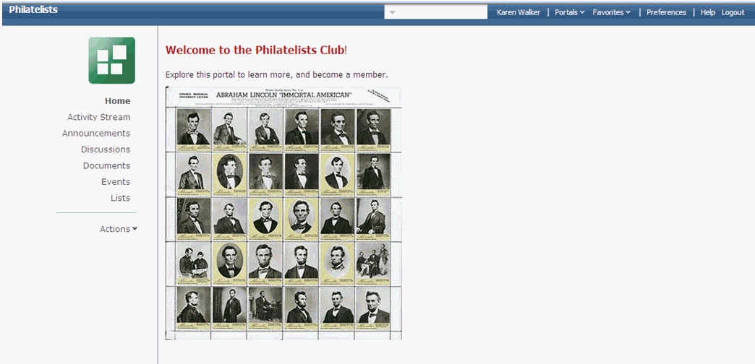

***Figure 10–2 Home Page of a New Portal Using a Top Navigation Page Template***

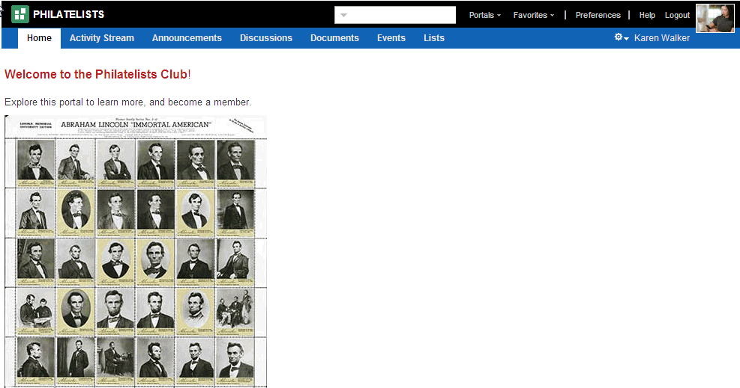

Each page in a portal provides access to related information. In the example portal under development above, the **Home** page welcome potential new member to the Philatelists club, the **Documents** page lists folders and files associated with the Philatelists club, the **Discussions** page provides a view of ongoing discussions with discussion forum management features, and so on. The portal moderator (or any portal member with the Portals-Manage Configuration permission) uses the pages available through the portal administration settings to build and manage the portal, expanding and customizing it as needs change and grow.

### Interacting with Portals Before Logging In(Public User)

Public portals are available to anyone with Internet access, without logging in to WebCenter Portal, allowing a portal to be shared with non-members and people outside of the WebCenter Portal community.

Public users who are not registered WebCenter Portal users can access public portals in two ways:

* + - Directly, using the portal URL provided to them.
    - From the WebCenter Portal Welcome page, if their installation is configured to display this page, exposing a link to public portals (Figure 10–3).

***Figure 10–3 Public Portals Link on Welcome Page***

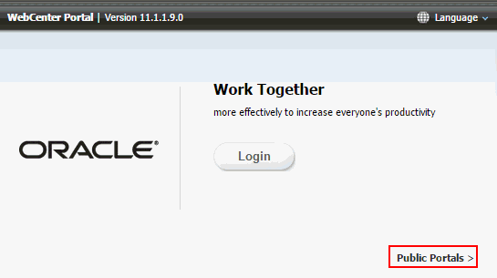

When a portal is made public, public users can view pages, lists, events, links and notes. To view Announcements, discussions, and documents, the portal moderator must explicitly grant these permissions. The public permissions granted by the portal moderator override the public permissions set by the system administrator at the application level.

### Viewingand Accessing Available Portals

You can participate in multiple portals and manage your portal memberships on the

**Portals** page in the Home portal.

To view and access the portals that are available to you:

1. Open the **Portals** page (Figure 10–4) in either of the following ways:
   * In the Home portal, click the **Portals** tab.
   * From the **Portals** menu, select **Browse Portals**.

***Figure 10–4 Portal Browser***

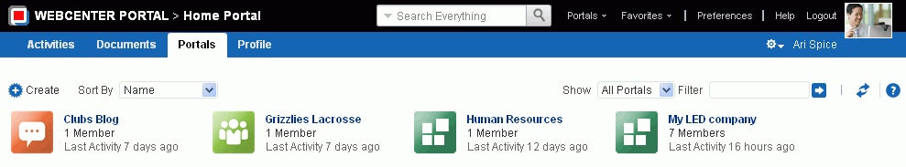

1. On the **Portals** page, from the **Show** list, select:
   * **All Portals** (Figure 10–5) to show all portals that are available to you, both public and private. Portals defined as *hidden* when created are not shown.

***Figure 10–5 Showing All Portals***

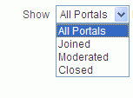

* + **Joined** to display portals of which you are a member.
  + **Moderated** to display portals for which you have moderator privileges.
  + **Closed** to display portals available to you that have been closed by the portal moderator. The content of a closed portal remains accessible and searchable to those who still want to reference it and portal members can continue working in the portal either by selecting **Closed Portals** as described here, or by direct URL (http://*host*:*port*/webcenter/portal/*portalName*).

1. To list one or more specific portals, enter a full or partial search term in the **Filter** field, then click the **Filter** icon to refresh the list with all portals for which a match is found in the **Display Name**, **Description**, or **Search Keywords** (specified when the portal was created or on the **Overview** page in the administration settings for the portal).
2. To clear the current search string and display all portals, click the **Clear Filter** icon.
3. To refresh the list of portals, first ensure that any prior search is cleared (click the

**Clear Filter** icon), then click the **Refresh** icon.

1. To go to the Home page of a portal, click the portal name or icon.
2. To display a menu of actions available on the portal, right-click a portal icon or name to explore the actions that are available to you, depending on your permissions in the portal (Figure 10–6, Figure 10–7, and Figure 10–8):

***Figure 10–6 Portal Actions Menu for Non-Member***

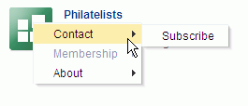

***Figure 10–7 Portal Actions Menu for Portal Viewer or Participant***

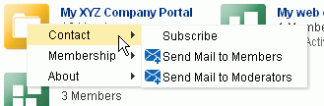

***Figure 10–8 Portal Actions Menu for Portal Moderator or Member with Manage Configuration Permission***

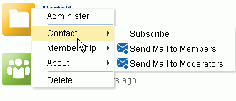

**Note:** Portal administration selections (**Administer** and **Delete**) are shown only if you are the portal moderator or have Manage Configuration permission in the portal.

Select the available actions, depending on your permissions in the portal:

* + **Administer** to open the portal administration settings pages, available only if you are the portal moderator or have Manage Configuration permission in the portal. See the "Administering a Portal" chapter in *Building Portals with Oracle WebCenter Portal*.
  + **Contact** menu:
    - **Subscribe** to open the Subscribe dialog, where you can select notification messages that you want to receive whenever the listed actions occur within the scope of the portal. See Section 10.3.2, "Setting Portal-Level Subscriptions."
    - **Send Mail to Members** and **Send Mail to Moderators**. See Section 10.5, "Sending Mail to Portal Members or Moderators."
  + **Membership** menu:
    - **Change Role** to change your role in the portal. See Section 10.13, "Changing Your Role in a Portal."
    - **Cancel Membership** to cancel your membership in the portal. See Section 10.14, "Cancelling Your Portal Membership."
  + **About** menu:
    - **Portal** to view information about the portal. See Section 10.6, "Viewing Information About a Portal."
    - **Similar Portals** to view other portals similar to the current portal. A portal is considered similar to another portal if the same people perform similar actions in it, especially if they edit the content. For more information, see Section 10.7, "Viewing Portals Similar to the Current Portal."
    - **Share Link** to share the URL link to the portal with others. See Section 10.8, "Publishing the Link to a Portal."
  + **Delete** to delete the portal, available only if you are the portal moderator or have Manage Configuration permission in the portal.

### Sending Mail to Portal Members or Moderators

**Note:** The **Send Mail** menu actions are available only if the profiles of one or more portal members or moderators specify a mail address, and you are a portal member.

You can send mail to the members or the moderators of a portal using the default mail distribution list for the portal. Advanced users can customize the mail distribution lists for a portal, as described in the "Configuring the Mail Distribution List for a Portal" section in *Building Portals with Oracle WebCenter Portal*.

**Note:** To use the task pane available through the Microsoft Office shared document management functionality (while editing a Microsoft Word, Excel, or PowerPoint file in a portal) to send mail to members of a portal, see Section 10.3.4.12, "Sending a Message."

You can send mail to portal members or moderators in either of the following ways:

* + - From the **Portals** menu, select **Browse Portals** to display the **Portals** page in the Home portal. Locate the portal to which the members or moderators belong, then right-click the portal icon or name, and select **Contact**, then **Send Mail to Members** or **Send Mail to Moderators** (Figure 10–9).

***Figure 10–9 Portal Actions Menu for Portal Viewer or Participant***



* + - When viewing a portal, click the **Actions** menu, and select **Contact**, then **Send Mail to Members** or **Send Mail to Moderators**.

**Note:** The location of the **Actions** menu is dependent on the page template in use. For example, it may be an icon in the menu bar in a top navigation template.

***Figure 10–10 Portal Actions Menu: Viewing Portal***

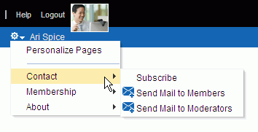

Your mail application opens, where you can compose and send mail to all members or moderators of the portal.

### Viewing Information About a Portal

To view information about a portal:

1. Open the About Portal dialog in any of the following ways:
   * From the **Portals** menu, select **Browse Portals** to display the **Portals** page in the Home portal. Locate the portal for which you want to view information, then right-click the portal icon or name, and select **About**, then Portal (Figure 10–11).

***Figure 10–11 Portal Actions Menu for Portal Viewer or Participant***

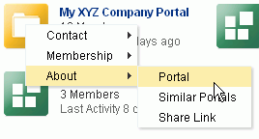

* + From the **Portals** menu, select **Portal Builder** to display the **Portals** page in Portal Builder. Select the portal for which you want to view information, then click the **Actions** icon in the toolbar and select **About Portal**.

***Figure 10–12 Portal Actions Menu: Portal Builder***

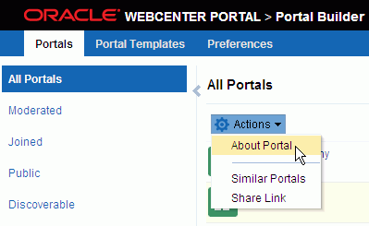

* + When viewing a portal, click the **Actions** menu, and select **About**, then **Portal**.

**Note:** The location of the **Actions** menu is dependent on the page template in use. For example, it may be an icon in the menu bar in a top navigation template.

***Figure 10–13 Portal Actions Menu: Viewing Portal***

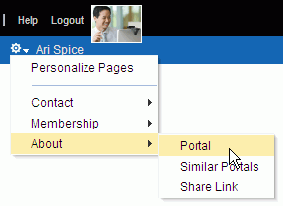

1. Explore the information in the About Portal dialog (Figure 10–14):

***Figure 10–14 About Portal Dialog***

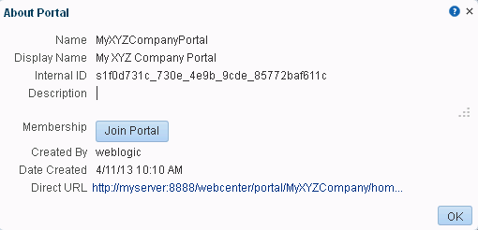

* **Name**: Internal name of the portal displayed in the portal URL.
* **Display Name**: Display name of the portal. This name displays at the top of the portal and other places where portals are available for selection, such as the **Portals** page.
* **Internal ID**: ID of the portal, which other applications may use to reference this portal.
* **Description**: A description of the portal, specified when creating the portal or in the portal administration settings.
* **Membership**: Your role in the portal. If you are not a member of this portal and the portal allows self-service membership, a **Join Portal** button displays here. See Section 10.10, "Joining a Portal."
* **Created By**: User name of the portal creator.
* **Date Created**: Date and time that the portal was created.
* **Direct URL**: URL that provides direct access to the portal.

### Viewing Portals Similar tothe Current Portal

A portal is considered similar to another portal if the same people perform similar actions in it, especially if they edit the content.

**See Also:** Section 23.3, "Working with Similar Portals"

To view a list of portals similar to the current portal:

1. Open the Similar Portals dialog in any of the following ways:
   * From the **Portals** menu, select **Browse Portals** to display the **Portals** page in the Home portal. Locate the portal for which you want to view information, then right-click the portal icon or name, and select **About**, then **Similar Portals** (Figure 10–15).

***Figure 10–15 Portal Actions Menu for Portal Viewer or Participant***

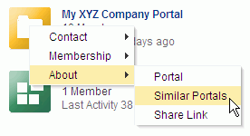

* + From the **Portals** menu, select **Portal Builder** to display the **Portals** page in Portal Builder. Select the portal for which you want to view information, then click the **Actions** icon in the toolbar and select **Similar Portals**.

***Figure 10–16 Portal Actions Menu: Portal Builder***

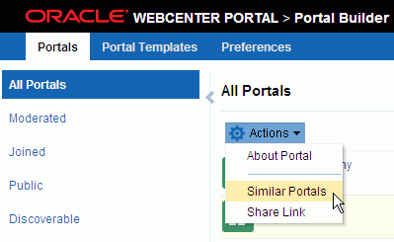

* + When viewing a portal, click the **Actions** menu, and select **About**, then

###### Similar Portals.

**Note:** The location of the **Actions** menu is dependent on the page template in use. For example, it may be an icon in the menu bar in a top navigation template.

***Figure 10–17 Portal Actions Menu: Viewing Portal***

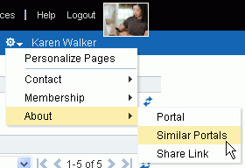

1. In the Similar Portals dialog, select a portal to open, or click the **Display Options**

(pencil) icon (Figure 10–18) to modify the criteria for similar portals.

***Figure 10–18 Similar Portals Display Options Dialog***

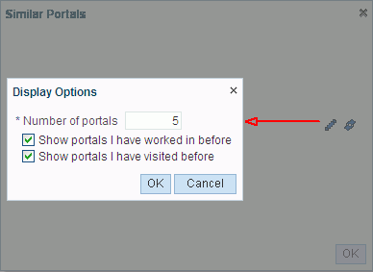

1. In the Display Options dialog (Figure 10–18), enter the number of portals to display and the display criteria, then click **OK**.

### Publishing the Link toa Portal

If you want to share a portal with others, you can publish a link to the portal that will appear in activity streams of other users. With appropriate permissions, users can directly access a portal by clicking the link that specifies the portal display name.

To publish the direct link to a portal:

1. Open the Share Link dialog in any of the following ways:
   * From the **Portals** menu, select **Browse Portals** to display the **Portals** page in the Home portal. Locate the portal for which you want to publish the link, then right-click the portal icon or name, and select **About**, then **Share Link** (Figure 10–19).

***Figure 10–19 Portal Actions Menu for Portal Viewer or Participant***

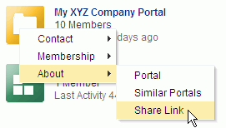

* + From the **Portals** menu, select **Portal Builder** to display the **Portals** page in Portal Builder. Select the portal for which you want to view information, then click the **Actions** icon in the toolbar and select **Share Link**.

***Figure 10–20 Portal Actions Menu: Portal Builder***

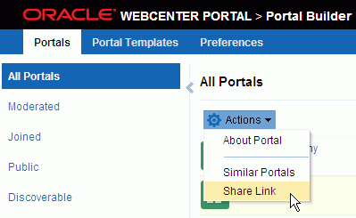

* + When viewing a portal, click the **Actions** menu, and select **About**, then **Share Link**.

**Note:** The location of the **Actions** menu is dependent on the page template in use. For example, it may be an icon in the menu bar in a top navigation template.

***Figure 10–21 Portal Actions Menu: Viewing Portal***

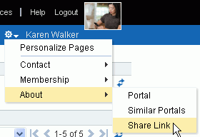

1. In the Share dialog (Figure 10–22), optionally enter a comment to appear with the link.

***Figure 10–22 Share Dialog for a Portal***

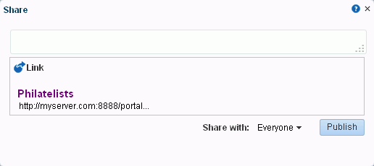

1. In the **Share with** list, select who you want to share the link with:
   * **Everyone** to share the link with all members of the current portal in their activity streams. This is useful to notify members of updates to the portal.
   * **Portals** to open the Select a Portal dialog, where you can select a portal to share the link in the activity streams of all members of the selected portal. This is useful for sharing information with members of other portals who may be interested in your portal.
2. Click **Publish**.

### Searching for a Portal

To search for a portal by a string in the portal name, description, or keywords:

1. On the **Portals** page (see Section 10.4, "Viewing and Accessing Available Portals"), enter a search string in the **Filter** field.
2. Click the **Filter** icon (Figure 10–23).

***Figure 10–23 Filter Icon***



The **Portals** page displays portals where the search string is found in the portal name, description, or keywords.

1. To clear the current search string and display all portals, click the **Clear Filter** icon (Figure 10–24).

***Figure 10–24 Clear Filter Icon***



### Joining a Portal

To become a member of a portal, you may be registered with WebCenter Portal, or you may be a public user. If a portal allows self-service membership, you can request membership to the portal. Or, you may receive an invitation to join a portal.

This section includes the following subsections:

* + - Section 10.10.1, "Joining a Portal (Registered WebCenter Portal User)"
    - Section 10.10.2, "Joining a Portal (Unregistered WebCenter Portal User)"

#### Joininga Portal (Registered WebCenter Portal User)

To become a member of a portal, you can join the portal. If a portal is configured to allow self-service membership, you can request membership to the portal. Or, you may receive an invitation to join a portal.

Some membership requests require approval from the portal moderator so you may not gain access immediately. You will receive a Worklist notification when your membership is approved.

To join a portal:

* + - 1. On the **Portals** page (see Section 10.4, "Viewing and Accessing Available Portals"), from the **Show** menu, select **All Portals**.
      2. To join a portal, you may have several options available to you, depending on the page template in use. For example, you may be able to simply click a portal to open the Request Membership dialog.

A generally available method to join a portal is through the About Portal dialog (see Section 10.6, "Viewing Information About a Portal").

* + - 1. In the About Portal dialog, next to **Membership**, click **Join Portal** (Figure 10–25).

***Figure 10–25 About Portal Dialog (for non-member)***

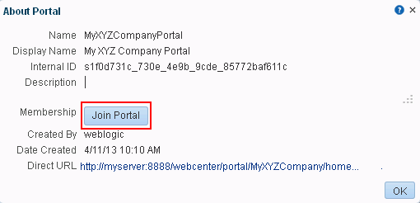

**Note: Join Portal** is shown only if the portal allows self-service membership, as described in the "Managing Self-Service Membership for a Portal" section in *Building Portals with Oracle WebCenter Portal*. If **Join Portal** is not shown, contact the portal moderator directly to request membership.

A portal membership request page similar to Figure 10–26 opens, showing the default Request Membership page. Because the portal moderator may customize this page, the page and roles you see may be different to the example shown here.

***Figure 10–26 Requesting Portal Membership***

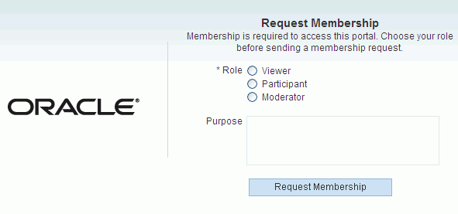

* + - 1. Select the type of **Role** you require in this portal.

**Note:** Out-of-the-box portal roles include Viewer, Participant, and Moderator, but a subset of these or other custom roles names may display, depending on what roles the portal moderator has defined for the portal.

* + - 1. (Optional) In the **Purpose** field, enter an explanation of why you need access to the portal with the role you have requested.
      2. Click **Request Membership**.

You may see a confirmation message similar to Figure 10–27, depending on whether or not the selected role requires moderator approval.

***Figure 10–27 Confirmation Message (No Approval Required)***

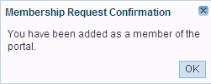

* + - 1. Click **OK**.
      2. On the **Portals** page, click the Refresh icon to confirm your new membership status.

**Note:** If membership requests require approval, you do not gain access immediately. Check back later or monitor your Worklist—you will receive notification as soon as your membership is approved.

#### Joininga Portal (Unregistered WebCenter Portal User)

If you are not a registered WebCenter Portal user, you can still view public portals, but you cannot join a portal unless you receive a mail message from the portal moderator inviting you to join a portal. If you want to join a portal, you must become a registered WebCenter Portal user.

Some membership requests require approval from the portal moderator so you may not gain access immediately. You will receive a Worklist notification when your membership is approved.

* + - 1. In the mail message you receive inviting you to join a portal, click the **Register Yourself** link included in the invitation mail to open the Self-Registration page, similar to Figure 10–28. Because the portal moderator may customize this page, the page you see may be different to the example shown here.

**Note:** The Self-Registration page displays only if the portal allows self-service membership, as described in the "Managing Self-Service Membership for a Portal" section in *Building Portals with Oracle WebCenter Portal*.

***Figure 10–28 Registering with WebCenter Portal***

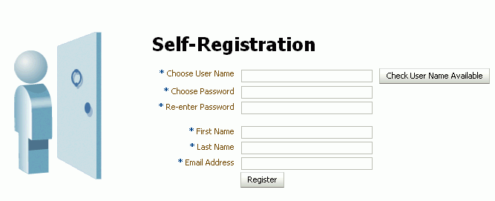

* + - 1. Choose a suitable **User Name**. The user name restrictions depend on the underlying identity store that is configured with WebCenter Portal.

Click **Check User Name Available** to determine whether a WebCenter Portal user is registered with that name. Click **OK** to dismiss the confirmation message and, if necessary, enter a different name.

* + - 1. Enter a suitable **Password**, and then **Re-enter Password** for verification. The password restrictions depend on the underlying identity store that is configured with WebCenter Portal.
      2. Enter your **First Name** and **Last Name**, and an **Email Address**.
      3. Click **Register**.

Once your User Name and Password are registered with WebCenter Portal, the portal to which you were invited opens.

### Searching ina Portal

WebCenter Portal includes the **Search** field at the top of the application for global (application-wide) searches. To perform searches limited to a single portal, an application specialist or portal moderator must create a new resource catalog, add the Search task flow (component) from the library to the catalog, and then assign this catalog to the portal. The Search task flow is not available in the default resource catalog.

### Working with Pages ina Portal

As a portal member, you will most likely be given access to pages in the portal. The portal moderator can grant you permissions to view, create, edit, and rename pages in the portal. Other portal members can grant you permissions to access the pages that they own. Pages that you create are for your own use only, unless you specifically share them with other users.

You can work with pages in a portal as described in the following sections:

* + - Section 10.12.1, "Showing or Hiding Pages in Your View of a Portal"
    - Section 10.12.2, "Opening a Page in a Portal"
    - Section 10.12.3, "Customizing Your View of a Page in a Portal"
    - Section 10.12.4, "Resetting All of Your User Customizations on a Page in a Portal"
    - Section 10.12.5, "Exposing a Portal Page in Your View of the Home Portal"
    - Section 10.12.6, "Sending Mail with a Link to a Page in a Portal"
    - Section 10.12.7, "Creating, Editing, and Managing a Page in a Portal"

#### Showing or Hiding Pages in Your Viewof a Portal

By default, a portal exposes the pages that are part of the portal navigation. You may want to personalize your view of the portal to hide some pages, or expose system pages that are hidden by default, such as a page for a tool that is enabled in the portal, such as Announcements or Lists.

To show or hide pages in your view of a portal:

* + - 1. Open the **Personalize Pages** page.

**Tip:** The way you access this page depends on the page template in use. For example, you may access it through an **Actions** menu.

* + - 1. On the **Personalize Pages** page, select or deselect the **Show Page** check box for the pages you want to show or hide (Figure 10–29).

**Note:** If you deselect the **Show Page** check box for the current page, the **Personalize Pages** page closes and the current page is hidden.

Within the Home portal, one page must always be shown; therefore, you cannot use this method to hide all pages.

***Figure 10–29 Personalize Pages for a Portal: Showing or Hiding a Page***



#### Opening a Page ina Portal

In a portal, members have access to system pages and member-created pages. The content on a portal page is typically targeted to a particular audience or objective.

The way that you access the pages of a portal depends on the page template that is defined for the portal, the controls that the portal moderator has made available, and the navigation model in use. In all configurations, however, you can open pages using a *pretty URL*.

You can open a page in a portal in any of the following ways:

* Click the page name in the portal navigation.
* Enter the following URL in your browser:

http://*host:port*/webcenter/portal/*portalName*/page/*pageName*

* Open the **Personalize Pages** page, and click the name of the page you want to open.

**Tip:** The way you access this page depends on the page template in use. For example, you may access it through an **Actions** menu.

#### Customizing Your Viewof a Page ina Portal

You can change your view of a given page in a portal in many ways, including rearranging your view of page content, hiding components, and resizing components. All of these options are *user customizations*, that is, they affect only your view. All other portal members' views remain unchanged.

This section describes the user customizations you can perform on a page:

* Section 10.12.3.1, "About User Customizations on a Page"
* Section 10.12.3.2, "Rearranging Page Content"
* Section 10.12.3.3, "Removing Components from Your View of a Page"
* Section 10.12.3.4, "Resizing Components"
* Section 10.12.3.5, "Collapsing and Expanding Components"

##### About User Customizations on a Page

You can customize the way pages appear in many ways without opening the page editor (Composer). For example, you can reposition, remove, resize, and collapse components, all within just your view of a page.

User customizations are yours and yours alone. That is, the changes you make through the procedures described in the following sections affect only your view of the page. No other users are affected by your changes.

**Note:** When you revise a component in page view mode while another user deletes the same component in page edit mode, an error page opens. Simply navigate back to the original page. The deleted component does not appear, and you can continue working on other components.

Whether you can customize a page depends on permissions granted to you or your application role and on how user customizations are configured. You can tell if you have such permission by the presence or absence of the controls discussed in this section. If you do not see these controls, contact the portal moderator to ask for a higher-level of access or for a configuration change.

##### Rearranging Page Content

Use drag-and-drop to rearrange the position of a component on a page. Components moved by drag-and-drop can be moved into any open position on a page.

To rearrange components by dragging and dropping on a page:

* Click and hold the header of the component you want rearrange, drag it to its target position, and drop it onto the page.

A shadow indicates where the component is placed when you drop it (Figure 10–30).

***Figure 10–30 Dragging an Events Calendar Above a Message Board***



##### Removing Components from Your Viewof a Page

If you find that a component is not useful to you and the component displays a

**Remove** icon, you can remove it from your view of the page.

Keep in mind that you can restore a removed component only by editing the page and adding a new component instance.

To remove a component from your view of a page:

* Click the **Remove** icon on the component header (see Figure 10–31).

***Figure 10–31 Remove Icon on a Component***



The component is removed from your view of the page.

##### Resizing Components

The border and header surrounding a component is also known as *chrome*. Chrome can clarify the boundaries of the component and provide an access point for component actions, such as those on the **Actions** menu and those embedded in the

chrome itself. In the latter case, the chrome may include a **Resize** handle that you can use to increase or decrease the height of the component (Figure 10–32).

***Figure 10–32 Resize Handle on a Component***



**Note:** The position of the resize handle differs for bidirectionally displayed components. Those components displayed in a right-to-left orientation display the resize handle on the left side.

To use this feature, click and hold the **Resize** handle and drag it up to decrease the height of the component or down to increase the height of the component.

##### Collapsing and Expanding Components

With one click, you can collapse some components so that they roll up like a window shade, useful for removing the visual noise of an unused component from your application view. Collapse is available when a component shows a header. With another click, you can expand a collapsed component.

Collapsing is useful for removing the visual noise of an unused component from your application view. Collapse is available when a component shows a header.

To collapse and expand components on a page:

1. Click the **Collapse** icon on the component header to roll the component up like a window shade (Figure 10–33).

***Figure 10–33 Collapse/Expand Icon on a Component***



1. Click the **Expand** icon on the component header to restore the full component to view (Figure 10–34).

***Figure 10–34 Collapsed Component***



#### Resetting All of Your User Customizations on a Page ina Portal

You can change your personal view of a given page in a portal in many ways, including rearranging your view of page content, hiding components, and resizing components, as described in Section 10.12.3, "Customizing Your View of a Page in a Portal."

To reset all of your personal customizations on a portal page:

* + - 1. In the portal, display the **Personalize Pages** page.

**Tip:** The way you access this page depends on the page template in use. For example, you may access it through an **Actions** menu.

* + - 1. On the **Personalize Pages** page, click the **Actions** icon for the page, and select

**Reset Layout** to open the Reset Layout dialog.

* + - 1. To confirm your intent to remove all of your user customization from the page, click **Reset**.

#### Exposing a Portal Page in Your Viewof the Home Portal

You can make a portal page available for viewing and revising from your view of the Home portal according to your permissions on the page. The portal name is prepended to the page name, so the *Sales Results* page in the portal *Finance* becomes *Finance - Sales Results* in your view of the Home portal.

If you delete such a page from your view of the Home portal, it remains in its original portal. In other words, deleting it simply removes it from your view of the Home portal; it does not actually delete the page. If the page is deleted from its parent portal, it is unavailable in your view of the Home portal. To clear it from your view, you must refresh the page list in the Home portal's **Personalize Pages** page.

To add a portal page to the list of pages in the Home portal, visible only to you in your personalized view of the Home portal:

* + - 1. In the portal, open the **Personalize Pages** page.

**Tip:** The way you access this page depends on the page template in use. For example, you may access it through an **Actions** menu.

* + - 1. On the **Personalize Pages** page, click the **Actions** icon for the page, and select **Add to Home Portal**.

When you add a portal page to your view of the Home portal, the page scope remains that of the portal.

#### Sending Mail witha Link toa Page ina Portal

If you own or have manage permissions on a page, you can send other portal members a link to the page.

To send mail to other portal members populated with a link to a page:

* + - 1. In the portal, display the **Personalize Pages** page.

**Tip:** The way you access this page depends on the page template in use. For example, you may access it through an **Actions** menu.

* + - 1. On the **Personalize Pages** page, click the **Actions** icon for the page, and select **Send Mail** to open your mail application compose window, showing a URL link to the page.

#### Creating, Editing, and Managing a Page ina Portal

Creating, editing, and managing pages in a portal are advanced tasks, described in the "Working with Portal Pages" chapters in *Building Portals with Oracle WebCenter Portal*".

### Changing Your Role ina Portal

If you are unable to perform all the actions that you would like in a portal, you can request a change to your membership role. For example, you might want to participate in an interesting discussion thread or raise a new issue but in your current role you are only allowed to view ongoing discussions.

Role change requests may or may not require approval, depending on how the portal moderator has defined membership changes for a particular role, as described in the "Managing Self-Service Membership for a Portal" section in *Building Portals with Oracle WebCenter Portal*. You will receive a Worklist notification when your new role is approved.

To change your portal role:

* + 1. Open the Change Membership dialog in either of the following ways:
       - From the **Portals** menu, select **Browse Portals** to display the **Portals** page in the Home portal. Locate the portal in which you want to change your membership role, then right-click the portal icon or name, and select **Membership**, then **Change Role** (Figure 10–35).

***Figure 10–35 Portal Actions Menu for Portal Viewer or Participant***

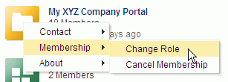

* + - * When viewing a portal, click the **Actions** menu, and select **Membership**, then

###### Change Role.

**Note:** The location of the **Actions** menu is dependent on the page template in use. For example, it may be an icon in the menu bar in a top navigation template.

***Figure 10–36 Portal Actions Menu: Viewing Portal***

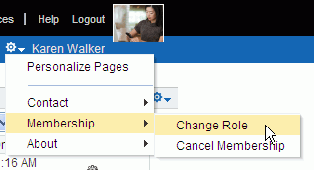

* + 1. In the Change Membership dialog (Figure 10–37), select your preferred role from the **New Role** list.

**Note:** The **New Role** list is active only if the portal moderator has allowed self-service membership changes. If **New Role** selections are disabled, contact the portal moderator directly to request a member role change.

If you wish to cancel your membership in the portal, click **Cancel Membership**.

***Figure 10–37 Change Membership Dialog***

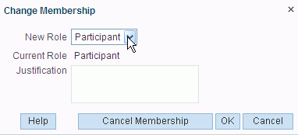

The portal moderator controls the list of roles displayed here, as described in the "Managing Self-Service Membership for a Portal" section in *Building Portals with Oracle WebCenter Portal*. Out-of-the-box portal roles include Viewer, Participant, and Moderator but a subset of these or other custom roles may display.

* + 1. Click **OK**.

A confirmation message displays whether or not the selected role change requires approval.

* + 1. Click **OK** to acknowledge the confirmation message.
    2. On the **Portals** page, click the **Refresh** icon to confirm your membership status has changed for the portal.

**Note:** Your new role is not effective immediately when membership change requests require approval. Check back later or monitor your Worklist; your new role will be effective as soon as the portal moderator approves it.

### Cancelling Your Portal Membership

When you no longer want or need membership in a portal, you can cancel your membership.

Some cancellation requests require approval from the portal moderator so you may not be removed from the portal immediately. You will receive a Worklist notification when your membership is removed.

Once you have successfully cancelled your membership in a portal, it will no longer be shown on the **Portals** page when you select **Joined** from the **Show** menu.

To cancel your membership in a portal:

* + 1. Open the Cancel Membership dialog in either of the following ways:
       - From the **Portals** menu, select **Browse Portals** to display the **Portals** page in the Home portal. Locate the portal in which you want to change your membership role, then right-click the portal icon or name, and select **Membership**, then **Cancel Membership** (Figure 10–38).

***Figure 10–38 Portal Actions Menu for Portal Viewer or Participant***

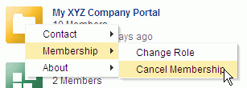

* + - * When viewing a portal, click the **Actions** menu, and select **Membership**, then

###### Change Role.

**Note:** The location of the **Actions** menu is dependent on the page template in use. For example, it may be an icon in the menu bar in a top navigation template.

***Figure 10–39 Portal Actions Menu: Viewing Portal***

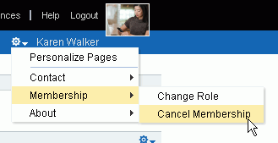

* + 1. Click **OK** to acknowledge the confirmation message.
    2. From the **Portals** menu, select **Browse Portals**. In the portal browser, select **Joined** from the **Show** menu, then click the **Refresh** icon to confirm that the portal no longer displays.

**Note:** If a cancellation request requires approval, you are not removed from the portal immediately. Check back later or monitor your worklist; you will receive notification when your unsubscribe request is approved or rejected by the portal moderator.

# Part III

## Managing Your Contacts

This chapter describes connections, which you can use to establish a social network with your work friends and associates.

This chapter includes the following topics:

* Section 5.1, "About Connections"
* Section 5.2, "Setting Connections Preferences"
* Section 5.3, "Viewing Another User's Profile"
* Section 5.4, "Viewing Connections"
* Section 5.5, "Adding Contacts"
* Section 5.6, "Removing Contacts"
* Section 5.7, "Creating and Managing Groups of Contacts"

**Permissions:** To perform the tasks in this chapter, you need the application-level permission People Connections: Connect with People. To work with connections lists, you also need the application-level permission People Connections: Update People Connections Data.

### About Connections

Connections provides a means of collecting your business friends and contacts into a social network, where you can manage your own connections and view the connections of others. Using People Connections preferences, you can grant differing levels of access to those who are and are not your connections. For example, you can enable access to views of your profile, message board, activity stream, and feedback to just your connections, leaving the unconnected without access. For your profile, you can limit view privileges to just your connections or enable your connections to view certain sections of your profile, while hiding those sections from users who are not your connections. For your message board and feedback, you can give everyone view access, but limit post access to just your connections or to a limited set of your connections through a connections list.

**See Also:** For information about setting your Connections preferences, see Section 11.2, "Setting Connections Preferences."

When you connect with other users, you give them access to your People Connections views, and gain access to theirs.

**Note:** People Connections encompasses Connections, Profile, Activity Stream, Message Board, and Feedback. For more information, see:

* + - Chapter 6, "Managing Your Profile"
    - Chapter 24, "Tracking Portal Activities"
    - Chapter 14, "Working with Feedback and the Message Board"

Before you begin to build your social network, your system administrator can set global application defaults that affect what all users may see and do with their own and other users' connections.

WebCenter Portal provides the following Connections views that can be added to a portal page:

* **Connections** for viewing and managing your connections, creating connections lists, and sending and responding to invitations to connect (Figure 11–1)

***Figure 11–1 Connections View***

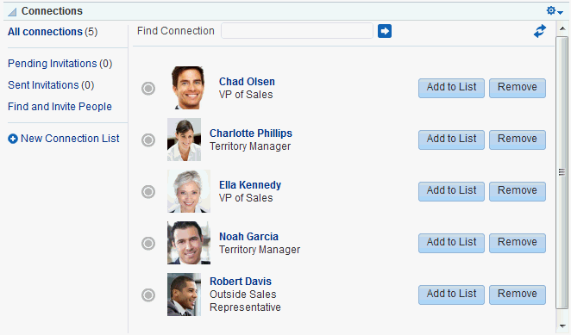

* **Connections - Card** for photos, status messages, and instant contact options to your connections (Figure 11–2)

***Figure 11–2 Connections - Card View***

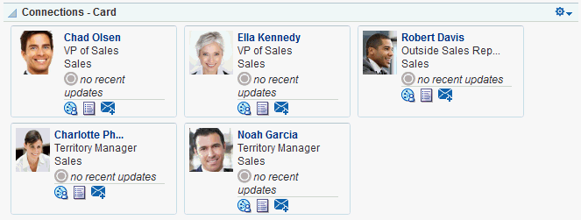

* **Connections - Detailed View** for photos and quick access to your connections and to features for inviting new connections, managing existing connections, and organizing your connections into lists (Figure 11–3). This is the same view you see when you click the **Connections** tab on the **Profile** page.

***Figure 11–3 Connections - Detailed View***

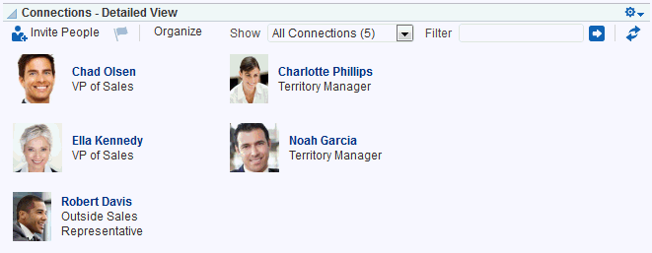

* **Connections - Quick View** for photos and quick access to your connections (Figure 11–4). This is the same view you see on the right side of the main **Profile** page.

***Figure 11–4 Connections - Quick View***

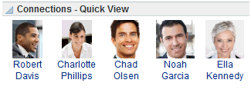

For information about using Connections features, see Section 11.4, "Viewing Connections," Section 11.5, "Adding Contacts," Section 11.6, "Removing Contacts," and Section 11.7, "Creating and Managing Groups of Contacts."

### Setting Connections Preferences

You use Connections preferences to specify who can view information about the people you have connected with and whether to accept invitations to be others' connections automatically.

To set Connections preferences:

1. Click **Preferences**.
2. Click **People** to display People Connections preferences.
3. Click the **Connections** tab (Figure 11–5).

***Figure 11–5 Connections Preferences***

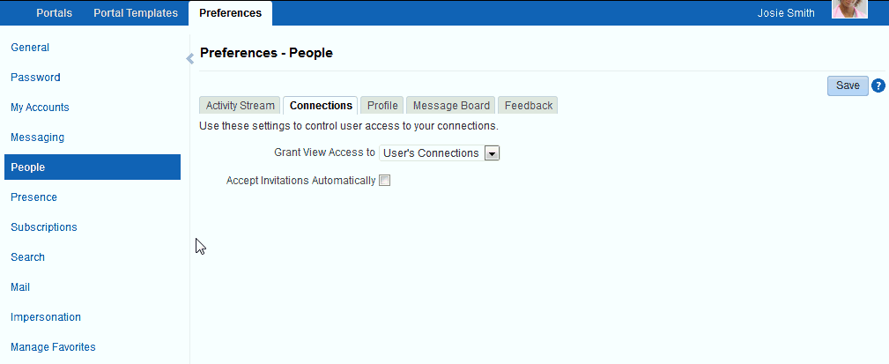

1. From the **Grant View Access to** list, select the users who can view your list of connections:
   * **Everyone**—All users, including users who are not logged in, can see information about your connections.
   * **Authenticated Users**—Only users who are logged in can view your connections.
   * **User's Connections**—Only you and your connections can view your connections.
   * **User Only**—Only you can view your connections.

**Note:** If the **Grant View Access to** list is disabled in your view contact your system administrator.

1. To automatically accept invitations to connect with another user, select **Accept Invitations Automatically**.

Deselect this check box to leave yourself the option of accepting, refusing, or ignoring an invitation to connect with another user.

1. When you are done, click **Save**.

### Viewing Another User's Profile

You access other users' profiles the same way you access your profile. For information, see Section 6.2, "Viewing a Profile."

### Viewing Connections

You can view your connections in any Connections view, including on the **Connections** tab of your Profile page, which you can navigate to by clicking your user name wherever it appears in the application.

This section describes how to access the Connections page and view or search through your connections. It includes the following subsections:

* + - Section 11.4.1, "Viewing Your Connections"
    - Section 11.4.2, "Searching Through Your Connections"

#### Viewing Your Connections

To view your connections:

* + - 1. Go to the Home portal, and open your profile page, for example, by clicking on your user name in the UI.

You can also use the following URL to navigate to a Profile page:

http://*host:port*/webcenter/portal/profile/*userName*

**Tip:** For *userName*:

* + - * + When *userName* matches the current user or is not specified, this URL navigates to your view of the Profile page.
        + When *userName* is not the current user's, it navigates to the specified user's view of the Profile page.
      1. On the Profile page, click the **Connections** tab (Figure 11–6).

***Figure 11–6 Connections Tab on Profile Page***

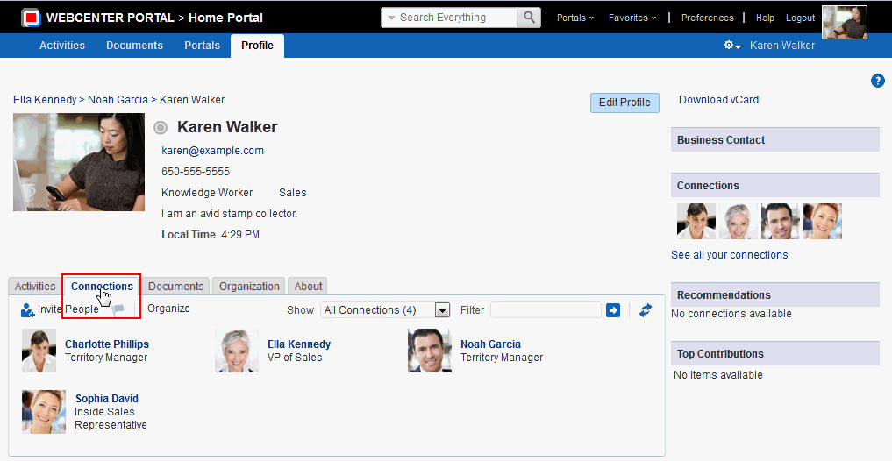

#### Searching Through Your Connections

The Connections search feature provides an efficient way to locate a particular connection in an otherwise long list of connections.

To search through your connections:

* + - 1. Go to the **Connections** page (as described in Section 11.4.1, "Viewing Your Connections.")
      2. In the **Filter** field, type the text you want to search for in your connections, and click next to the **Filter** field.

**Tip:** You can search for part or all of a name, email, title, or department.

To exit the search, click next to the **Filter** field.

### Adding Contacts

This section includes the following subsections:

* + - Section 5.5.1, "Inviting Others to Connect"
    - Section 5.5.2, "Viewing Invitations to Connect"
    - Section 5.5.3, "Responding to Invitations to Be a Connection"

#### Inviting Others to Connect

Connecting to another user potentially provides view access to that user's personal Profile and Activity Stream, and view and post access to the user's Message Board. The level of access you have to a connection is determined by the People Connections defaults set by your system administrator, the individual user's People Connections preference settings, and properties set on the Connections view.

**See Also:** For information about Connections Preferences, see Section 11.2, "Setting Connections Preferences."

You can issue invitations from the Connections - Detailed View or from the **Connections** tab on your Profile page. This section describes the **Connections** tab method.

To invite another user to connect:

* + - 1. Go to the **Connections** tab (as described in Section 11.4.1, "Viewing Your Connections."
      2. On the **Connections** tab, click the **Invite People** link to open the Invite People dialog (Figure 11–7).

***Figure 11–7 Invite People Dialog***

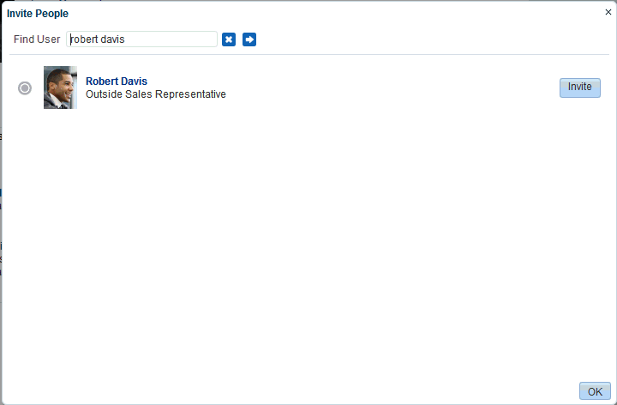

* + - 1. In the **Find User** field, type the user name of the person you want to invite to be your connection, then click .
      2. Click the **Invite** link next to the user of interest to open the Invitation Message dialog (Figure 11–8).

***Figure 11–8 Invitation Message Dialog***

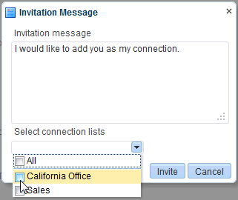

* + - 1. Use the default message, or type a new one.
      2. Optionally, from the **Select connection lists** list, select one or more connections lists to which to add the user once the invitation is accepted.
      3. Click **Invite**.

If the person you have invited set preferences to automatically accept all invitations, you are connected immediately. Otherwise, the invitation becomes available in the recipient's view of the **Connections** tab of the recipient's Profile page or in the Connections - Detailed View.

#### Viewing Invitations to Connect

You can view the invitations you have sent and received in the Connections - Detailed View and on the **Connections** tab of your Profile page. This section describes the **Connections** tab method. It includes the following subsections:

* Section 11.5.2.1, "Viewing Invitations You Have Sent"
* Section 11.5.2.2, "Viewing Invitations You Have Received"

##### Viewing Invitations You Have Sent

To view invitations you have sent:

1. Go to the **Connections** tab (as described in Section 11.4.1, "Viewing Your Connections."
2. From the **Show** menu, select **Sent Invitations**.

The **Connections** page refreshes, now showing a list of the pending invitations to connect that you have sent (Figure 11–9).

***Figure 11–9 Sent Invitations View***

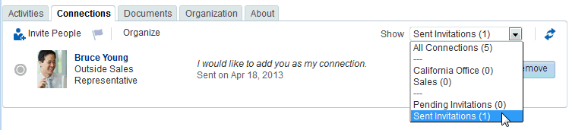

**Note:** In the **Show** menu, the number next to **Sent Invitations**

represents the number of pending invitations you have sent.

##### Viewing Invitations You Have Received

To view invitations you have received:

1. Go to the **Connections** tab (as described in Section 11.4.1, "Viewing Your Connections."
2. From the **Show** menu, select **Pending Invitations**.

**Tip:** Alternatively, click .

The **Connections** page refreshes, now showing a list of the pending invitations to connect that you have received (Figure 11–10).

***Figure 11–10 Pending Invitations View***

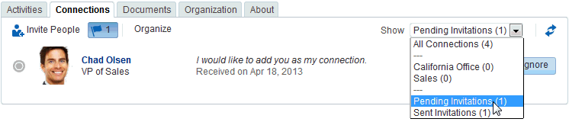

**Tip:** In the **Show** menu, the number next to **Pending Invitations**

represents the number of pending invitations you have received.

#### Responding to Invitations to Be a Connection

Connections provides two methods for responding to an invitation to connect:

* + - * You can set your Connections preferences to accept such invitations automatically. For information, see Section 11.2, "Setting Connections Preferences."
      * You can manually accept, decline, or ignore such invitations through the Connections - Detailed View or on the **Connections** tab of your Profile page.

This section describes the manual method of responding to invitations to connect from the **Connections** tab.

To respond to invitations to connect:

1. Go to the **Connections** tab (as described in Section 11.4.1, "Viewing Your Connections."
2. From the **Show** menu, select **Pending Invitations** to display a list of your pending invitations.

**Tip:** Alternatively, click .

1. Next to a given invitation, click your desired response (Figure 11–11).

***Figure 11–11 Pending Invitations View Showing Accept, Decline, and Ignore Buttons***

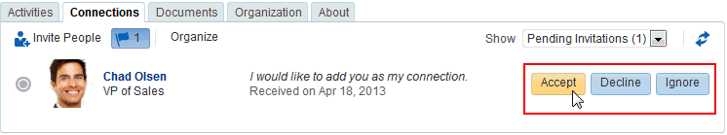

* + **Accept**—Make the connection.
  + **Decline**—Refuse the connection, with notification. When you decline an invitation to connect, the issuer becomes aware of this by watching his sent invitations.
  + **Ignore**—Remove the connection, without responding. When you ignore an invitation to connect, the issuer does not become aware of this by watching his sent invitations.

Once you respond to an invitation, it is removed from the list of received invitations. The users whose invitations you accept appear in your view of the **Connections** tab.

1. Optionally, return to your default view of the **Connections** tab by selecting **All Connections** from the **Show** menu.

### Removing Contacts

Included in the process of managing your connections is the occasional necessity of removing connections: they may leave your group or the company, or there may no longer be a compelling reason to stay connected.

Controls for removing a connection are available through the **Connections** tab of your Profile page and the Connections viewer and Connections - Detailed View. This section describes the **Connections** tab method.

To remove one of your connections:

* + 1. Go to the **Connections** tab (as described in Section 11.4.1, "Viewing Your Connections."
    2. Click **Organize** to open the Organize Connections and Lists dialog.
    3. Click the **Remove** button next to the connection to remove (Figure 11–12).

***Figure 11–12 Remove Connection***

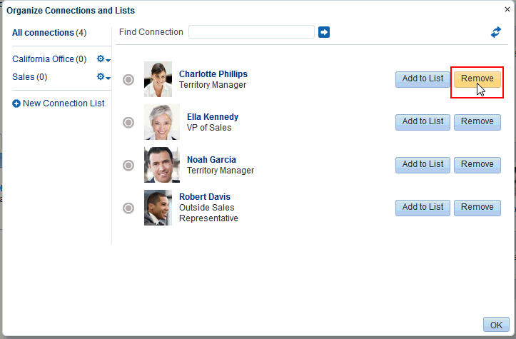

* + 1. In the confirmation dialog, click **Yes** to remove the selected connection.
    2. Click **OK** to close the Organize Connections and Lists dialog.

### Creating and Managing Groups of Contacts

Connections provides a means of grouping your connections into lists for managing the display of your connections and your connections activities. For example:

* You can select a list and view just its members on the **Connections** tab or in the Connections viewer or Connections - Detailed View.
* You can configure Activity Stream preferences to show activities only from specified connections lists
* This section describes how to create and manage lists of connections. It includes the following subsections:
* Section 5.7.1, "Creating a Connections List"
* Section 5.7.2, "Adding a Connection to a List"
* Section 5.7.3, "Removing a Connection from a List"
* Section 5.7.4, "Deleting a Connections List"

#### Creating a Connections List

You can create a connections list using the Connections viewer and Connections - Detailed View and on the **Connections** tab of your Profile page. This section describes the **Connections** tab method.

To create a list of connections:

* + - 1. Go to the **Connections** tab (as described in Section 11.4.1, "Viewing Your Connections."
      2. Click **Organize** to open the Organize Connections and Lists dialog.
      3. Click **New Connection List** (Figure 11–13) to open the **Create List** dialog.

***Figure 11–13 New Connection List***

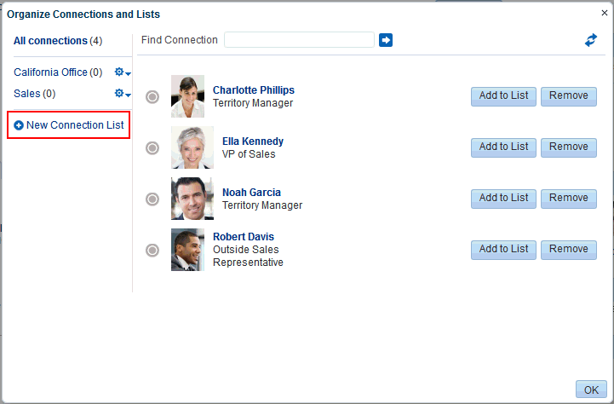

* + - 1. Enter a name for your list of connections, and click **Save and Close** to create the list and open it in the Organize Connections and Lists dialog.

**Tip:** To view all of your connections, click **All connections**.

**See Also:** For information about adding connections to a list, see Section 11.7.2, "Adding a Connection to a List."

#### Adding a Connection toa List

You can add connections to a Connections list on the **Connections** tab of your Profile page and the Connections viewer and Connections - Detailed View. This section describes the **Connections** tab method.

To add a connection to a Connections list:

* + - 1. Go to the **Connections** tab (as described in Section 11.4.1, "Viewing Your Connections."
      2. Click **Organize** to open the Organize Connections and Lists dialog.
      3. Click **Add to List** (Figure 11–14) next to the user.

***Figure 11–14 Add to List***

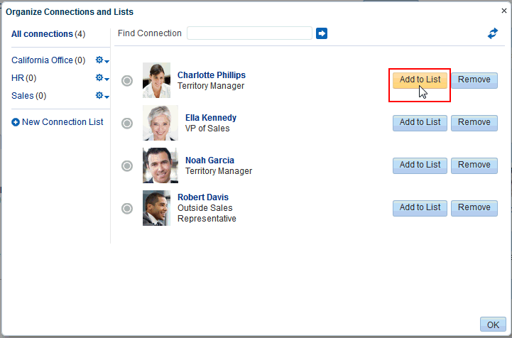

* + - 1. In the Add to List dialog (Figure 11–15), select one or more lists, then click **Save and Close**.

***Figure 11–15 Add to List Dialog***

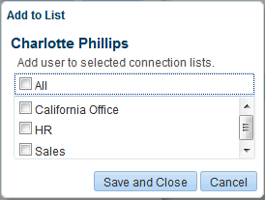

**Tip:** Click **All** to add the selected user to all of your Connections lists.

* + - 1. Repeat steps 3 and 4 until you are done.
      2. Click **OK** to close the Organize Connections and Lists dialog.

#### Removing a Connection froma List

To remove a connection from a list:

* + - 1. Go to the **Connections** tab (as described in Section 11.4.1, "Viewing Your Connections."
      2. Click **Organize** to open the Organize Connections and Lists dialog.
      3. Select the list from which to remove a connection (Figure 11–16) to display the connections list.

***Figure 11–16 Organize Connections and Lists Dialog with California Office List Selected***

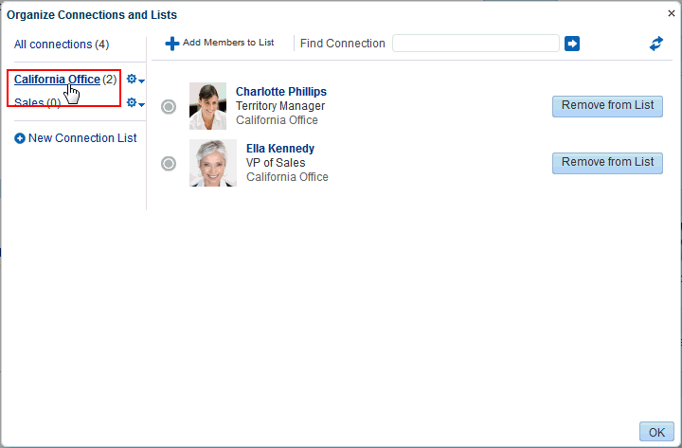

* + - 1. Click **Remove from List** next to the user to open the Remove from List dialog (Figure 11–17).

***Figure 11–17 Remove from List Dialog***

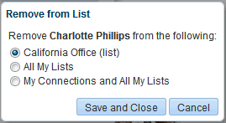

* + - 1. Select to remove the selected user from the current list or from all lists of which the user is a member, or select **My Connections and All My Lists** to remove the selected user from all lists and remove the user from your connections.
      2. Click **Save and Close**.
      3. Repeat steps 3 through 5 until you are done.
      4. Click **OK** to close the Organize Connections and Lists dialog.

#### Deletinga Connections List

When you delete a Connections list, you are not deleting the connections you added to the list. You are deleting only the selected grouping, that is, the list itself. The connections that were on the deleted list continue to be your connections.

You can delete a Connections list from the **Connections** tab of your Profile page and from the Connections viewer and Connections - Detailed View. This section describes the **Connections** tab method.

To delete a connections list:

* + - 1. Go to the **Connections** tab (as described in Section 11.4.1, "Viewing Your Connections."
      2. Click **Organize** to open the Organize Connections and Lists dialog.
      3. Click the **Actions** icon next to the Connections list you want to delete, and select

**Delete List** from the resulting menu (Figure 11–18).

***Figure 11–18 Delete List Option on Actions Menu***

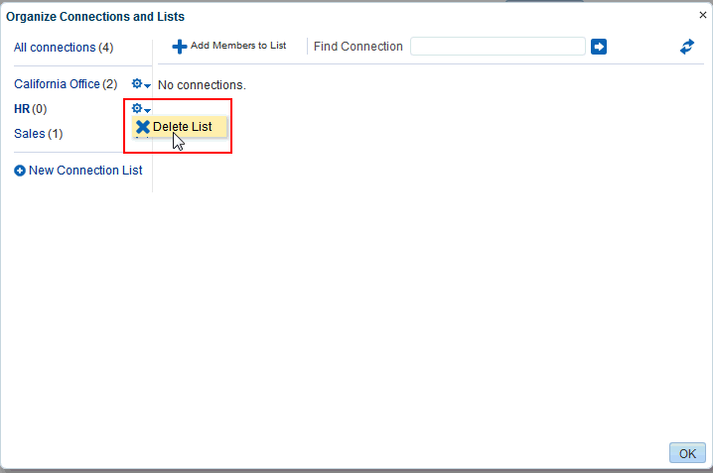

* + - 1. In the resulting confirmation dialog, click **Yes** to delete the list.
      2. Click **OK** to close the Organize Connections and Lists dialog.

## Working with Feedback and the Message

**Board**

This chapter describes Feedback viewers and Message Board for posting, viewing, and managing feedback and messages to and from your connections.

This chapter includes the following topics:

* Section 6.1, "About Feedback"
* Section 6.2, "Setting Feedback Preferences"
* Section 6.3, "Viewing Feedback"
* Section 6.4, "Posting Feedback"
* Section 6.5, "Deleting Feedback"
* Section 6.6, "About Messages"
* Section 6.7, "Setting Message Preferences"
* Section 6.8, "Viewing Messages"
* Section 6.9, "Posting Messages"
* Section 6.10, "Editing Messages"
* Section 6.11, "Deleting Messages"
* Section 6.12, "Enabling Other Users to Post Feedback and Messages for You"

**Permissions:** To perform the tasks in this chapter, you need the application-level permission People Connections: Update People Connections Data.

### About Feedback

Feedback provides a means of viewing, posting, and managing feedback between you and other users. To view your feedback, you must add a Feedback viewer to one of your personal pages (a page you created) in the Home portal. To receive feedback from other users, you must provide other users access to that personal page and set your feedback preferences to allow those users to view and/or post feedback for you. To view or post feedback for another user, you must be granted access to that user's personal page and access to view and/or post feedback for the user through that user's preferences.

For information on adding a Feedback viewer to a personal page and providing access to other users, see Section 14.12, "Enabling Other Users to Post Feedback and Messages

for You."

**Notes:**

* + - Before you access your view of Feedback or your Feedback preferences, your system administrator can set global application defaults that affect what all users may see and do with their own and other users' feedback.
    - In addition to being available in Feedback viewers, Feedback posts are streamed to the Activity Stream (unless your system administrator has configured the Activity Stream not to show feedback activity).
    - You can elect not to show Feedback activity in *your* view of the Activity Stream through your personal Activity Stream preferences. For more information, see Section 11.3, "Setting Activity Stream Preferences."
    - If feedback posts are streamed to the Activity Stream, be aware that even those feedback posts you mark *private* (so that it is shown only to you and the poster in *your* Feedback viewer) will still show up in the Activity Stream of your connections and the poster's connections.

WebCenter Portal provides the following Feedback views:

* **Feedback** for viewing, posting, and managing Feedback (Figure 14–1)

***Figure 14–1 Feedback***

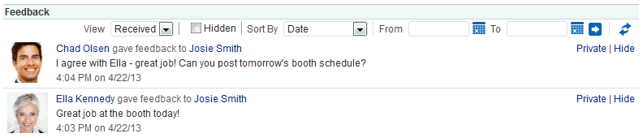

* **Feedback - Quick View** for viewing and posting Feedback (Figure 14–2)

***Figure 14–2 Feedback - Quick View***

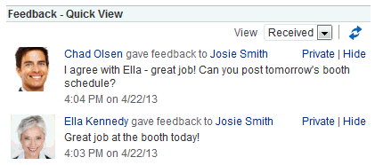

### Setting Feedback Preferences

Use Feedback preferences to specify who can view the Feedback you have given and received and who can post Feedback in your Feedback views.

To set Feedback Preferences:

1. Open the Preferences page.
2. Click **People Connections** to display People Connections Preferences.
3. Click the **Feedback** tab to bring it forward (Figure 14–3).

***Figure 14–3 Feedback Preferences***

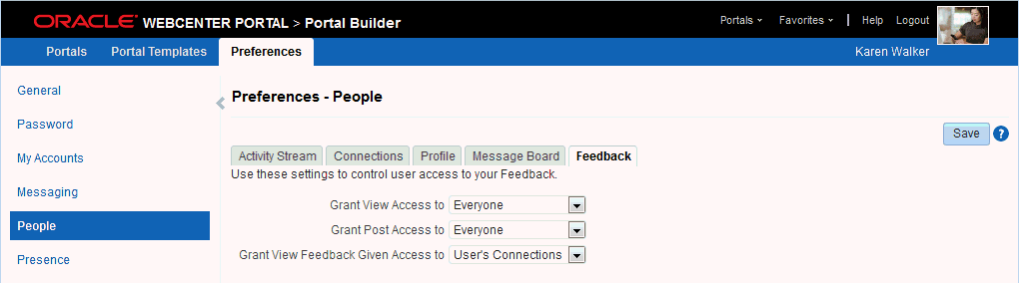

1. Set your Preferences for Feedback.

Table 14–1 lists and describes each option.

***Table 14–1 Feedback Preference Options***

|  |  |
| --- | --- |
| **Option** | **Description** |
| Grant View Access to | Select who can view Feedback given to you.   * **Everyone**—All users, including users who are not logged in, can view the Feedback you have given. * **Authenticated Users**—Only users who are logged in can view the Feedback you have given. * **User's Connections**—Only you and your Connections can view the Feedback you have given. * **User Only**—Only you and the user for whom you have provided Feedback can view the Feedback you have given. |
| Grant Post Access to | Select who can provide Feedback to you.   * **Everyone**—All users, including users who are not logged in, can post Feedback messages to you. * **Authenticated Users**—Only users who are logged in can post Feedback messages to you. * **User's Connections**—Only you and your Connections can post Feedback messages to you. * **User Only**—No one can post Feedback messages to you. |
| Grant View Feedback Given Access to | Select who can view Feedback you have received.   * **Everyone**—All users, including users who are not logged in, can view Feedback you have received. * **Authenticated Users**—Only users who are logged in can view Feedback you have received. * **User's Connections**—Only you and your Connections can view Feedback you have received. * **User Only**—No one can view Feedback you have received. |

1. Click **Save**.

### Viewing Feedback

This section provides information about accessing the Feedback you have posted or received and hiding and unhiding posted Feedback. It includes the following sections:

* + - Section 14.3.1, "Viewing Feedback You Have Posted or Received"
    - Section 14.3.2, "Sorting and Filtering Feedback Posts"
    - Section 14.3.3, "Hiding Feedback in Your Own View"
    - Section 14.3.4, "Showing Hidden Feedback"
    - Section 14.3.5, "Marking Feedback Received as Private"

#### Viewing Feedback You Have Postedor Received

A **View** menu on Feedback viewers provides a means of accessing the Feedback you have posted for others and the Feedback you have received from others.

To view Feedback you have posted or received:

* + - 1. Go to the Feedback viewer in your Home portal.
      2. Select an option from the **View** menu (Figure 14–4):
         * **Given**—To view the Feedback you have posted for others
         * **Received**—To view the Feedback others have left for you

***Figure 14–4 Feedback View Menu***

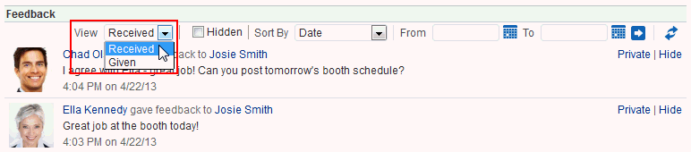

#### Sorting and Filtering Feedback Posts

The Feedback viewer includes sorting and filtering features for controlling what is shown in your view. Use the sorting feature to sort your Feedback by date or by person—that is, the user name of the person who left the Feedback. Use the filtering feature to display Feedback posted on a particular date or within a given date range.

To sort and filter your Feedback:

* + - 1. Go to the Feedback viewer.
      2. Select an option from the **Sort By** menu (Figure 14–5):

***Figure 14–5 Sort By Menu on Feedback Viewer***

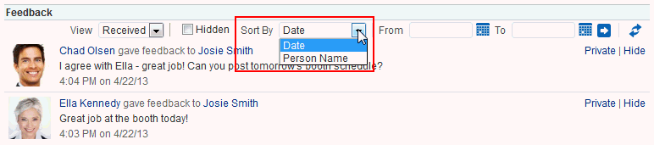

* + - * + **Date**—To sort Feedback posts from the most recent to the oldest.
        + **Person Name**—To sort Feedback posts by the name of the user who left it for you (**View** is set to **Received**) or by the name of the user you left it for (**View** is set to **Given**).
      1. To specify a date range, enter a start date in the field that follows **From** and enter an end date in the field that follows **To** (Figure 14–6).

***Figure 14–6 Sort By Date Range Fields on Feedback Viewer***

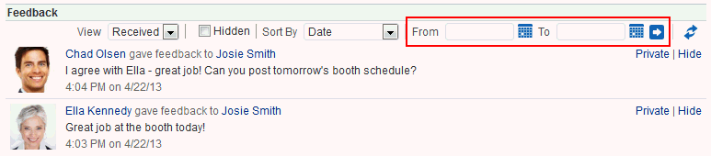

**Tip:** You must enter both a start and end date, even when you want to view Feedback posts from a given day. In such a case, enter the same date in both fields.

Instead of entering dates, you can click the **Select Date** icon next to a field to select a date from a calendar.

**Accessibility Note:** In WebCenter Portal, you cannot use the keyboard to select a date from the calendar that pops up when you click the **Select Date** icon. Instead, manually enter the date into the field.

* + - 1. Click the **Search** icon.

All of the Feedback posts (either received or given) that fall within the specified date range appear in the Feedback viewer.

**Tip:** To remove the date filtering criteria from your Feedback view, click the **Clear Date** icon.

#### Hiding Feedback in Your Own View

You can hide any Feedback in your own Feedback view. Hiding provides a means of removing Feedback posts from your own view without actually deleting them. Users to whom you have given access to your Feedback can still see the posts you have hidden.

**Notes:**

* For information about undoing this action, see Section 14.3.4, "Showing Hidden Feedback."
* To hide a feedback post from everyone except you and the poster, mark the post as private. See Section 14.3.5, "Marking Feedback Received as Private."

To hide Feedback in your own view:

* + - 1. Go to the Feedback viewer in your Home portal.
      2. Click the **Hide** link next to the Feedback message you want to hide (Figure 14–7).

***Figure 14–7 Hide Link on a Feedback Message***

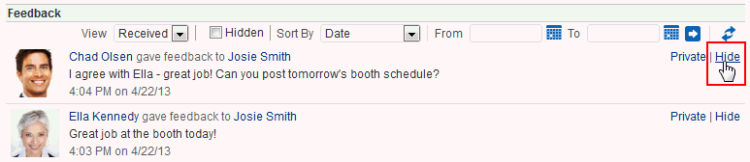

#### Showing Hidden Feedback

Use the **Hidden** check box on the Feedback viewer to show all the Feedback you have hidden. The **Hidden** check box provides a means of showing all hidden Feedback in one operation, making it available to be unhidden or deleted.

To show hidden Feedback posts:

* + - 1. Go to the Feedback viewer in your Home portal.
      2. Select the **Hidden** check box (Figure 14–8).

***Figure 14–8 Hidden Check Box on a Feedback Viewer***

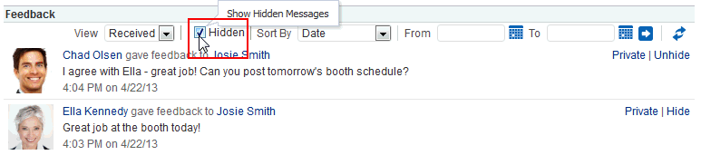

* + - 1. All the Feedback posts you have hidden are shown.
      2. Click the **Unhide** link to the right of the Feedback you want to show (Figure 14–9).

***Figure 14–9 Unhide Link on a Feedback Viewer***

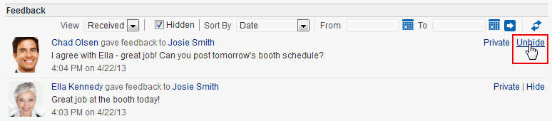

* + - 1. To remove hidden Feedback posts from your view, deselect the **Hidden** check box.

#### Marking Feedback Received as Private

You can mark Feedback you have received as private so that it shows only to you and the poster. To mark a post as private, click the **Private** link next to the post

(Figure 14–10).

**Notes:**

* If you do not see portal the **Private** link, your portal moderator might have hidden the link.
* Unless Activity Stream is configured at the application level or the personal level (through Preferences) to omit Feedback activity, your connections and the poster's connections can still see private Feedback in their Activity Streams.
* For more information, see Section 11.3, "Setting Activity Stream Preferences."

***Figure 14–10 Private Link on a Feedback Message***

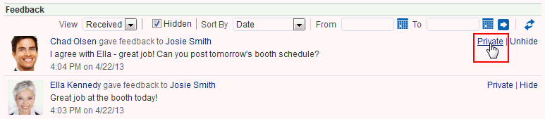

Your portal moderator can hide the **Private** link. Also, unless Activity Stream is configured at the application level or the personal level (through Preferences) to omit Feedback activity, your connections and the poster's connections can see even private Feedback in their Activity Streams.

**See Also:** For more information, see Section 11.3, "Setting Activity Stream Preferences."

### Posting Feedback

Use Feedback to pass along remarks to your connections about their efforts and results. Keep in mind that a wider audience than just your connections may see your Feedback message.

To post a Feedback message:

* + 1. Go to the page the user has set up to receive Feedback.

**See Also:** For more information, see Section 14.12, "Enabling Other Users to Post Feedback and Messages for You."

* + 1. Click **Add Feedback** (Figure 14–11).

***Figure 14–11 Add Feedback Button on a Feedback Viewer***

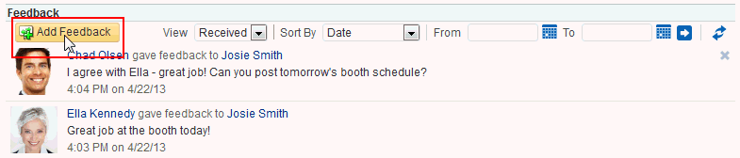

* + 1. In the resulting Add Feedback dialog, enter your Feedback in the text area (Figure 14–12).

**Tip:** The Add Feedback dialog provides an integrated rich text editor that enables you to add styles, links, and other HTML encoding to your Feedback.

***Figure 14–12 Add Feedback Dialog with Rich Text Editor***

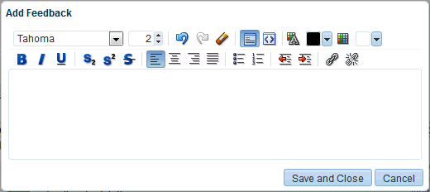

* + 1. When you finish entering text, click **Save and Close**.

Your Feedback appears in the selected user's Feedback view.

### Deleting Feedback

You can delete Feedback you have posted to other users, provided your system administrator has enabled you to do so.

If Activity Stream is configured to show Feedback activity, deleted Feedback posts nonetheless continue to show in the Activity Stream of the recipient and all of your connections.

**See Also:** For information about configuring your personal Activity Stream Preferences, see Section 11.3, "Setting Activity Stream Preferences."

To delete Feedback you have posted:

* + 1. Go to the Feedback viewer in your Home portal.
    2. From the **View** menu, select **Given**.
    3. Click the **Delete** icon next to the post you want to delete (Figure 14–13).

***Figure 14–13 Delete Icon on a Feedback Message***

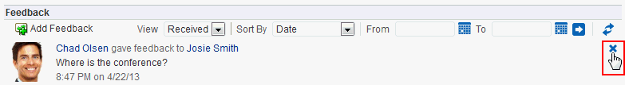

* + 1. Click **Delete** in the resulting confirmation dialog.

The Feedback is deleted from your view and from the view of the user for whom you left it.

### About Messages

On personal pages in the Home portal, Message Board provides a means of viewing and posting messages to and from you and other users. To view your messages, you must add a Message viewer to one of your personal pages (a page you created) in the Home portal. To receive messages from other users, you must provide other users access to that personal page and set your message preferences to allow those users to view and/or post messages for you. To view or post messages for another user, you must be granted access to that user's personal page and access to view and/or post messages for the user through that user's preferences.

For information on adding a Message Board viewer to a personal page and providing access to other users, see Section 14.12, "Enabling Other Users to Post Feedback and Messages for You."

In portals other than the Home portal, a Message Board viewer provides a means of viewing and posting messages within the scope of the portal. In a portal, every instance of a Message Board shows the same content: messages left by authorized users who are members of the portal. If you cannot perform actions in a portal Message Board, contact the portal moderator.

**Notes:**

* Before you access your view of Message Board or your Message Board preferences, your system administrator can set global application defaults that affect what all users may see and do with their own and other users' messages.
* In addition to being available in Message Board viewers, messages are streamed to the Activity Stream (unless your system administrator has configured the Activity Stream not to show Message Board activity).
* You can elect not to show Message Board activity in *your* view of the Activity Stream through your personal Activity Stream preferences. For more information, see Section 11.3, "Setting Activity Stream Preferences."
* If messages are streamed to the Activity Stream, be aware that even those messages you mark *private* (so that it is shown only to you and the poster in *your* Message Board viewer) will still show up in the Activity Stream of your connections and the poster's connections.

WebCenter Portal provides the following Message Board views:

* **Message Board** for adding, viewing, updating, hiding, deleting, and managing your view of messages, and for marking messages as private and sharing private messages (Figure 14–14)

***Figure 14–14 Message Board***

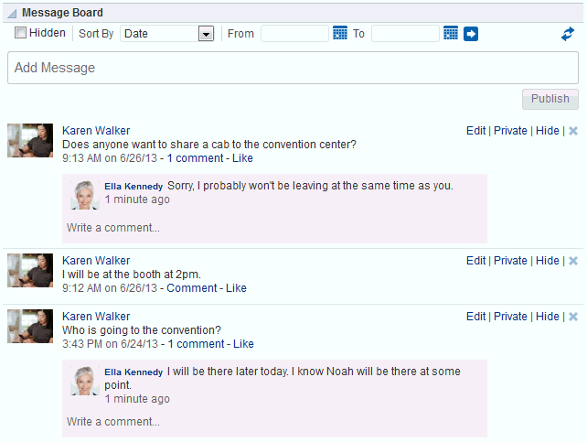

* **Message Board - Quick View** for adding, viewing, updating, hiding, and deleting messages, and for marking messages as private and sharing private messages (Figure 14–15)

***Figure 14–15 Message Board - Quick View***

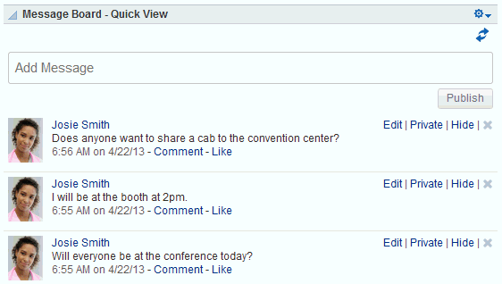

**See Also:** Publisher has many qualities in common with Message Board, but is a separate feature. For more information about Publisher, see Chapter 15, "Liking, Commenting On, and Sharing Items in WebCenter Portal."

### Setting Message Preferences

Use Message Board preferences to specify who can view and post to your Message Board.

To set Message Board Preferences:

* + 1. Open the Preferences page.
    2. Click **People Connections** to display People Connections Preferences.
    3. Click the **Message Board** tab to bring it forward (Figure 14–16).

***Figure 14–16 Message Board Preferences***

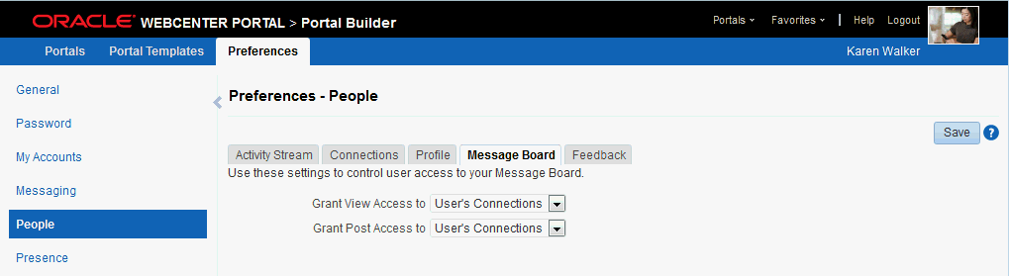

* + 1. Set your Preferences for the Message Board. Table 14–2 lists and describes each option.

***Table 14–2 Message Board Preference Options***

|  |  |
| --- | --- |
| **Option** | **Description** |
| Grant View Access to | Select who can view your Message Board:   * **Everyone**—All users, including users who are not logged in, can view your Message Board messages. * **Authenticated Users**—Only users who are logged in can view your Message Board messages. * **User's Connections**—Only you and the users you your Connections can view your Message Board messages. * **User Only**—Only you can view your Message Board messages. |
| Grant Post Access to | Select who can post messages to your Message Board:   * **Everyone**—All users, including users who are not logged in, can post messages to your Message Board. * **Authenticated Users**—Only users who are logged in can post messages to your Message Board. * **User's Connections**—Only you and your Connections can post messages to your Message Board. * **User Only**—Only you can post messages to your Message Board. |

* + 1. Click **Save**.

### Viewing Messages

Once you and your connections have set up your own Message Boards, you can see your own and, potentially, each other's messages. This section provides information about how to view each other's messages post-set-up. It includes the following subsections:

* Section 6.8.1, "Viewing Messages Others Have Left for You"
* Section 6.8.2, "Viewing Messages Others Have Received"
* Section 6.8.3, "Viewing Messages Sent to a Selected Portal"

#### Viewing Messages Others Have Left for You

To view Message Board messages other users have left for you, go to the personal page in the Home portal that you have set up to receive Message Board messages

(Figure 14–14).

#### Viewing Messages Others Have Received

To view Message Board messages other users have received (including those you have left for them), go to the page the user has made available to you in your view of the Home portal. You can access this page through the **Personalize Pages** page. For more information, see Section 9.2, "Opening a Page in the Home Portal."

#### Viewing Messages Sent toa Selected Portal

Message Boards placed in a portal provide a means of viewing and posting messages within the portal context. All default Message Board views within a given portal display the same content: messages left by authorized users who are members of the portal. All users with access to the portal can see the posted messages.

#### Sorting and Filtering Message Board Messages

Your full view of the Message Board includes sorting and filtering features for managing your view of your messages. Use the sorting feature to sort your messages by date or by the person who left the message. Use the filtering feature to show messages posted on a particular date or within a given date range.

To sort and filter your Message Board messages:

* + - 1. Go to the Message Board viewer.
      2. From the **Sort By** menu, select a sorting option (Figure 14–17):

***Figure 14–17 Options on Sort By Menu***

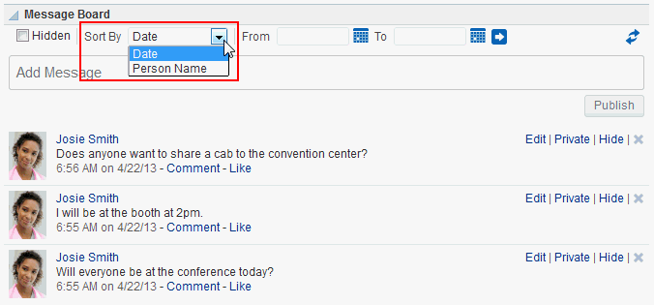

* + - * + **Date**—Sort your messages by the date they were posted, from most recent to oldest.
        + **Person Name**—Sort your messages by the user name of the person who posted them, from A to Z.
      1. To show messages between a particular range of dates, enter the beginning and end of the range respectively in the fields after **From** and **To** (Figure 14–18).

***Figure 14–18 Sort By Date Range Options***

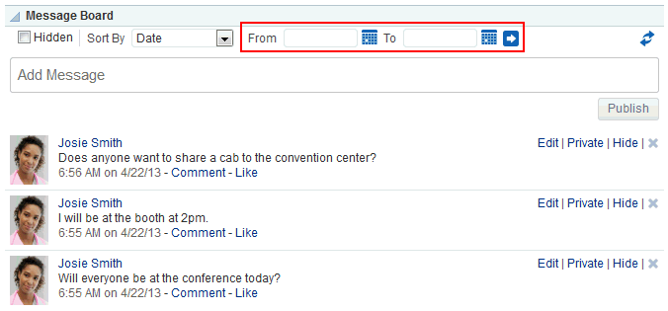

**Tip:** Instead of entering dates, you can click the **Select Date** icon next to a field to select a date from a calendar.

**Accessibility Note:** In WebCenter Portal, you cannot use the keyboard to select a date from the calendar that pops up when you click the **Select Date** icon. Instead, manually enter the date into the field.

* + - 1. Click the button to the right of the fields to apply the filter.

The Message Board refreshes, showing only those messages that fit your sorting and filtering criteria.

**Tip:** To remove the date filtering criteria from your Message Board view, click the **Clear Date** icon that appears to the right of the date range fields after you filter by date.

***Figure 14–19 Clear Date Icon***

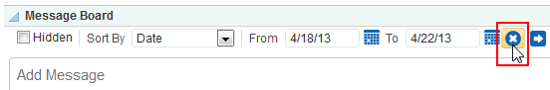

#### Hiding Messages in Your Viewof Message Board

You can hide messages in your Message Board in one of two ways: you can hide a specific message or hide public or private messages. Hiding provides a means of removing messages from your own view without actually deleting them. It is a non-permanent way to reduce the visual clutter of your Message Board view.

**Note:** Users to whom you have given access to your messages can still see the messages that you have hidden.

To hide a specific message in your view of the Message Board:

* + - 1. Go to the message you want to hide in your view of the Message Board.
      2. Click the **Hide** link next to the message you want to hide (Figure 14–20).

***Figure 14–20 Hide Link on a Message***

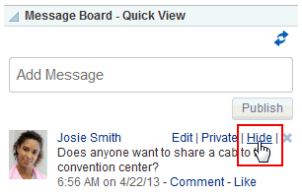

The message is hidden in your view of the Message Board. Other users you have permitted to view your Message Board can see this message when they visit your view.

To hide messages of a particular type (private or public) in your view of the Message Board:

1. Open the page editor (Composer) for the personal page in the Home portal that includes the Message Board.

**See Also:** For more information, see Section 9.5, "Editing a Personal Page."

1. In Design view (the default view when you edit a page), click the Edit icon ( ) on the Message Board viewer to open the Component Properties dialog.

**See Also:** Editing component properties is an advanced task. For more information about editing component properties, see the "Setting Properties on a Component" section in *Building Portals with Oracle WebCenter Portal*.

1. In the Component Properties dialog, on the **Parameters** tab, from the **Message Type** drop-down list, select the type of messages you want to see in your view of the Message Board:
   * **All** - (default) Displays both public and private messages.
   * **Public** - Displays only public messages.
   * **Private** - Displays only private messages.
2. Click **Save** to save the page.
3. Click **Close** to exit page edit mode.

Messages of the selected type appear in your view of the Message Board; all other messages are hidden in your view of the Message Board. Other users you have permitted to view your Message Board can see all messages when they visit your view.

#### Showing Hidden Messages

Use the **Hidden** check box on the Message Board to show all of the messages you have hidden. The **Hidden** check box provides a means of showing all hidden messages in one operation, making it available to be unhidden or deleted.

To show hidden Message Board messages:

* + - 1. In your view of the Message Board, select the **Hidden** check box to show the messages you have hidden (Figure 14–21).

***Figure 14–21 Hidden Check Box on a Message Board Viewer***

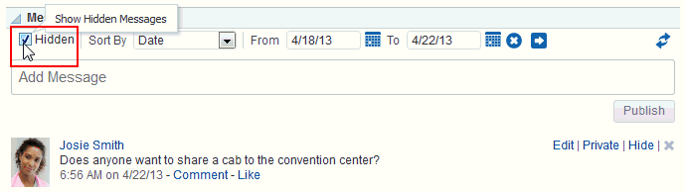

* + - 1. Click the **Unhide** link next to the message you want to show (Figure 14–22).

***Figure 14–22 Unhide Link on a Message Board Viewer***

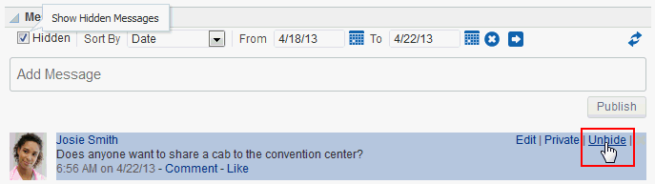

* + - 1. Optionally, deselect the **Hidden** check box to hide the messages that are still marked as hidden.

### Posting Messages

This section describes the various ways you can post messages and attachments. It includes the following subsections:

* + - Section 6.9.1, "Posting a Message Through Message Board"
    - Section 6.9.2, "Posting a Private Message"
    - Section 6.9.3, "Sharing a Private Message"

#### Posting a Message Through Message Board

This section describes how to post a message to all of your connections through Message Board.

**See Also:** For information about Connections, see Chapter 11, "Managing Your Contacts."

To post a Message Board message:

* + - 1. Go to a Message Board view.
      2. In the text box, enter a message.
      3. Click **Publish** (Figure 14–23).

***Figure 14–23 Publish Button on a Message Board View***

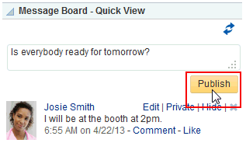

The message appears in all of your connections' views of Message Board and Activity Stream.

#### Posting a Private Message

Provided you are authorized to do so, you can post a private message to any of your connections. When you mark a message as *private*, only you and the recipient can see the message in your views of Message Board; however, all of your connections and all of the recipient's connections can see private messages in Activity Stream, unless the application is configured to omit Message Board activity from the Activity Stream or you have configured your Activity Stream preferences to do so.

**See Also:** For more information, see Section 11.3, "Setting Activity Stream Preferences."

To post a private message:

* + - 1. Go to your **My Profile** page and click **Connections** to bring it forward.

**Tip:** If necessary, set the **Show** menu to **All Connections**.

* + - 1. Click the name of the user to whom you want to send a private message. In the Profile popup, click **Add Message** (Figure 14–24).

***Figure 14–24 Add Message Link in Profile Popup***

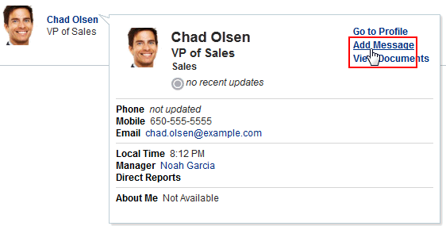

* + - 1. Enter your message in the Add Message dialog (Figure 14–25).

***Figure 14–25 Add Message Dialog***

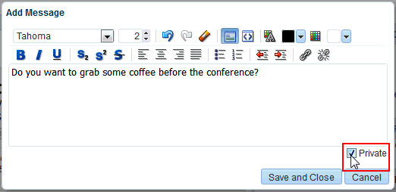

* + - 1. Select the **Private** check box to allow only the recipient to see the message.
      2. Click **Save and Close** when you have finished.

The message appears in the recipient's views of Message Board and Activity Stream.

#### Sharing a Private Message

When you receive a private message, you can opt to share that message with all users who have access to your Message Board by marking it as *shared*. When someone sends you a message marked *private*, only you and the sender can see it in the Message Board (though all of your connections and the sender's connections can see the message in their Activity Streams, unless the Activity Stream in configured to omit Message Board activity).

**See Also:** For information about omitting certain types of activities from Activity Stream at the application and personal levels, see Section 11.3, "Setting Activity Stream Preferences."

When you mark a private message as shared, you open it up to those permitted to see your view of the Message Board.

To mark a message as shared:

* + - 1. Go to the message you want to mark as shared in your view of the Message Board.
      2. Click the **Share** link next to the relevant message (Figure 14–26).

***Figure 14–26 Share Link on a Private Message***

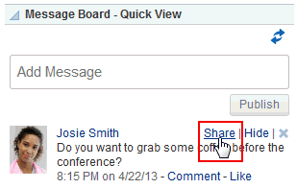

The message can be viewed by everyone who can access your Message Board.

### Editing Messages

Your system administrator can configure the Message Board feature to enable users to revise the messages they leave. Provided this permission is in place, you can edit any message you post.

To edit a Message Board message:

* + 1. Go to the message you want to edit.
    2. Click the **Edit** link associated with the message (Figure 14–27).

***Figure 14–27 Edit Link on a Message***

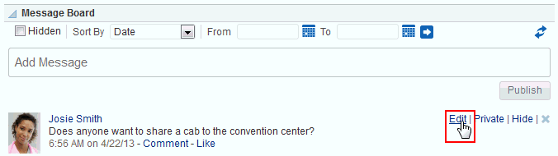

The Edit Message dialog opens with a rich text editor pre-populated with your message text (Figure 14–28).

***Figure 14–28 Edit Message Dialog***

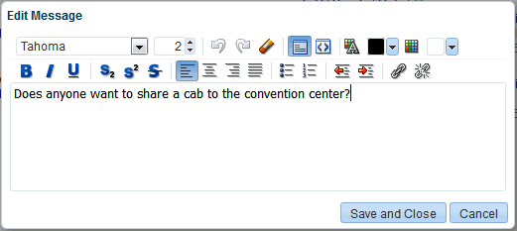

* + 1. Revise your message, and click **Save and Close**.

### Deleting Messages

Your system administrator can configure the Message Board to allow users to delete the messages they send. Provided this permission is in place, you can delete any message you send.

To delete a message you sent:

* + 1. Go to your view of the Message Board, and click the **Delete** icon next to the message you want to delete (Figure 14–29).

***Figure 14–29 Delete Icon on a Message***

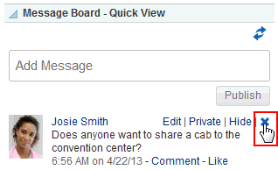

* + 1. In the resulting confirmation dialog, click the **Delete** button.

### Enabling Other Users to Post Feedback and Messages for You

To set up your Feedback and Message Board viewers so that users can post feedback and messages specifically for you, you must add a Feedback or Message Board viewer to a personal page in your view of the Home portal, and share that page with your

connections. Additionally, you must set a parameter on the Feedback or Message Board viewer to identify yourself as the viewer owner. After this is set up, your connections can access this page and post messages and feedback for you. This section steps you through this process.

To enable other users to post feedback and messages for you:

* + 1. Create a new personal page or edit an existing personal page in the Home portal to which to grant access to your connections.

**See Also:** For more information, see Section 9.3, "Creating a Personal Page in the Home Portal" or Section 9.5, "Editing a Personal Page."

* + 1. In Design view (the default view when you edit a page), find the Feedback or Message Board viewer you want to add to the page, and click **Add**.

***Figure 14–30 Message Board Viewers in Composer***

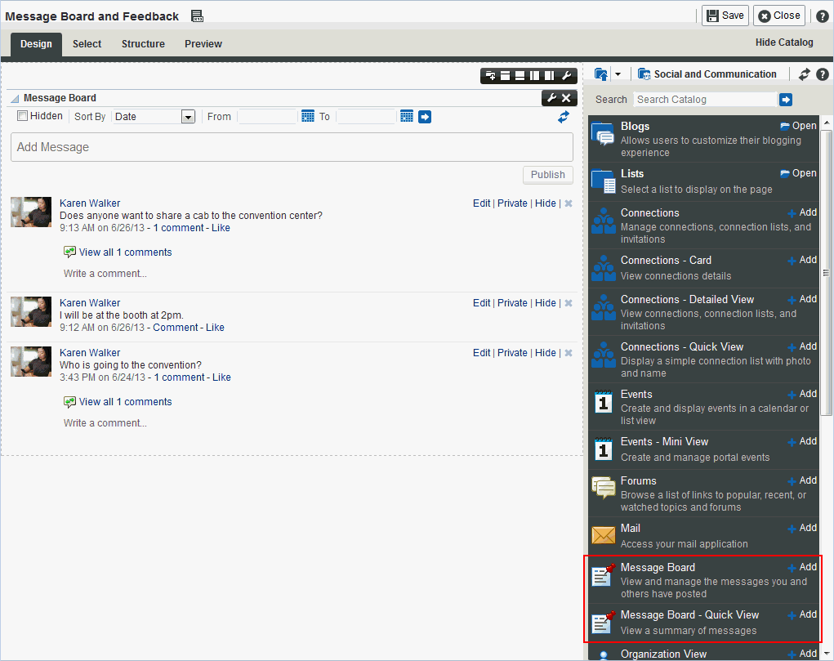

**Notes:**

* + - * The Message Board viewers are stored in the **Social and Communication** folder by default.
      * Your system administrator must add the Feedback viewers to a resource catalog to make them available to you.

**See Also:** Editing a personal page is no different than editing a page in a portal, but it is an advanced task. For more information about adding a viewer, see the "Editing a Page" section in *Building Portals with Oracle WebCenter Portal*.

* + 1. Click the Edit icon ( ) on the viewer to open the Component Properties dialog.

**See Also:** Editing component properties is an advanced task. For more information about editing component properties, see the "Setting Properties on a Component" section in *Building Portals with Oracle WebCenter Portal*.

* + 1. In the Component Properties dialog, on the **Parameters** tab, enter your user name in the required field:
       - For Feedback, enter your user name in the **Resource Id** text box.
       - For Feedback - Quick View, enter your user name in the **User Id** text box.
       - For Message Board and Message Board - Quick View, enter your user name in the **User Name** text box.

**See Also:** Editing component properties is an advanced task. For more information about other component properties, see the "Setting Message Board and Feedback Task Flow Properties" section in *Building Portals with Oracle WebCenter Portal*.

* + 1. Click **Save** to save the page.
    2. Click **Close** to exit page edit mode.
    3. Set page access to enable other users to view the page as described in Section 9.6, "Setting Security for a Personal Page."

**Tip:** When you share one of your personal pages in the Home portal with other users, the shared page appears on their **Personalize Pages** page. The other users can then use controls on the **Personalize Pages** page to show the page in their own view of the Home portal.

* + 1. Set your preferences to allow users to view and/or post feedback and/or messages for you. For more information, see Section 14.2, "Setting Feedback Preferences" and Section 14.7, "Setting Message Preferences."

All users who have access to the page see the Feedback or Message Board viewers that you place there, but only the users to whom you have granted access, through preferences, see any content in the components.

You might want to send a link to this page to the users to whom you granted access, inviting them to leave you feedback or messages. For more information, see

Section 9.13, "Sending Mail with a Link to a Personal Page."

## Liking, Commenting On, and Sharing Items in

**WebCenter Portal**

This chapter describes how to like, comment on, and share items (such as messages, activities, files, links, and so on) in WebCenter Portal.

This chapter includes the following topics:

* Section 7.1, "About Liking Items in WebCenter Portal"
* Section 7.2, "Liking Items"
* Section 7.3, "About Commenting on Items in WebCenter Portal"
* Section 7.4, "Commenting on Items"
* Section 7.5, "About Sharing Items in WebCenter Portal"
* Section 7.6, "Sharing Streamed Items with a Wider Audience"
* Section 7.7, "Sharing Messages, Files, and URLs"

**Permissions:** To perform the tasks in this chapter, you need the application-level permission People Connections: Update People Connections Data.

### About Liking Items in WebCenter Portal

Liking is an accumulative rating system that enables you to see at a glance which items are liked and who likes them. A counter keeps track of the number of users who like an item and a link is available for viewing the users who like it. In a group of items, you can determine the most favored by its number of likes.

You can express liking for Message Board messages, Activity Stream entries, files, wikis, and blog entries.

**Tip:** Whether you or any user can like a message or activity depends on whether your system administrator has enabled liking for these features.

**Note:** Liking an activity associated with an item (for example, an activity entry for adding a document) is not the same as liking the item. The like count is calculated separately for the activity and the item.

### Liking Items

To like an item, click the **Like** link or icon associated with the item:

* + - For Message Board messages and Activity Stream entries, click the **Like** link under the message or entry (Figure 15–1).

***Figure 15–1 Like Link in the Activity Stream***

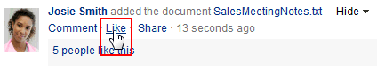

* + - For files in a Document list view (on the **Documents** page or in the Document Explorer, Document Manager, or Folder Viewer), click the Like icon (the star) in the file's row (Figure 15–2).

***Figure 15–2 Like Icon in Document List View***



* + - For files and wikis in the Document Viewer, click the Like icon (the star) in the menu bar (Figure 15–3).

***Figure 15–3 Like Icon in Document Viewer***

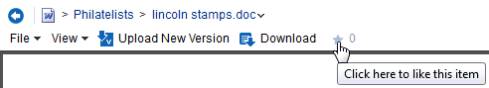

* + - For blog posts, click the Like icon (the star) at the bottom of the post (Figure 15–4).

***Figure 15–4 Like Icon in Blog Post***

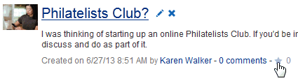

The text under the **Like** link or the number to the right of the Like icon (Figure 15–5) indicates the number of users that like the file. Click the text or number to view a list of other users who have "liked" the item.

***Figure 15–5 Like Icon Count***

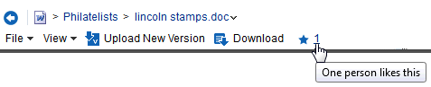

To remove your favorable rating (that is, *unlike* the object), click the **Unlike** link or click the star again.

### About Commenting on Items in WebCenter Portal

Commenting provides a means of adding your thoughts, opinions, and questions directly to a given item in WebCenter Portal.

You can comment on Message Board messages, Activity Stream entries, files, wikis, and blog entries.

**Notes:**

* + - Commenting on an activity associated with a file (for example, an adding a document activity entry) is not the same as commenting on the file.
    - Public users viewing a public document cannot comment on the document.

### Commenting on Items

To enter a comment on an item:

1. Access comments by performing one of the following actions:
   * For Message Board messages and Activity Stream entries, click the **Comment**

link under the message or entry (Figure 15–6).

***Figure 15–6 Comment Link in the Activity Stream***

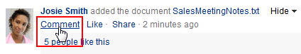

* + For files in a Document list view (on the **Documents** page or in the Document Explorer, Document Manager, or Folder Viewer), open the Comments pane in any of the following ways:
    - Click the **View** menu, and select **Details**.
    - Right-click to display the file's context menu and select **Details**.
    - Click the value in the **Comments** column (Figure 15–7) for the file. This value indicates the number of comments that have been entered for each file.

***Figure 15–7 Comments Column for a File***



* + For files and wikis in the Document Viewer or Rich Text Editor, scroll to the bottom of the document and click the **Comments** tab (Figure 15–8).

***Figure 15–8 Comments Pane***

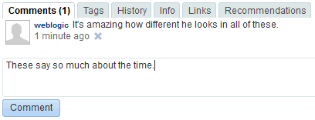

* + For blog posts, click the **comments** link at the bottom of the post (Figure 15–4).

1. To add a comment, enter it in the input area (Figure 15–9), then click **Comment**.

***Figure 15–9 Write a Comment Text Box***

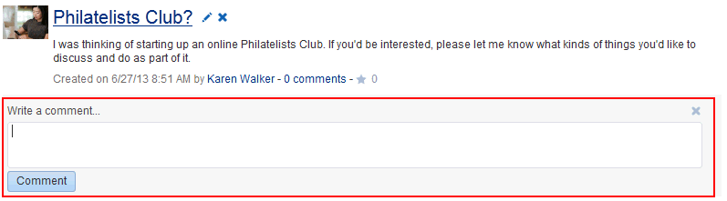

To delete a comment:

1. Click the **Delete** icon associated with the comment (Figure 15–10).

***Figure 15–10 Delete Icon for a Comment in the Activity Stream***

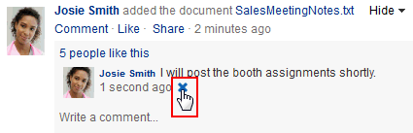

1. In the confirmation dialog, click **OK**.

**Note:** You can delete your own comments, or, if you are a portal moderator, you can delete comments in the portal you moderate.

### About Sharing Items in WebCenter Portal

Sharing provides a means of on-the-spot distribution of items, status messages, files, and URLs of particular interest to a selected audience. Sharing is available in a few different forms:

* + - Share an item you receive in your Activity Stream by posting it to your connections' Activity Streams (for more information, see Section 15.6.1, "Reposting Streamed Items").
    - Share an item you receive in your Activity Stream through email (for more information, see Section 15.6.2, "Emailing Streamed Items").
    - Share an item, status message, file, or URL through Publisher (for more information, see Section 15.7, "Sharing Messages, Files, and URLs").

To share an item directly from your Activity Stream, the item must contain an object. For example, you can share "Jack has updated doc.xml," but you cannot share "Jack and Jill are now connected." You can share anything you post through Publisher because the post itself is an object.

### Sharing Streamed Items witha Wider Audience

You can share items that appear in your view of the Activity Stream with a wider audience. For example, when your view of the Activity Stream reports that one of your connections updated a document of great interest to all of your connections, you can share that streamed item with all of your connections.

You can do so by posting the streamed item to all of your connections' Activity Streams or to the Activity Streams of connections who belong to a named portal. You can also share streamed items through email, enabling you to share it with users to whom you are not connected or to make use of mail distribution lists.

**Note:** To share an item directly from your Activity Stream, the item must contain an object. For more information, see Section 15.5, "About Sharing Items in WebCenter Portal."

This section includes the following subsections:

* + - Section 7.6.1, "Reposting Streamed Items"
    - Section 7.6.2, "Emailing Streamed Items"

#### Reposting Streamed Items

To repost a streamed item to your connections' Activity Streams:

* + - 1. Go to the item you want to share, click **Share**, then click **This activity**

(Figure 15–11)

***Figure 15–11 Share - This Activity Option***

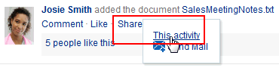

* + - 1. In the resulting Share dialog, optionally, enter a message to accompany the shared object (Figure 15–12).

***Figure 15–12 Adding a Message to a Shared Object***

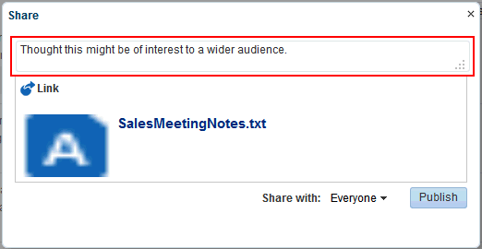

**Note:** When you share a message, rather than a file or a link, you cannot enter another message to accompany it.

* + - 1. From the **Share with** menu (Figure 15–13), select with whom you want to share the object:

***Figure 15–13 Share With Menu***

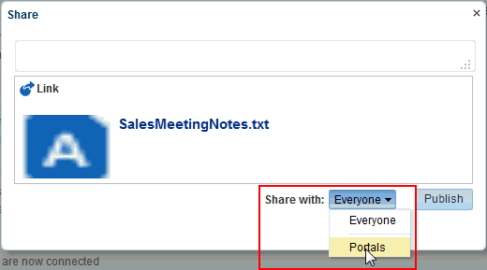

* + - * + Select **Everyone** to share the item with all of your connections.
        + Select **Portals** to open the Select a Portal dialog (Figure 15–14), where you can select a portal to share the item on the Home page of the portal.

***Figure 15–14 Select a Portal Dialog***

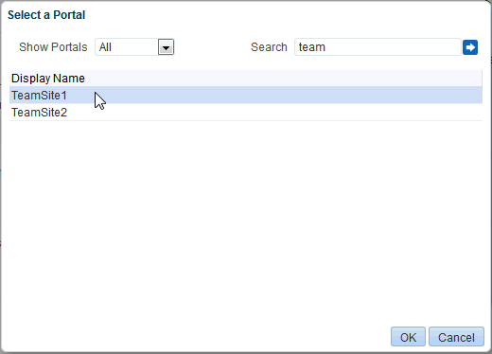

From the **Show portals** menu:

Select **All** to show all of the portals to which you have access.

Select **Joined** to show all of the portals you have explicitly joined.

Select **Moderated** to show all of the portals for which you are a moderator.

Select **Public** to show all public portals.

Alternatively, enter the name of a portal in the **Search** field and execute the search. Results appear in the dialog.

Click a portal, and then click **OK**.

* + - 1. Click **Publish**.

The item is posted to the Activity Streams of the selected recipients or on the Home page of the selected portal.

#### Emailing Streamed Items

To share a streamed item through email, use the **Send Mail** option. The Send Mail option is available on streamed items that include objects, such as a document. It is otherwise not available.

To share a streamed item through email:

* + - 1. Go to the item you want to share, click **Share**, then click **Send Mail** (Figure 15–15)

***Figure 15–15 Share - Send Mail Option***

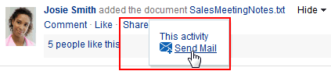

A mail message opens, prepopulated with a link to the selected item.

* + - 1. Address, write, and send the message as you would any other email.

### Sharing Messages, Files, and URLs

Publisher provides a means of publishing messages, files, and URLs to your connections' Activity Streams or to a portal's Activity Stream.

**Notes:** A portal's Activity Stream can be displayed in the portal, but portal members can also display the portal's activities in their own Activity Streams.

This section steps you through Publisher features. It includes the following subsections:

* + - Section 7.7.1, "About Publisher"
    - Section 7.7.2, "Publishing a Message"
    - Section 7.7.3, "Sharing Files Through Publisher"
    - Section 7.7.4, "Sharing URLs (Links) Through Publisher"
    - Section 7.7.5, "Deleting a Published Message"

**See Also:** For information about Activity Stream, see Chapter 24, "Tracking Portal Activities." For information about Profiles, see Chapter 6, "Managing Your Profile."

#### About Publisher

Publisher is very similar in operation to the Message Board (see Chapter 14, "Working with Feedback and the Message Board"). It differs in a few ways:

* + - * You can use it to send out messages, but not to receive them. It provides no feature for viewing messages.
      * It is specifically made to work in conjunction with Activity Stream, where the messages you enter are published.
      * It is not controlled by configuration settings at the application level nor through your own personal Preferences. You specify who sees your published messages through a control in Publisher itself.

**Note:** Your system administrator can also specify that a message published through Publisher be used as a user's Profile status message (Figure 15–16).

***Figure 15–16 Published Message Used as Profile Status***

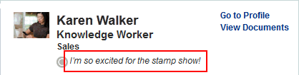

**See Also:** For information about Profile, see Chapter 6, "Managing Your Profile."

Depending on how your system administrator configured Publisher, it can show options for sharing messages, files, or links (Figure 15–17) or just show options for sharing documents (Figure 15–18).

***Figure 15–17 Publisher***

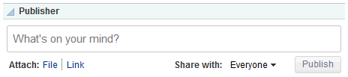

***Figure 15–18 Publisher - Document Upload Only***

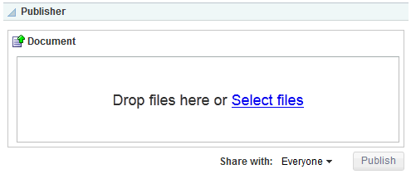

**Note:** The **Share with** menu in Publisher appears only in the Home portal, not in other portals. This menu allows users to select whether to share information with your connections or only members of a specified portal. When Publisher is in a portal other than the Home portal, the published information is always shared with members of that portal.

In default WebCenter Portal installations, Publisher is part of the **Activities** page, which is provided in the Home portal for all authenticated users (that is, users who are logged in).

The default **Activities** page also contains an Activity Stream view where the messages you enter through Publisher are published.

Publisher features can also be embedded in some Profile views.

#### Publishing a Message

Publisher enables you to post a message to the Activity Stream to share with other users, and, if your system administrator has configured it, to display as your Profile status message.

To publish a message:

1. Go to the **Activities** page in the Home portal or to another view of Publisher in WebCenter Portal.

**Tip:** The way you access the **Activities** page depends on the page template in use. For example, in a side navigation template, you may access it through an **Activities** link.

1. Click in the text area, and enter a message (Figure 15–19).

***Figure 15–19 Publishing a Message***

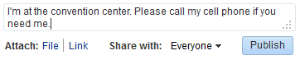

**Note:** The **Share with** menu in Publisher appears only in the Home portal, not in other portals. This menu allows users to select whether to share information with your connections or only members of a specified portal. When Publisher is in a portal other than the Home portal, the published information is always shared with members of that portal.

1. If you are viewing Publisher from the Home portal, select an option from the

**Share with** menu (Figure 15–20):

***Figure 15–20 Share With Menu***

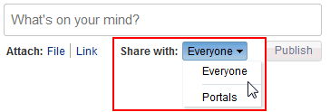

* + Select **Everyone** to share the item with all of your connections.
  + Select **Portals** to open the Select a Portal dialog (Figure 15–21) and select a portal. The shared file will appear in the selected portal's Activity Stream.

***Figure 15–21 Select a Portal Dialog***



From the **Show portals** menu:

* + - Select **All** to show all of the portals to which you have access.
    - Select **Joined** to show all of the portals you have explicitly joined.
    - Select **Moderated** to show all of the portals for which you are a moderator.
    - Select **Public** to show all public portals.

Alternatively, enter the name of a portal in the **Search** field and execute the search. Results appear in the dialog.

Click a portal, and click **OK**.

1. Click **Publish**.

Your message appears in your Activity Stream and, as appropriate, your connections' Activity Streams or the portal's Activity Stream.

#### Sharing Files Through Publisher

Depending on whether you are sharing a personal file or a portal file, the shared file can appear in your connections' Activity Streams or in a portal's Activity Stream.

Additionally, sharing a file through Publisher also stores the file in the Public folder of your personal document library.

**Tip:** If you prefer to have greater control over where a shared file is stored in your document library, you can upload it to the folder you prefer. Such uploads are also reported in your connection's activity streams, provided your Activity Stream is configured to show them. For more information, see Section 11.3, "Setting Activity Stream Preferences."

**Notes:**

* + - * Alternate methods of sharing files are described in Section 19.21, "Sharing the URL for a Folder or File." The difference with sharing files through Publisher is that the file is also stored in the Public folder of your personal document library. This is useful when the FrameworkFolders folder service is enabled, where folders and files include parent information in their metadata. Because other users do not have access to the parent folder for your personal documents, you cannot share a file from your personal document library (the **Documents** page in the Home portal) by only providing the URL. Instead, you can either copy the file to the Public folder, or share a personal file through Publisher, which is made accessible to any user in the Public folder of your personal document library. Similarly, you can use Publisher to share portal files where users may not have access to the parent folder in the portal.
      * Your system administrator can disable the ability to share files through Publisher. If you do not see the **Attach: File** link, contact your system administrator.

To share files through Publisher:

1. Go to the **Activities** page in the Home portal or to another view of Publisher in WebCenter Portal.
2. Optionally, click in the text area and enter the message you want to accompany the file.
3. Next to **Attach**, click **File** to open the field for attaching a file (Figure 15–22)

***Figure 15–22 Attach File Field***

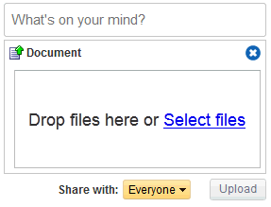

**Note:** The **Share with** menu in Publisher appears only in the Home portal, not in other portals. This menu allows users to select whether to share information with your connections or only members of a specified portal. When Publisher is in a portal other than the Home portal, the published information is always shared with members of that portal.

1. Click **Select files** to navigate to and select the file you want to share.
2. If you are viewing Publisher from the Home portal, select an option from the

**Share with** menu.

**Note:** For more information, see Step 3 of Section 15.7.2, "Publishing a Message."

1. Click **Upload**.

The file is added to your Activity Stream and, as appropriate, your connections' Activity Streams or the portal's Activity Stream. It is also stored in the Public folder of your personal document library.

**Note:** Whether a file or a link to a file is shown depends on how your system administrator configured the Activity Stream.

#### Sharing URLs (Links) Through Publisher

In addition to sharing messages through Publisher, you can share links. To share links through Publisher:

1. Go to the **Activities** page in the Home portal or to another view of Publisher in WebCenter Portal.
2. Optionally, click in the text area and enter the message you want to accompany the link.
3. Next to **Attach**, click **Link** to open field for entering a URL (Figure 15–23).

***Figure 15–23 Attach Link Field***

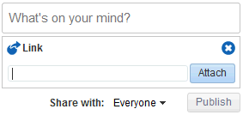

**Note:** The **Share with** menu in Publisher appears only in the Home portal, not in other portals. This menu allows you to select whether to share information with your connections or only members of a specified portal. In a portal other than the Home portal, the published information is always shared with members of that portal.

1. Enter the URL you want to share, and click **Attach**.
2. If you are viewing Publisher from the Home portal, select an option from the

**Share with** menu.

**Note:** For more information, see Step 3 of Section 15.7.2, "Publishing a Message."

1. Click **Publish**.

The link is added to your Activity Stream and, as appropriate, your connections' Activity Streams or the portal's Activity Stream.

**Note:** Whether a file or a link to a file is shown depends on how your system administrator configured the Activity Stream.

#### Deleting a Published Message

Next to text or links that you post, there is a delete icon (Figure 15–24). Click the delete icon to delete your message.

***Figure 15–24 Delete Message***

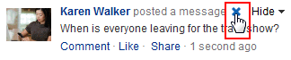

**Note:** Messages that include shared files do not display a delete icon. To delete a message with a shared file, go to your Public documents folder (for example, on the **Documents** page, open the **Public** folder) and delete it from there. For more information, see Section 19.12, "Deleting Folders and Files."

# Part IV

## Creating and Managing Documents

This chapter describes how to create and manage content in WebCenter Portal. This chapter contains the following topics:

* Section 8.1, "About Creating and Managing Documents in WebCenter Portal"
* Section 8.2, "Actions for Working with Folders and Files"
* Section 8.3, "Personalizing Your View of Documents"
* Section 8.4, "Creating a Folder"
* Section 8.5, "Creating a File"
* Section 8.6, "Opening a Folder or File"
* Section 8.7, "Using the Rich Text Editor (RTE)"
* Section 8.8, "Editing or Updating a File"
* Section 8.9, "Renaming a Folder or File"
* Section 8.10, "Copying and Pasting Folders and Files"
* Section 8.11, "Moving Folders and Files"
* Section 8.12, "Deleting Folders and Files"
* Section 8.13, "Refreshing Folder Contents"
* Section 8.14, "Hiding and Showing Folders"
* Section 8.15, "Managing Tags on Files"
* Section 8.16, "Viewing and Deleting File Version History"
* Section 8.17, "Working with Folder and File Properties"
* Section 8.18, "Managing Document Links"
* Section 8.19, "Viewing Document Recommendations"
* Section 8.20, "Opening or Saving PDF Files"
* Section 8.21, "Sharing the URL for a Folder or File"
* Section 8.22, "Setting Security Options on a Folder or File"
* Section 8.23, "Subscribing to a File"
* Section 8.24, "Liking a File"
* Section 8.25, "Adding a Folder or File to Your Favorites"
* Section 8.26, "Searching for Documents"
* Section 8.27, "Working with Workflow-Enabled Content"

**Permissions:** To perform the tasks in this chapter on your personal pages, you need the application-level permission Pages: Create, Edit, and Delete Pages. Users with this permission can create and manage their personal pages in the Home portal.

To perform the tasks in this chapter on portal pages, you need the portal-level permissions Customize Pages and Edit Content and Create Documents (which includes delete permissions on documents that you create), granted by the portal moderator. To delete documents that are not your own, you must have Delete Documents permission.

To set security on a document in a portal, you must have Documents: Administration permission, granted by the portal moderator.

For information about roles and permissions, see the "Understanding Permissions and Permission Models in a Portal" section in *Building Portals with Oracle WebCenter Portal*.

### About Creating and Managing Documents in WebCenter Portal

In WebCenter Portal, you can create and manage documents at runtime in a variety of ways:

* + - *Content Presenter* provides the ability to edit wiki documents, HTML files, or Site Studio files in-context, and create new Site Studio files in the connected Content Server content repository. Using Content Presenter is an advanced task, described in the "Publishing Content Using Content Presenter" chapter in *Building Portals with Oracle WebCenter Portal*.
    - The *Documents* feature provides several views that offer capabilities to create, open, edit, delete, copy, rename, move, share, search, view, and manage information about folders and files in any connected content repository, including wikis and blogs. An application specialist may expose the **Documents** page in a portal (Figure 19–1), or add one or more document views to a page to allow you to create and manage documents. The following sections describe the document views that may be available to you on a portal page:
      * Section 8.1.1, "About the Document Explorer"
      * Section 8.1.2, "About the Document Manager"
      * Section 8.1.3, "About the Folder Viewer"
      * Section 8.1.4, "About the Document Viewer"

***Figure 19–1 Documents Page in a Portal***

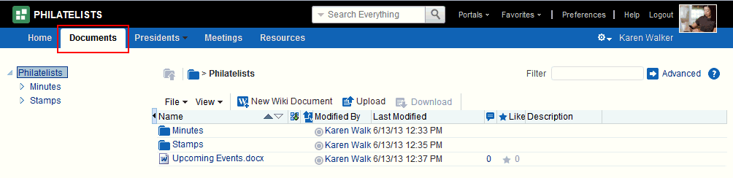

#### About the Document Explorer

The Document Explorer displays a list of folders and files in two panes. The left pane shows folders in a nested hierarchy, and the right pane shows the contents of the currently selected folder (Figure 19–2).

***Figure 19–2 Document Explorer***

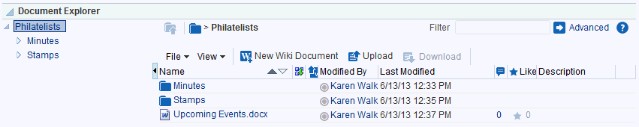

If you see only a single pane (default), click the **Restore Pane** icon at the middle-left of the list of documents.

Conversely, click the Collapse Pane icon at the middle-left to hide the left pane. In the Document Explorer, you can:

* + - * Click the expand and collapse icons for a folder to show and hide the subfolders.
      * Click a *folder* in the left or right pane to display the contents of that folder in the right pane, and drill down further into subfolders.
      * Click a *file* in the right pane to display a preview of the file contents in the Document Viewer preview pane, with file management options, including in-place editing for some file types. If the file type does not support a preview (for example, .mp3 music files, video files, or .zip files) or if you are using an Apple iOS device, the preview pane displays the file properties (see Section 8.1.4, "About the Document Viewer") rather than a preview of the file content.
      * Click in a *row* (not on the folder or file name) in the right pane to perform menu actions on the folder or file in that row (see Section 8.2, "Actions for Working with Folders and Files").

Alternatively, right-click a folder or file to display a context menu of available actions.

* + - * Drag and drop folders and files in the hierarchy to reorganize the file or folder structure.

#### About the Document Manager

The Document Manager displays folders and files as specified by its Layout property, which is set by the application specialist:

* + - * **Explorer layout** (default): Displays folders and files in two panes; the left pane shows folders, and the right pane show the contents of the currently selected folder (Figure 19–3). This layout is very similar to the Document Explorer.
      * **Table layout**: Displays only the contents of the current folder in a single pane, with the capability to click a folder to drill down, refreshing the pane with the folder contents (Figure 19–4).
      * **Tree Table layout**: Displays the folder hierarchy in a single pane, beginning with the root folder, with the capability to expand and collapse folders (Figure 19–5). This layout may be familiar to Mac OS X users.

***Figure 19–3 Document Manager: Explorer Layout***

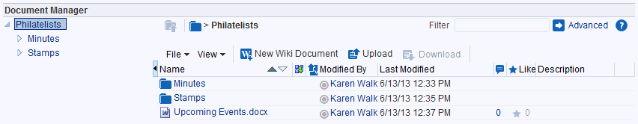

***Figure 19–4 Document Manager: Table Layout***

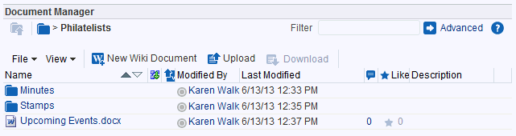

***Figure 19–5 Document Manager: Tree Table Layout***

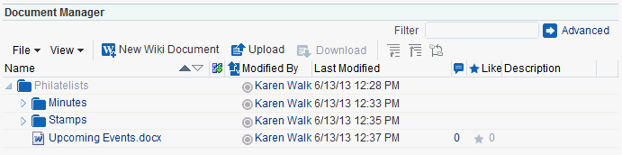

In the Document Manager, you can:

* + - * Click the expand and collapse icons for a folder to show and hide the contents in the folder within the folder hierarchy.
      * Click a *folder* to display the contents of only that folder, and drill down further into subfolders.
      * Click a *file* to display a preview of the file contents in the Document Viewer preview pane, with file management options, including in-place editing for some file types. If the file type does not support a preview (for example, .mp3 music files, video files, or .zip files) or if you are using an Apple iOS device, the preview pane displays the file properties (see Section 8.1.4, "About the Document Viewer") rather than a preview of the file content.
      * Click in a *row* (not on the folder or file name) in the right pane to perform menu actions on the folder or file in that row (see Section 8.2, "Actions for Working with Folders and Files").

Alternatively, right-click a folder or file to display a context menu of available actions.

* + - * Drag and drop folders and files in the hierarchy to reorganize the file or folder structure.

#### About the Folder Viewer

The Folder Viewer displays the contents of a folder in a single pane as a flat listing (Figure 19–6), providing in-place preview and editing of the contents of the folder, and robust document management capabilities with a straightforward interface that should be familiar to Windows users.

***Figure 19–6 Folder Viewer***

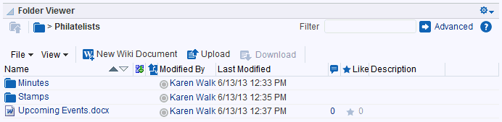

In the Folder Viewer, you can:

* + - * Click a *folder* to display the contents of that folder, and drill down further into subfolders.
      * Click a *file* to display a preview of the file contents in the Document Viewer preview pane, with file management options, including editing for some file types. If the file type does not support a preview (for example, .mp3 music files, video files, or .zip files) or if you are using an Apple iOS device, the preview pane displays the file properties (see Section 8.1.4, "About the Document Viewer") rather than a preview of the file content.
      * Click in a *row* (not on the folder or file name) in the right pane to perform menu actions on the folder or file in that row (see Section 8.2, "Actions for Working with Folders and Files").

Alternatively, right-click a folder or file to display a context menu of available actions.

* + - * Drag and drop folders and files in the hierarchy to reorganize the file or folder structure.

#### About the Document Viewer

The Document Viewer displays the contents and/or properties of a file or folder (Figure 19–7).

***Figure 19–7 Document Viewer***

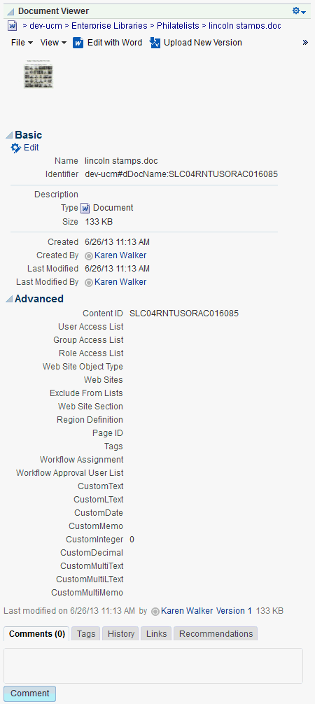

The Document Viewer displays different content depending on the type of item selected to appear (wiki document, Microsoft file, image, and so on):

* + - * Toolbar with menus and actions

For all item types; the options differ depending on the item type (see Section 8.2, "Actions for Working with Folders and Files")

* + - * File preview

For files that support a preview (for example, wiki documents, Microsoft files, images, PDFs)

* + - * Basic properties: the file name, content repository identifier, item type, size, date and time file was created, who created it, date and time file was last modified, and who modified it

For Microsoft files, and files that do not support a preview (for example, .mp3

music files, video files, or .zip files)

* + - * Advanced properties

For Microsoft files and files that do not support a preview

* + - * The following tabbed panes:
        + **Comments**: Enter or delete comments for a file to provide additional information that you want to convey to other users about the file. See Section 15.4, "Commenting on Items."
        + **Tags**: Specifies keywords related to the content of the file. Tags are useful for making a file more widely discoverable in search results. See Section 8.15, "Managing Tags on Files."
        + **History**: Provides version information about the current file, and allows you to selectively delete versions. For more information, see Section 8.16, "Viewing and Deleting File Version History."
        + **Info**: Provides the option to edit some properties such as file name and description. In the Advanced section, displays metadata property settings for the file. See Section 8.17, "Working with Folder and File Properties."
        + **Links**: Provides a way to view, access, and associate related information by linking a file to a discussion, document, event, note, or URL. For example, you can create a link to associate a project plan document with a list of project issues. See Section 8.18, "Managing Document Links."
        + **Recommendations**: Provides suggestions of other documents you might want to view, based on the current document. See Section 8.19, "Viewing Document Recommendations."

By default, the **Comments** pane displays as the active pane. If you have previously launched the Document Viewer to preview a file in the current session, then select another file to preview, the active pane in the Document Viewer is the pane that you last selected when previewing the prior file.

### Actions for Working with Folders and Files

The actions for working with folders and files available in the Document view toolbars (menus and buttons) and context menus are summarized in the following sections:

* + - Section 8.2.1, "Folder and File Actions in List Viewers"
    - Section 8.2.2, "File and Folder Actions in the Document Viewer"

#### Folder and File Actions in List Viewers

Table 19–1 summarizes the folder and file management options when viewing a listing of folders and/or files (for example, on the Documents page, in the Document Manager, in the Document Explorer, in the Folder Viewer, or in the Document List Viewer). These options are available from the menus and buttons in the viewer toolbars and from the context menu that appears when you right-click a folder or file.

***Table 19–1 Actions for Folders and Files***

|  |  |  |  |
| --- | --- | --- | --- |
| **Location** | **Actions** | **Applicable to:** | **Description** |
| File menu or context menu | Edit or Edit with *Application* | file | For a selected file, opens the file in-place and automatically checks the file out. Wiki documents and HTML files open in RTE; Office files open in their corresponding application. See Section 8.8.4, "Editing Files In-Place."  Available for wiki documents, blog posts, HTML, and Microsoft Office (Word, Excel, and PowerPoint) files only. |
| File menu or context menu | Upload New Version | file | If you have write permissions on a selected file, opens the Upload Document pane where you can specify a new version of the file to upload to replace the existing file. See  Section 8.8.5, "Uploading a New Version of an Existing File."  Not available for wiki documents or blog posts. |
| File menu and context menu | Check Out | file | For a selected file, checks the file out, locking it for update by other users. See Section 8.8.1, "Checking a File Out."  Not available for wiki documents or blog posts. |
| File menu and context menu | Cancel Check Out | file | For a selected file, cancels the checked out status without updating it, unlocking it to allowing other users to update it. See Section 8.8.1, "Checking a File Out."  Not available for wiki documents or blog posts. |
| File menu | New Folder | folder | Opens the Create Folder dialog where you can specify a name for a new folder. See  Section 8.4, "Creating a Folder." |
| File menu and context menu | Rename | folder or file | Opens the Rename dialog where you can rename the selected folder or file. See Section 8.9.1, "Renaming a Folder or File Using a Menu." |
| File menu and context menu | Cut | folder or file | Stores the path to the selected folder(s) or file(s) to paste elsewhere. If a folder or file is not subsequently pasted, it is restored to the location where it was cut. If a folder or file is deleted at the source location before pasting, it will not be moved to the paste location. See Section 8.11, "Moving Folders and Files." |

***Table 19–1 (Cont.) Actions for Folders and Files***

|  |  |  |  |
| --- | --- | --- | --- |
| **Location** | **Actions** | **Applicable to:** | **Description** |
| File menu and context menu | Copy | folder or file | Stores the path to the selected folder or file to paste as a copy elsewhere. If a folder or file is deleted at the source location before pasting, it will not be copied to the paste location. See Section 8.10, "Copying and Pasting Folders and Files." |
| File menu | Paste | folder or file | Pastes the folder or file in the buffer to the current folder. See Section 8.10, "Copying and Pasting Folders and Files." |
| File menu and context menu | Delete | folder or file | Deletes the selected folder or file. See Section 8.12, "Deleting Folders and Files." |
| File menu and context menu | Share | file | Opens a dialog where you specify the users, groups, or select a portal where the URL for the selected file will be published in Activity Streams, along with a message. See  Section 8.21.3, "Publishing the URL for a File to Activity Streams." |
| File menu and context menu | Security | folder or file | Opens the Security Settings dialog, where you can set custom access permissions for the selected file, or select to inherit the permissions of the parent folder. For more information, see Section 8.22, "Setting Security Options on a Folder or File."  Available only if your system administrator has configured item-level security between Content Server and WebCenter Portal. |
| Context menu | Open | folder or file | Opens a folder to display its contents and make it the top-level folder. See Section 8.6.1, "Opening a Folder." |
| View menu and context menu | Details | folder or file | Opens the folder or file in the Document Viewer, where you see the properties and/or preview of the folder or file. For more information, see Section 8.1.4, "About the Document Viewer." |
| View menu and context menu | Get a Link | folder or file | Opens the Get a Link dialog, where **Direct URL** provides a direct link to open the folder or file in WebCenter Portal. For files, the **Download URL** provides a direct link to allow users to open the file in its default application, or choose to save the file to their local file system. See Section 8.21, "Sharing the URL for a Folder or File." |
| View menu | Containing Folder Info | folder or file | Opens the Properties pane of the parent folder of the current folder or file. See Section 8.17, "Working with Folder and File Properties." |
| View menu | Refresh Content | folder or file | Retrieves the contents of the current folder from the content repository to reflect all changes since the last retrieval. See  Section 8.13, "Refreshing Folder Contents." |
| View menu | Hide Folders | folder or file | Refreshes the listing to show only files in the current folder, or show folders if this action is currently active. See Section 8.14, "Hiding and Showing Folders." |

***Table 19–1 (Cont.) Actions for Folders and Files***

|  |  |  |  |
| --- | --- | --- | --- |
| **Location** | **Actions** | **Applicable to:** | **Description** |
| View menu | Columns submenu | folder or file | Provides a submenu to select the columns that you want to display. See Section 8.3.1, "Hiding and Showing Columns." |
| View menu | Reorder Columns | folder or file | Opens the Reorder Columns dialog where you can organize the displayed columns into a different order. See Section 8.3.2, "Reordering Columns." |
| View menu | New Wiki Document | file | Opens the Rich Text Editor where you can define a new wiki document, created at the same level as the currently selected file, or in the current folder. See Section 8.5.2, "Creating a Wiki Document."  Not available in the Document List Viewer. |
| Button on toolbar | Upload | file | Opens a panel where you can upload files from your local file system or a network drive. See Section 8.5.1, "Uploading Files."  Not available in the Document List Viewer. |
| Button on toolbar and context menu | Download | file | Opens a dialog to save files to your local file system. See Section 8.8.3, "Downloading a File."  Not available in the Document List Viewer. |

#### File and Folder Actions inthe Document Viewer

Table 19–2 summarizes the file and folder management options in the Document Viewer or the Document Viewer preview pane or window.

The *Document Viewer preview pane or window* opens when you:

* + - * Right-click a *folder* and choose **Details** from the folder context menu to display the details of that folder.
      * Click a *file* to display a preview of file contents. This allows for file previewing and editing for some file types. If the file type does not support a preview (for example, .mp3 music files, video files, or .zip files) or if you are using an Apple iOS device, the preview pane displays the file properties (see Section 8.1.4, "About the Document Viewer") rather than a preview of the file content.

***Table 19–2 Document Viewer Preview Pane Actions for Folders and Files***

|  |  |  |  |
| --- | --- | --- | --- |
| **Location** | **Actions** | **Applicable to:** | **Description** |
| File menu | Send Mail | file or folder | Opens your mail application with the body of the mail message showing the direct URL to the currently open folder or file, as well as the URL to the current portal, if applicable. See Section 8.21.2, "Mailing the URL for a Folder or File." |
| File menu | Subscribe | file | Activates monitoring of the activities on a file. Whenever any change is made to the file, you will be notified in your personal Activity Stream in the Home portal. See Section 8.23, "Subscribing to a File." |
| File menu | Share | file | Opens a dialog where you specify the users, groups, or select a portal where the URL for the selected file will be published in Activity Streams, along with a message. See Section 8.21.3, "Publishing the URL for a File to Activity Streams." |
| File menu | Add To Favorites | file or folder | Adds the selected folder or file to your WebCenter Portal Favorites list. See Section 8.25, "Adding a Folder or File to Your Favorites." |
| File menu | Check Out | file | Checks the current file out, locking it from update by other users. See Section 8.8.1, "Checking a File Out."  Not available for wiki documents or blog posts. |
| File menu | Workflow Settings | folder | Opens the Workflow Settings dialog, where you can assign workflow to the selected folder in a portal. For more information, see the "Assigning a Workflow to a Folder in a Portal" section in *Building Portals with Oracle WebCenter Portal*.  Available only when the connected content repository is Content Server and your system administrator has completed the prerequisite configuration. |
| File menu | Security | file or folder | Opens the Security Settings dialog, where you can set custom access permissions for the selected folder or file, or select to inherit the permissions of the parent folder. For more information, see  Section 8.22, "Setting Security Options on a Folder or File."  Available only if your system administrator has configured item-level security between Content Server and WebCenter Portal. |

***Table 19–2 (Cont.) Document Viewer Preview Pane Actions for Folders and Files***

|  |  |  |  |
| --- | --- | --- | --- |
| **Location** | **Actions** | **Applicabl** | **e to: Description** |
| File menu | Annotate with AutoVue | file | Opens the selected file in the AutoVue file viewer on Content Server, where you can provide comments and individualized mark-up. For more information, see Section 9.3, "Collaborating on Documents Using Oracle AutoVue."  Available only when Oracle AutoVue is installed and your system administrator has configured Oracle AutoVue functionality. |
| View menu | Open in Browser | file | Opens the current file in your default browser application. See Section 8.6.2, "Opening a File."  Available for images, text, wiki documents, and HTML files only. |
| View menu | Open as PDF | file | Opens the current file in the Document Viewer preview pane in PDF. See Section 8.6.2, "Opening a File" and Section 8.6.3, "Opening or Saving PDF Files."  Available for any file type for which Content Server is configured to convert to PDF. |
| View menu | Download PDF | file | Opens a browser dialog where you can choose to open the file with Adobe Acrobat Reader, or save it to your local file system as a PDF file. See Section 8.8.3, "Downloading a File" and Section 8.6.3, "Opening or Saving PDF Files."  Available for any file type for which Content Server is configured to convert to PDF. |
| View menu | Comments | file | Opens the Comments pane for the current file in the tabbed pane area at the bottom of the Document Previewer, providing a text input area where you can enter a comment for the file. See Section 15.4, "Commenting on Items." |
| View menu | Version History | file | Opens the History pane for the currently selected file in the tabbed pane area at the bottom of the Document Previewer, showing the existing versions of the file, where you can delete selected versions. See Section 8.16, "Viewing and Deleting File Version History." |
| View menu | Info | file | Opens the Info pane for the currently selected file in the tabbed pane area at the bottom of the Document Previewer, where you can view and edit Basic and Advanced properties. See Section 8.17, "Working with Folder and File Properties." |

***Table 19–2 (Cont.) Document Viewer Preview Pane Actions for Folders and Files***

|  |  |  |  |
| --- | --- | --- | --- |
| **Location** | **Actions** | **Applicable to:** | **Description** |
| View menu | Get a Link | file or folder | Opens the Get a Link dialog for the current folder or file, where **Direct URL** provides a direct link to open the folder or file in WebCenter Portal, and the **Download URL** provides a direct link to allow users to open the folder or file in its default application, or choose to save the file to their local file system. See  Section 8.21, "Sharing the URL for a Folder or File." |
| View menu | Refresh Content | file or folder | Retrieves the current folder or file from the content repository to reflect all changes since the last retrieval. |
| Button on toolbar | Edit or Edit with *Application* | file | For a selected file, opens the file in-place and automatically checks the file out. Wiki documents and HTML files open in RTE; Office files open in their corresponding application. See Section 8.8.4, "Editing Files In-Place."  Available for wiki documents, blog posts, HTML, and Microsoft Office (Word, Excel, and PowerPoint) files only. |
| Button on toolbar | Upload New Version | file | If you have write permissions on a selected file, opens the Upload Document pane where you can specify a new version of the file to upload to replace the existing file. See Section 8.8.5, "Uploading a New Version of an Existing File."  Not available for wiki documents or blog posts. |
| Button on toolbar | Download | file | Opens a dialog to download the current file to your local file system. See  Section 8.8.3, "Downloading a File." |
| Button on toolbar | Select Template | file | Opens the Select Template dialog, where you can choose a Site Studio region display template or a custom Content Presenter display template to preview how the Site Studio file will look in the selected template.  **Note:** The Document Viewer is intended to provide only a preview of Site Studio content based on a selected template. To publish the content on a page, your application specialist can use Content Presenter. |

### Personalizing Your Viewof Documents

Document personalizations enable you to change your own view of documents by hiding or showing columns and by rearranging the list of documents according to the sort order of a particular column, as described in the following sections:

* + - Section 8.3.1, "Hiding and Showing Columns"
    - Section 8.3.2, "Reordering Columns"
    - Section 8.3.3, "Sorting Files and Folders"

#### Hiding and Showing Columns

Hiding and showing one or more informational columns is useful for simplifying or expanding the details that are displayed with folders and files.

To hide or show informational columns in your unique view:

* + - 1. On the **Documents** page or in the Document Explorer, Document Manager, or Folder Viewer on a page, click the **View** menu, and select **Columns** (Figure 19–8).

***Figure 19–8 Columns Menu in Document Explorer***

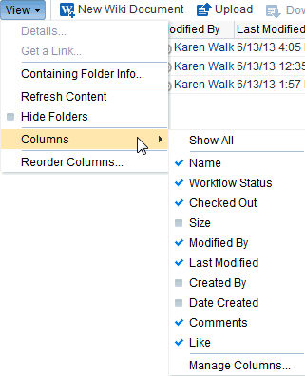

* + - 1. Select the columns you want to show through one of the following methods:
         * Select **Show All** to display all available columns.
         * Select or deselect individual columns in the **Columns** menu to show or hide them.
         * Click **Manage Columns**, then in the Manage Columns dialog (Figure 19–9), move columns to the **Hidden Columns** or **Visible Columns** boxes as desired. Click **OK** when you are finished.

***Figure 19–9 Manage Columns Dialog***

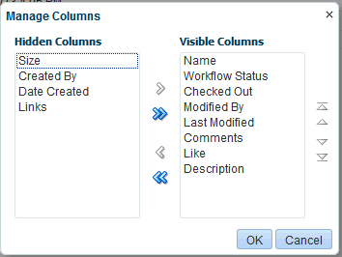

If changes do not display immediately, click the **View** menu, and select **Refresh Content.**

#### Reordering Columns

Reordering the informational columns is useful for prioritizing the details that are displayed with folders and files, depending on the information in which you are most interested.

To reorder the informational columns in your unique view:

* + - 1. On the **Documents** page or in the Document Manager, Document List Viewer, Document Explorer, or Folder Viewer, click the **View** menu, and select **Reorder Columns**.

The Reorder Columns dialog opens (Figure 19–10).

***Figure 19–10 Reorder Columns Dialog***

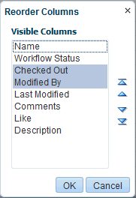

* + - 1. Select one or more columns, then click the reorder icons to rearrange the order of the columns.

#### Sorting Files and Folders

Sorting columns enables you to quickly rearrange the order of files and folders in your view. Each column provides a one-click sorting feature that you can use to instantly rearrange all content according to the ascending (1, 2, 3, A, B, C) or descending (C, B, A, 3, 2, 1) order of a particular column.

To sort folders and files in your unique view:

* + - 1. On the **Documents** page or in the Document Explorer, Document List Viewer, Document Manager, or Folder Viewer, move your cursor over the header of the column you want to use to sort folders and files.
      2. Click the **Sort Ascending** icon to sort the column in ascending order (1, 2, 3, A, B, C, or smallest to largest), or click the **Sort Descending** icon to sort the column in descending order (C, B, A, 3, 2, 1, or largest to smallest) (Figure 19–11).

***Figure 19–11 Sort Ascending and Sort Descending Icons***

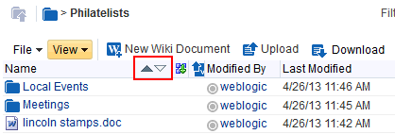

**Note:** The sorting icons display over the column that is the current sorting column. For other columns, the icons display when you hover your mouse pointer over the column name.

### Creating a Folder

With appropriate permissions, you can create a folder in any document container (Documents viewer) that displays folders. The new folder is created at the same level as the current location. When you create a new folder, this action is not reflected in the Activity Stream.

If you create a subfolder in a parent folder that is assigned a workflow (see the "Assigning a Workflow to a Folder in a Portal" section in *Building Portals with Oracle WebCenter Portal*), the subfolder inherits the workflow assignment of the parent folder.

**Note:** Other methods to create and copy folders when the back-end content repository is Content Server are:

* + - Create a network place to a portal, then use Windows Explorer to create and copy folders, as described in Section 10.4, "Working with Microsoft Windows Explorer Integration."
    - Use the task pane available through Microsoft Office shared document management functionality to create a new folder in a portal, as described in Section 10.3.4.2, "Adding a New Folder."

To create a folder:

1. On the **Documents** page or in the Document Explorer, Document Manager, or Folder Viewer on a page, navigate to the folder under which to create the new folder.
2. From the **File** menu, select **New Folder**.

The Create Folder dialog opens (Figure 19–12).

***Figure 19–12 Create Folder Dialog***

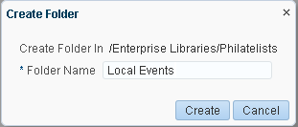

1. In the **Folder Name** field, enter a name for the folder; for example, Local Events.

**Note:** If WebCenter Portal is configured to use FrameworkFolders as the folder service, the following characters are not allowed in folder and file names:

? # & / \ * " | < > : ^

Letters, numbers, spaces, and periods (.) are allowed.

1. Click **Create** to create the folder and close the dialog.

### Creating a File

You can create new files in the connected content repository using Documents by either uploading a file, or creating a new wiki document, as described in the following sections:

* + - Section 8.5.1, "Uploading Files"
    - Section 8.5.2, "Creating a Wiki Document"

#### Uploading Files

**Notes:**

* + - * If your system administrator has configured a maximum upload size, uploading large files (size greater than 250MB) in Microsoft Internet Explorer 9 (running with Flash) takes longer to display the upload progress percentage and to complete the upload. This is expected behavior. For more information, see the "Changing the Maximum File Upload Size" section in *Administering Oracle WebCenter Portal*.
      * WebCenter Portal does not support uploading a new wiki document or a new version of a wiki document from the file system. If you upload an HTML file, you cannot convert it to a wiki document due to differences in underlying metadata. For information about wiki documents in WebCenter Portal, see Chapter 17, "Working with Wikis."

You can upload new files from your local file system or a mapped network drive to the connected content repository, or refresh multiple existing files with new versions.

To upload a new version of a *single* existing file that already exists in the connected content repository, see Section 8.8.5, "Uploading a New Version of an Existing File."

**Note:** Other methods to upload files when the back-end content repository is Content Server are:

* + - * Create a Windows network place to a portal, then use Windows Explorer to add files of any type, as described in Section 10.4, "Working with Microsoft Windows Explorer Integration." This method provides the ability to add multiple files at once to a portal, rather than uploading a maximum of 10 files at a time through the Upload Document pane, as described in this section.
      * Use the Microsoft Office shared document management functionality to save a local Microsoft Word, Excel, or PowerPoint file, or use the task pane to add files of any type to the Content Server repository, as described in Section 10.3.4.1, "Adding a File."
      * Use WebDAV, which is installed with Content Server

out-of-the-box, to establish a connection to your WebCenter Portal application, then drag and drop content in your Content Server repository to the folder assigned to the target portal, or drag and drop content between portals. When dragging and dropping content to the target folder, do not drag the source folder to the target; drag and drop only the content that is stored under the folder. If you do not know the WebDAV URL for the Content Server that is used to store documents, contact your Fusion Middleware Administrator. If the base URL for that Content Server is http://*host*:*port*/*relative_web_root*, the WebDAV root URL will be http://*host*:*port*/*relative_web_ root*/idcplg/webdav. For example: http://wchost:16200/dav/cs/idcplg/webdav/

* + - * Use the Batch Loader utility, as described in the "Batch Loading Content" chapter in *Administering Oracle WebCenter Content*.

To upload files to the connected content repository:

1. On the **Documents** page or in the Document Explorer, Document Manager, or Folder Viewer on a page, navigate to the folder for the file(s) you plan to upload or create a new folder (see Section 8.4, "Creating a Folder").
2. Click **Upload**.

The Upload Document pane opens (Figure 19–13 shows the pane in FireFox, Figure 19–14 shows the pane in Internet Explorer), providing an area where you can add the file(s) to be uploaded.

***Figure 19–13 Upload Document Pane (in FireFox Browser)***

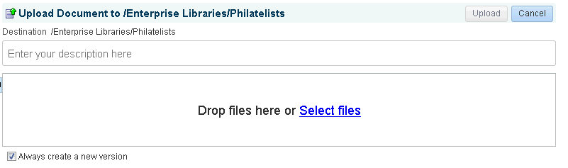

***Figure 19–14 Upload Document Pane (in Internet Explorer Browser)***

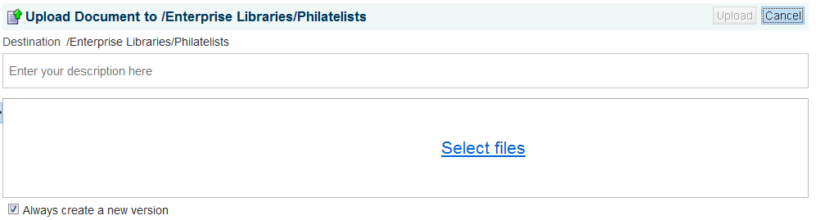

1. Follow the steps in one of the following sections:
   * Section 8.5.1.1, "Uploading a File with a Content Profile"
   * Section 8.5.1.2, "Uploading One or More Files without a Content Profile"

##### Uploading a File with a Content Profile

If the original version of a file is associated with a content profile in Content Server, or if you want to associate a new file with a content profile, you must first select the content profile to open the Content Check In Form, where you will upload the file *by itself*. You cannot select a profile when uploading multiple files.

Selecting a content profile enforces uniformity by requiring values for certain metadata fields that must be provided before the file can be uploaded. For example, a press release profile might include fields about who to contact, release date, and so on.

**Note:** To enable the **Upload Profiles** selection list, your system administrator must configure *both* of the following requirements:

* + - * + Users must access the WebCenter Portal application through Oracle HTTP Server (OHS) to expose Content Server and the WebCenter Portal application under the same host and port. For information about setting up OHS as the front-end to WebCenter Portal, your system administrator can refer to the "Configuring Content Server" section in *Administering Oracle WebCenter Portal*.
        + WebCenter Portal must be connected to a Content Server repository, with the webContextRoot parameter set to /cs. For information on setting webContextRoot, your system administrator can refer to the "Registering Content Repositories for WebCenter Portal or Portal Framework Applications" section in *Administering Oracle WebCenter Portal*. For information on setting webContextRoot through WLST, see the "createJCRContentServerConnection" and "setJCRContentServerConnection" sections in *WebLogic Scripting Tool Command Reference*.

To upload a file associated with a content profile:

1. Select the profile from the **Upload Profiles** list, which displays the content profiles that have been created in Content Server (Figure 19–15).

**Note:** Content profiles must be created in Content Server; there are no seeded content profiles. For information about creating a content profile, your system administrator can refer to the "Creating Content Profiles in Content Server" section in *Administering Oracle WebCenter Portal*.

***Figure 19–15 Selecting Content Profile for a File***

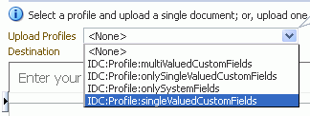

The Profile Upload pane displays the Content Check In Form, with metadata fields for the selected content profile (Figure 19–16).

***Figure 19–16 Content Profile Metadata Fields***

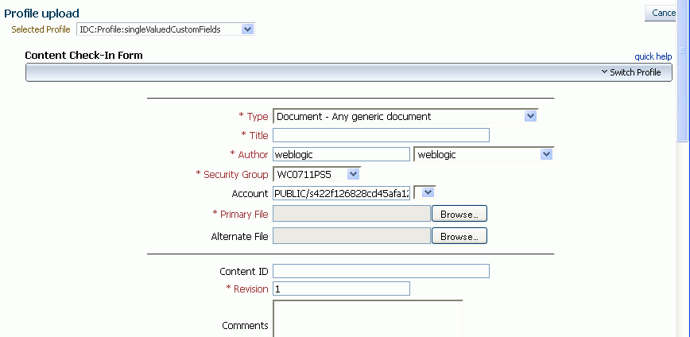

1. In the **Primary File** field, specify the name of the file to be uploaded.
2. Enter values for other metadata field values to associate with the file.

**Note:** Content Server may require certain mandatory metadata field values for a selected content profile to ensure a successful check-in.

Mandatory fields are identified in the dialog by an asterisk and red text.

For information about content profile metadata field requirements for Content Server, your system administrator can refer to the "Uploading Documents" chapter in *Using Oracle WebCenter Content*. The fields described in the "Content Check-In Form" section in the appendix are mandatory for Content Server. All content profiles must include them, otherwise the check-in will fail.

In addition to the mandatory metadata field values required by Content Server for specific content profiles, every content profile must include additional metadata fields required by WebCenter Portal.

Your system administrator must add these fields to a content profile as hidden fields so that the end user cannot override the values populated by WebCenter Portal:

* + xCollectionID - for the folder name to be persisted
  + xIdcProfile - for the profile value to be persisted
  + dRevLabel - required by the CHECKIN_SEL_FORM API to enable a new version to be checked in

This information is provided to the system administrator in "Creating Content Profiles in Content Server" section in *Administering Oracle WebCenter Portal*.

1. Click **Check In**.

The specified file is uploaded and listed in the current folder in your portal.

##### Uploading One or More Files without a Content Profile

To upload one or more files (maximum 10) without an associated content profile:

1. Select the file(s) to upload in either of the following ways:
   * (In FireFox or Chrome browsers only) Select the file(s) in your local file system and drag them into the Upload Document pane.
   * Click **Select files**, then navigate to and select the file(s) you want to upload.
2. In the Upload Document pane, optionally, provide a description of the file(s) in the

**Description** field. This description is assigned to all the files in the upload set.

1. If the file(s) already exist in the connected content repository, select **Always create a new version** to create a new version of the file(s). Deselect the check box if you want to be notified if a file with the same name already exists in the target folder in the content repository, and be provided with options.
2. Click **Upload**.
   * If a file with the same name already exists in the target folder, and **Always create a new version** is selected, a new version of the file is added at same level as the currently selected file. See Section 8.16, "Viewing and Deleting File Version History."
   * If a file with the same name already exists in the target folder, and **Always create a new version** is selected, *but the file is checked out by another user*, an

Information dialog notifies you that the file cannot be uploaded and provides the name of the user who has it checked out.

* + If a file with the same name already exists in the target folder, and **Always create a new version** is *not* selected, the Resolve Name Conflict pane opens.

Select the desired action:

* + **Ignore this file** to cancel the upload operation for the current file. This is useful when uploading multiple files to skip only the current file, and continue to upload subsequent files in the batch.
  + **Create a new version of the existing file** to create a new version of the file. See Section 8.16, "Viewing and Deleting File Version History."

**Note:** If the connected content repository does not support versioning, this selection is **Overwrite the existing file** to replace the existing file with the new file.

If the file is already checked out to another user or you do not have the permissions required to create a new version or overwrite the file, this selection is disabled.

* + **Use another name for the uploaded file** to display a **Name** field where you can enter a new name for the file. If you specify a name that matches another existing file, a message notifies you to enter a different name.

#### Creating a Wiki Document

In addition to uploading files (see Section 8.5.1, "Uploading Files") to the connected content repository, you can create wiki documents using either of the following two methods:

* + - * **New Wiki Document** action, as described in Section 17.2.1, "Creating a Wiki Document Using the New Wiki Document Action."
      * Wiki page style, as described in Section 17.2.2, "Creating a Wiki Using the Wiki Page Style."

For more information about wiki documents in WebCenter Portal, see Chapter 17, "Working with Wikis."

### Opening a Folder or File

This section describes opening folders/files and downloading/saving files in the following sections:

* + - Section 8.6.1, "Opening a Folder"
    - Section 8.6.2, "Opening a File"
    - Section 8.6.3, "Opening or Saving PDF Files"

#### Opening a Folder

You can open a folder to display its contents, which does not display folders.

**Note:** Other methods to open folders when the back-end content repository is Content Server are:

* + - * Create a network place to a portal, then use Windows Explorer to open folders and files, as described in Section 10.4, "Working with Microsoft Windows Explorer Integration."
      * Use the task pane available through Microsoft Office shared document management functionality to open folders in a portal, as described in Section 10.3.4.7, "Managing Folders."

To open a folder to display its contents and make it the top-level folder:

* On the **Documents** page or in the Document Explorer, Document Manager, or Folder Viewer on a page, either:
  + Click the folder name.
  + Or, right-click the folder, and choose **Open**.

#### Opening a File

With appropriate permissions, you can open files of any type to preview file contents or properties in a read-only view.

The Document Explorer, Document Manager, and Folder Viewer open files in-place in a Document Viewer preview pane; the Document List Viewer and Recent Documents open files in a separate Document Viewer preview window.

**Note:** Another method to open files when the back-end content repository is Content Server is:

* + - * Create a network place to a portal, then use Windows Explorer to open folders and files, as described in Section 10.4, "Working with Microsoft Windows Explorer Integration."

To open a read-only view of a file:

* On the **Documents** page or in the Document Explorer, Document Manager, or Folder Viewer on a page, click the file name to open the file in a Document Viewer preview pane or window.

**Notes:**

* + Some file types do not support a preview. An attempt to open such a file displays the properties of the file in the Document Viewer.
  + For files of types that support a preview, the file must also support display in an inline frame to open in the Document Previewer. For example, if an HTML file includes coding that disallows display in an inline frame, it will not display in the Document Previewer, but instead overlays the current window with the HTML file content.

The appearance of the file in the preview pane or window depends on the file type:

* **For files that support PDF format**: The file displays either in an in-place PDF viewer (Figure 19–17) or in a slide viewer (Figure 19–18).

***Figure 19–17 File Preview in PDF Viewer***

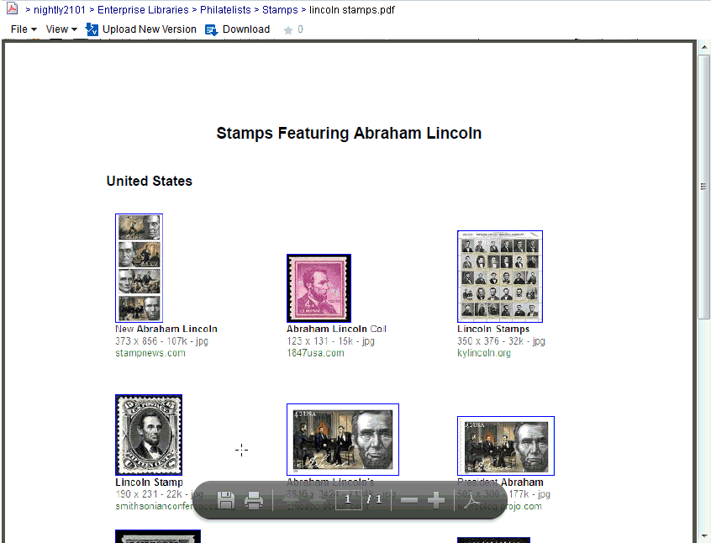

**Note:** To enable the slide preview functionality, your system administrator must configure *all* of the following requirements:

* + Users must access the WebCenter Portal application through Oracle HTTP Server (OHS) to expose Content Server and the WebCenter Portal application under the same host and port. For information about setting up OHS as the front-end to WebCenter Portal, see the "Configuring Content Server" section in *Administering Oracle WebCenter Portal*.
  + WebCenter Portal must be connected to a Content Server repository, with the webContextRoot parameter set to a Content Server host name. For information on setting webContextRoot, see the "Registering Content Repositories" section in *Administering Oracle WebCenter Portal*. For information on setting webContextRoot through WLST, see the "createJCRContentServerConnection" and "setJCRContentServerConnection" sections in *WebLogic Scripting Tool Command Reference*.
  + Oracle WebCenter Content settings for document conversion using IBR must be configured correctly.

***Figure 19–18 File Preview in Slide Viewer (see Note)***

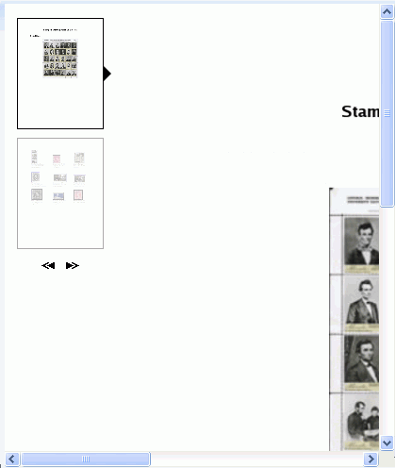

* **For HTML, text, image, XML files**: In the preview pane or window, click the **View** menu, and select **Open in Browser** to open the file in a separate tab in your browser.
* **For any file type for which Content Server is configured to convert to PDF**: In the preview pane or window, click the **View** menu, and select **Open as PDF** to open a PDF version of the file.

To edit files, see Section 8.8, "Editing or Updating a File."

#### Opening or Saving PDFFiles

From the Document Viewer preview pane, you can open or save the PDF version of the currently open file to your local file system. This choice is available for any file type for which Content Server is configured to convert to PDF.

**Notes:**

* + - * To enable the conversion of wikis and blogs into PDF, your system administrator must configure the WebCenter Conversion component, as described in the "Enabling the Conversion of Wikis and Blogs into PDFs" section in *Administering Oracle WebCenter Portal*.
      * Only images that have been added through the Rich Text Editor (RTE) using the Embed Image feature are visible in the generated PDF. Images referenced with an external URL do not display in the PDF. For information on the RTE, see Section 8.7, "Using the Rich Text Editor (RTE)."

To open or save a file in PDF:

* In the Document Viewer preview pane, click the **View** menu, and select:
  + **Open as PDF** to open the file in a new tab in your browser in Adobe Acrobat Reader's PDF Viewer plug-in.
  + **Download PDF** to open a browser dialog where you can save the file to your local file system as a PDF file.

### Using the Rich Text Editor (RTE)

The Rich Text Editor (RTE) is a fully-integrated HTML text editor, which you can use to create and edit wiki documents and blog posts, and edit HTML files. Figure 19–19 shows create mode, and Figure 19–20 shows edit mode.

***Figure 19–19 New Wiki Document in Rich Text Editor***

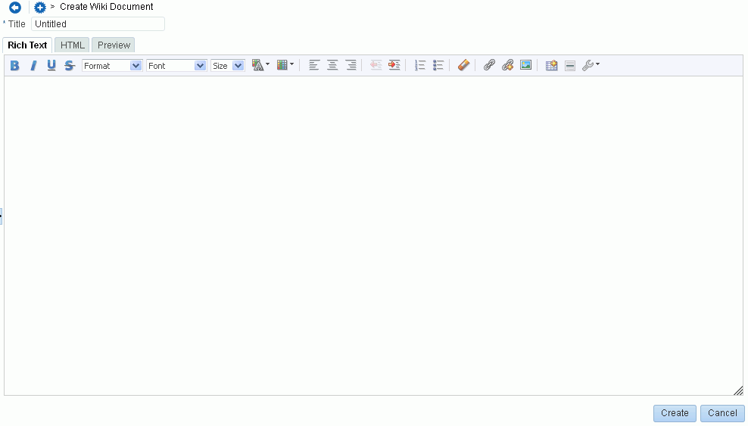

***Figure 19–20 Editing Blog Post in Rich Text Editor***

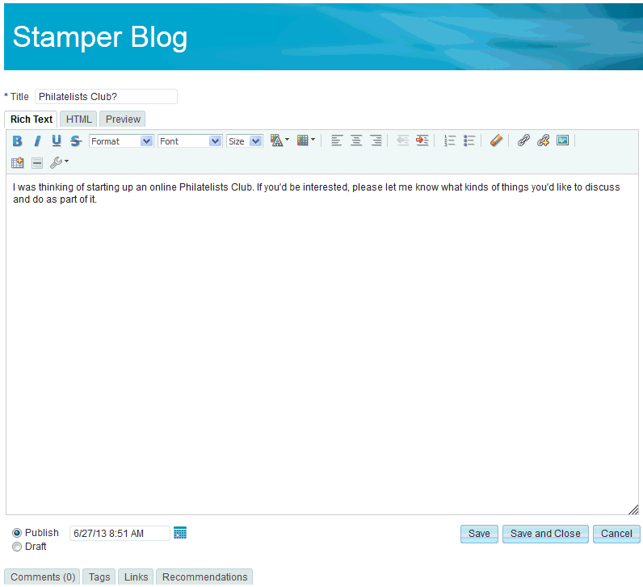

To use the RTE:

* + 1. Open the RTE either by creating a new wiki document (see Section 8.5.2, "Creating a Wiki Document") or blog post (see Section 18.5.2, "Creating a Blog Post"), or editing a wiki (see Section 17.3, "Editing a Wiki"), blog post, or HTML file (see Section 8.8.4, "Editing Files In-Place").
    2. For a new wiki document or blog post, enter a display name in the **Title** field.
    3. Add, revise, and preview text, formatting, styling, and links in the **Rich Text**, **HTML**, **Wiki Markup**, and/or **Preview** tabbed panes.

**Notes:**

* + - * For information about using the toolbar and features in the **Rich Text** pane, see Section 8.7.2, "About the Rich Text Editor Toolbar," Section 8.7.3, "Working with Tables in the Rich Text Editor," and Section 8.7.4, "Using the Keyboard in the Rich Text Editor."
      * Apple iPad users cannot make selections from drop-down lists in the RTE. This is a known limitation.
      * By default, the **Wiki Markup** tab is hidden in the RTE. Your system administrator can change this setting, as described in the "Showing and Hiding the Wiki Markup Tab in the Rich Text Editor" section in *Administering Oracle WebCenter Portal*.
      * If you switch from the **Wiki Markup** tab to another tab in the RTE, your content might become garbled. As a workaround, if you go to the **Wiki Markup** tab, click **Save and Close** or **Cancel** rather than switching to another tab in the RTE.
    1. (For wiki documents and HTML files only) Select the **Minor Edit?** check box if you do not want to notify portal members about your changes.

Leaving this check box deselected updates the Activity Stream and sends notifications after you save your changes.

* + 1. In the tabbed panes along the bottom of the RTE, you can add comments, tags, or links pertinent to the document or post. For more information, see Section 15.4, "Commenting on Items," Section 8.15, "Managing Tags on Files," and

Section 8.18, "Managing Document Links."

* + 1. Save your changes:
       - To create and save a new wiki document or blog post, click **Create**.
       - To save updates to an existing wiki document, blog post, or HTML file, click

**Save**. To save updates and exit the RTE, click **Save and Close**.

#### About the Rich Text Editor Tabbed Panes

The RTE provides four tabbed panes where you can create and edit your wiki and HTML documents, and blog posts:

* + - * **Rich Text**. Create and revise content in a WYSIWYG environment using the icons and controls in the RTE toolbar (see Section 8.7.2, "About the Rich Text Editor Toolbar").

**Note:** Apple iPad users cannot make selections from drop-down lists in the RTE. This is a known limitation.

* + - * **HTML**. Enter HTML manually. This includes entering source code for HTML not handled by the WYSIWYG icons and controls on the **Rich Text** tab.

If you exit the **HTML** pane, then come back to it again, any HTML that may have been entered on separate lines will reformat to display on a single line, as is customary for most HTML editors.

**Notes:**

* + - * + The RTE ignores the following types of tags when entered in HTML because they are irrelevant or redundant within the RTE context:

script tags

form elements, such as input, select, textarea, and form

frame/frameset

document tags, such as html, head, body, meta, and title

unknown tags; for example: <foo></foo>

* + - * + Changes to the behavior of the default CSS selectors in a wiki or blog is not supported.
      * **Preview** (wiki documents and blog posts only). Shows a preview of your wiki document or post as it will appear when published.
      * **Wiki Markup** (wiki documents only). If shown, use this tab to enter your own wiki markup. For the full set of wiki markup syntax, click **Wiki Markup Help** and refer to Table 19–3. Any formatting not provided by Wiki Markup uses HTML.

**Note:**

* + - * + By default, the **Wiki Markup** tab is hidden in the RTE. Your system administrator can change this setting, as described in the "Showing and Hiding the Wiki Markup Tab in the Rich Text Editor" section in *Administering Oracle WebCenter Portal*.
        + If you switch from the **Wiki Markup** tab to another tab in the RTE, your content might become garbled. As a workaround, if you go to the **Wiki Markup** tab, click **Save and Close** or **Cancel** rather than switching to another tab in the RTE.

***Table 19–3 Wiki Markup Syntax and Examples***

|  |  |  |  |
| --- | --- | --- | --- |
| **Element** | **Syntax** | **Example** | **Output** |
| italics | //*string*// | //Sales// team | *Sales* team |
| bold | \*\**string*\*\* | **Sales** team | **Sales** team |
| bulleted list | * *listItem*   ** *subitem*  ** *subitem*   * *listItem* | * Managers:   ** John Smith  ** Monica Gallo   * Contributors: |  |
| numbered list | # *listItem*  ## *subitem*  ## *subitem*  # *listItem* | # Dairy  ## Milk  ## Cheese  # Bread |  |

***Table 19–3 (Cont.) Wiki Markup Syntax and Examples***

|  |  |  |  |
| --- | --- | --- | --- |
| **Element** | **Syntax** | **Example** | **Output** |
| web link | [[*URL*|*linkName*]] | [[[http://www.oracle.co](http://www.oracle.com/)m|Search Oracle]]  [[http://fmw.vm.oracle.com:888 8/webcenter/portal/Philatelist s/page/presidents|Presidents]] | Search Oracle Presidents  Click link to view target in browser window |
| WebCenter link | [[owc://*svcId*/*rsrcId*|*linkName*]  ]  For service ID values, ask your system administrator.  To find the resource ID, view the item properties (right-click and choose **Details**. | [[owc://oracle.webcenter.docli b/dev-ucm#dDocName:OWCSVR01USO RAC026779|Results]] | Results  Click link to view resource in browser window |
| Anchor for link target | <<<anchor:*anchorName*>>> | <<<anchor:forecast>>>  (inserted at section describing sales forecast to act as a target for links) | (Invisible)  In HTML: <a  id="forecast" name="forecast"></a> |
| Line break | \\ | xxxx \\ xxxx | xxxx xxxx |
| Horizontal line | ---- | xxxx  ----  xxxx | xxxx  xxxx |
| Image  (All  browser-suppor ted image types such as JPG, GIF, and PNG) | {{*URL*/*imageFile*|*linkName*}} | [[[http://www.myco.com/Sales/ch](http://www.myco.com/Sales/ch) art.jpg|Quarterly Sales]] | Quarterly Sales  Click link to view image in browser window |
| Table | |=*head*|=*head*|...|=*head*|  |*value*|*value*|...|*value*|  Repeat for each row of table | |=ID|=Name|=Dept|  |1356|Bob King|Sales| |  |

#### About the Rich Text Editor Toolbar

Table 19–4 describes the RTE toolbar icons and controls on the **Rich Text** tab, where you can create and revise content in a WYSIWYG environment.

To perform an operation assigned to an icon, click the icon once to either immediately perform the action or open a dialog with further configuration options.

***Table 19–4 Rich Text Editor Toolbar Icons and Controls on Rich Text Tab***

|  |  |
| --- | --- |
| **Control** | **Description** |
|  | **Bold**, **Italic**, **Underline**, and **Strike Through**. Select text, and click the desired font style icon; or click an icon, and enter text. Click the icon again to exit the font style. |

***Table 19–4 (Cont.) Rich Text Editor Toolbar Icons and Controls on Rich Text Tab***

|  |  |
| --- | --- |
| **Control** | **Description** |
|  | **Paragraph Format**. Select a format, then enter text; or highlight text, then select a format. |
|  | **Font Name**. Select a font, then enter text; or highlight text, then select a font. |
|  | **Font Size**. Select a size, then enter text; or highlight text, then select a size. |

***Table 19–4 (Cont.) Rich Text Editor Toolbar Icons and Controls on Rich Text Tab***

|  |  |
| --- | --- |
| **Control** | **Description** |
|  | **Text Color** or **Background Color**. Select text, and click the desired text or background color icon, then select a color. Or, click an icon and select a color, then enter text. |
|  | **Left Justify**, **Center Justify**, and **Right Justify**. Select text, and click to apply the desired text alignment; or click an icon, and enter text. |
|  | **Decrease Indent** and **Increase Indent**. Select text, and click the desired indent icon to move text left or right. |
|  | **Numbered List** and **Bulleted List**. Start a new line, click the desired list type icon, and enter text. Or, select lines of text and click an icon. Click the icon again to remove the list formatting. Alternately, end list mode by pressing Enter twice after the last item. |
|  | **Remove Format**. Select text, and click this icon to remove all font styling, such as font types, sizes, weights, and colors.  Lists and indents are not affected. |

***Table 19–4 (Cont.) Rich Text Editor Toolbar Icons and Controls on Rich Text Tab***

|  |  |
| --- | --- |
| **Control** | **Description** |
|  | **Select Resource**. Select text to link to an existing WebCenter Portal resource, then click this icon to open the Select Resource dialog. Select a resource (for example, a document or an announcement in the current portal, or a URL) to be linked from the selected text. Clicking the linked text in the document opens the selected resource in the Document Viewer preview pane.  **New Resource**. Select text to link to a new WebCenter Portal resource, then click this icon to open the New Resource dialog. Select a resource to be linked from the selected text, then create the resource (for example, a discussion forum topic or note), specify the external location of the resource (for example, a URL), specify a name for the new resource (for example, a wiki document), or upload the resource from your local file system or a connected network drive (for example, a document).  *Note*: If you create a new wiki document in this manner, WebCenter Portal creates a placeholder for the new wiki document in the current folder. To add content to the new wiki document, you must navigate to it and open it in the RTE.  The links created using **Select Resource** and **New Resource** are created as inline links, and are not added to the **Links** tab associated with the details of the linking resource.  For information about links to resources in WebCenter Portal, see Chapter 32, "Linking Information in WebCenter Portal."  **Embed Image**. Click to open the Embed Image dialog:   * Click **Select Image** to select an image in the current portal. * Click **Upload Image** to upload an image from your local file system or a connected network drive. |
|  | **Table**. Click to open the Table Properties dialog.  See Section 8.7.3, "Working with Tables in the Rich Text Editor." |
|  | **Insert Horizontal Line**. Click to insert a horizontal line at the current cursor location. |
|  | **Tools**:   * **Maximize/Minimize**. Click to expand the RTE to fill the entire screen, or reduce the RTE to display inside the WebCenter Portal application. * **Select All**. Select all content in the body in the text input area. * **Find** or **Replace**. Click to open the Find and Replace dialog, where you can search for a string, or replace a given string with specified text. * **Snippet**. In a blog post, select a portion of text, then click this icon to display that portion as a summary of the blog post on the blog summary page (or digest page), with a **Read More** link to allow users to view the full blog. In a wiki document, this functionality is not available. |

***Table 19–4 (Cont.) Rich Text Editor Toolbar Icons and Controls on Rich Text Tab***

|  |  |
| --- | --- |
| **Control** | **Description** |
|  | **Cut**, **Copy**, or **Paste**. Select text, then right-click to display context menu to cut or copy selected text, or paste text in the buffer at the current cursor location.  **Note**: If a browser security warning displays, you can either use keyboard commands (see Section 8.7.4, "Using the Keyboard in the Rich Text Editor") or configure your browser to grant access to the clipboard. For example, for the FireFox browser, see <http://kb.mozillazine.org/Granting_> JavaScript_access_to_the_clipboard. |

#### Working with Tables inthe Rich Text Editor

To create a table in the RTE, click the **Table** icon in the toolbar (Figure 19–21).

***Figure 19–21 Rich Text Editor: Table Icon***



The Table Properties dialog window opens (Figure 19–22), where you can set basic properties for the table, as described in Table 19–5.

***Figure 19–22 Rich Text Editor: Table Properties Dialog (Basic Properties)***

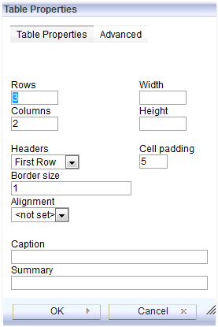

***Table 19–5 Rich Text Editor: Basic Table Properties***

|  |  |
| --- | --- |
| **Property** | **Description** |
| **Rows** | (Required) Enter the number of rows in the table. |
| **Columns** | (Required) Enter the number of columns in the table. |
| **Width** | Enter the width of the table, selecting either pixels or a percent value. Giving the width as a percent value lets you set the proportion of the editing area that the table will occupy. |
| **Height** | Enter the height of the table in pixels. |
| **Headers** | Select the table element to format as headers, which applies special formatting to them. You can apply header formatting to First Row, First Column or Both. |
| **Border Size** | Enter the width of the table borders. |
| **Alignment** | Select the alignment of the table on the page Left, Center, or Right. |
| **Cell padding** | Enter the space between the cell border and its contents, in pixels. |
| **Caption** | Enter label text to be displayed above the table. |
| **Summary** | Enter a summary of the table contents that is available for assistive devices like screen readers. It is good practice to provide tables with meaningful summary text to make them more accessible to users with disabilities. |

Click the **Advanced** tab to expose the advanced table properties (Figure 19–23), which you can set as described in Table 19–6.

***Figure 19–23 Rich Text Editor: Table Properties Dialog (Advanced Properties)***

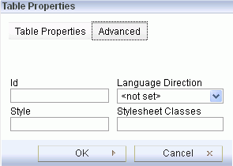

***Table 19–6 Rich Text Editor: Advanced Table Properties***

|  |  |
| --- | --- |
| **Property** | **Description** |
| **Id** | Enter a unique identifier for a table element in the document (id attribute). |
| **Language Direction** | Select the direction of the text in the table: left to right (LTR) or right to left (RTL) (dir attribute). |
| **Style** | Enter the CSS style definitions (style attribute). Note that each value must end with a semi-colon and individual properties should be separated with spaces. |

***Table 19–6 (Cont.) Rich Text Editor: Advanced Table Properties***

|  |  |
| --- | --- |
| **Property** | **Description** |
| **Stylesheet Classes** | Enter the class of the table element (class attribute). If a table element is assigned more than one class, separate class names with spaces. |

With a table inserted into your document, you can enter values directly in the cells. Additional editing is available through the context menu. To open the context menu, right-click the table and choose actions as described in Table 19–7.

***Table 19–7 Rich Text Editor: Table Context Menu Selections***

|  |  |
| --- | --- |
| **Action** | **Description** |
| **Paste** | Pastes the content on the clipboard at the current cursor location |
| **Cell** | See Section 8.7.3.1, "Editing Table Cells in the Rich Text Editor." |
| **Row** | See Section 8.7.3.2, "Editing Table Rows in the Rich Text Editor." |
| **Column** | See Section 8.7.3.3, "Editing Table Columns in the Rich Text Editor." |
| **Delete Table** | Deletes the entire table and its contents. |
| **Table Properties** | Opens the Table Properties dialog, where you can modify properties as described in Table 19–5, " Rich Text Editor: Basic Table Properties" and Table 19–6, " Rich Text Editor: Advanced Table Properties", with the exception of the number of rows and columns. |

##### Editing Table Cells in the Rich Text Editor

To insert, delete, merge, or cells, or modify cell properties, right-click a cell (*the current cell*) to display the context menu, then choose **Cell** to expand the submenu of cell actions (Figure 19–24), and choose actions as described in Table 19–8.

To select multiple cells, drag the mouse over the cell, then right-click to open the context menu.

***Figure 19–24 Rich Text Editor: Table Cell Actions***

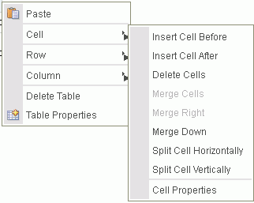

***Table 19–8 Rich Text Editor: Table Cell Menu Selections***

|  |  |
| --- | --- |
| **Action** | **Description** |
| **Insert Cell Before** | Inserts a new cell before the current cell(s). |
| **Insert Cell After** | Inserts a new cell after the current cell(s). |
| **Delete Cells** | Deletes the current cell(s). |
| **Merge Cells** | Merges multiple selected cells into one. This option is available only if two or more cells are selected. |
| **Merge Right** | Merges the selected cell with a cell on its right. This option is available only if no more than one cell is selected. |
| **Merge Down** | Merges the selected cell with a cell located below it. This option is available only if no more than one cell is selected. |
| **Split Cell Horizontally** | Splits the selected cell in two, creating a new cell on its right. The content of the cell appears in the original, left cell. This option is available only if no more than one cell is selected. |
| **Split Cell Vertically** | Splits the selected cell in two, creating a new cell below it. The content of the cell appears in the original, upper cell. This option is available only if no more than one cell is selected. |
| **Cell Properties** | Opens the Cell Properties dialog, where you can configure cell size, type, color, and content alignment, as described in  Section 8.7.3.1.1, "Editing Table Cell Properties in the Rich Text Editor." |

###### 19.7.3.1.1 Editing Table Cell Properties inthe Rich Text Editor

Table cells can be further customized, creating a unique look and feel. From the table context menu, select **Cell**, then **Cell Properties** to open the Cell Properties dialog (Figure 19–25) where you can set cell properties for the table, as described in

Table 19–9.

***Figure 19–25 Rich Text Editor: Table Cell Properties Dialog***

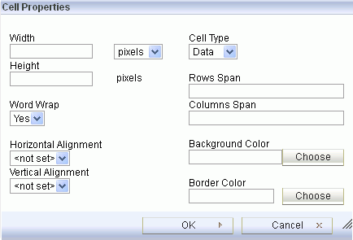

***Table 19–9 Rich Text Editor: Table Cell Properties***

|  |  |
| --- | --- |
| **Action** | **Description** |
| **Width** | Enter the width of the cell, selecting either pixels or a percent value. Giving the width as a percent value lets you set the proportion of the row that the cell (and the column it is located in) will occupy. |
| **Height** | Enter the height of the cell in pixels. |
| **Cell Type** | Select the type of the table cell — either a normal data cell or a header cell with special formatting. |
| **Word Wrap** | Select whether or not to wrap content in the current cell. |
| **Rows Span** | Enter a numeric value to specify the number of rows over which to stretch the cell downward. This value sets the rowspan attribute. |
| **Columns Span** | Enter a numeric value to specify the number of columns over which to stretch the cell to the right. This value sets the colspan attribute. |
| **Horizontal Alignment** | Select the horizontal alignment of table cell contents: Left, Center, or Right. |
| **Vertical Alignment** | Select the vertical alignment of table cell contents: Top, Middle, Bottom, or Baseline. |
| **Background Color Border Color** | Enter the color of the cell background and/or border using any of the following methods:   * Enter an RGB value in rgb(*nn*, *nn*, *nn*) format, where *nn* is a numeric value on a scale from 0 to 255 representing the red, green, and blue channel. * Enter a hexadecimal RGB value, in #*nnnnnn* format, where the *nnnnnn* is the three pairs of hex color values representing the red, green, and blue channel. * Click **Choose** to open the Select color dialog where you can select from the color palette. |

##### Editing Table Rows in the Rich Text Editor

To insert or delete rows in a table, right-click a row (*the current row*) to display the context menu, then choose **Row** to expand the submenu of row actions (Figure 19–26), and choose actions as described in Table 19–10.

To select multiple rows, drag the mouse over the rows, then right-click to open the context menu.

***Figure 19–26 Rich Text Editor: Table Row Actions***

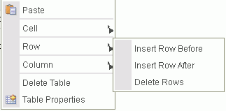

***Table 19–10 Rich Text Editor: Table Row Menu Selections***

|  |  |
| --- | --- |
| **Action** | **Description** |
| **Insert Row Before** | Inserts a new row before the current row(s). |
| **Insert Row After** | Inserts a new row after the current row(s). |
| **Delete Rows** | Deletes the current row(s). |

##### Editing Table Columns in the Rich Text Editor

To insert or delete columns in a table, right-click a column (*the current column*) to display the context menu, then choose **Column** to expand the submenu of column actions (Figure 19–27), and choose actions as described in Table 19–11.

To select multiple columns, drag the mouse over the columns, then right-click to open the context menu.

***Figure 19–27 Rich Text Editor: Table Column Actions***

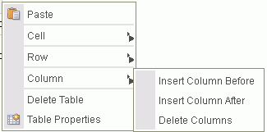

***Table 19–11 Rich Text Editor: Table Column Menu Selections***

|  |  |
| --- | --- |
| **Action** | **Description** |
| **Insert Column Before** | Inserts a new column before the current column(s). |
| **Insert Column After** | Inserts a new column after the current column(s). |
| **Delete Columns** | Deletes the current column(s). |

#### 19.7.4 Using the Keyboard inthe Rich Text Editor

The Rich Text Editor is compliant with several accessibility standards, including the Web Content Accessibility Guidelines (WCAG), the US Section 508 Amendment to the Rehabilitation Act of 1973 and the IBM Web Accessibility Checklist. To this end, you can use the RTE with the keyboard as well as a screen reader. The currently supported screen reader solution is JAWS.

For more information about accessibility in WebCenter Portal, see Section 5.4, "Setting Your Accessibility Options."

Table 19–12 summarizes the keyboard keys and combinations available to you to navigate and edit text in the RTE.

***Table 19–12 Rich Text Editor: Keyboard***

|  |  |
| --- | --- |
| **Keyboard Keys** | **Description** |
| **Alt+F10** | Moves to the toolbar. |

***Table 19–12 (Cont.) Rich Text Editor: Keyboard***

|  |  |
| --- | --- |
| **Keyboard Keys** | **Description** |
| **Tab** | In the toolbar, moves to the next button group. In a dialog, moves to the next element. |
| **Shift+Tab** | In the toolbar, moves to the previous button group. In a dialog, moves to the previous element. |
| **Left Arrow**/**Right Arrow** | In the toolbar, moves between buttons within a button group. In a dialog, moves within a field. |
| **Enter** | In the toolbar, selects the current button or menu item, or expands a drop-down list or menu.  In a dialog, confirms entry at current cursor location). |
| **Down Arrow**/ **Up Arrow** | Moves between selections in a drop-down list. |
| **Esc** | Closes a menu without executing any command. When inside a submenu, closes the submenu and returns focus to the parent context menu. Press Esc again to close it.  In a dialog, cancels entries and closes dialog (equivalent to clicking **Cancel** or **Close**). |
| ***In the editing area***: |  |
| **Shift+F10** | Opens the context menu of the current element (use down arrow and up arrow to move between selections in the menu, and Enter to select an action). |
| **Alt+F10** | Moves to the tab selection in a dialog (use left and right arrow keys to move between tabs, and Enter to move to the fields on a tab). |
| **Ctrl+A** | Selects the entire content in the editing area. |
| **Ctrl+B** | Changes the formatting of the selected text to bold or remove the bold formatting of the selected text. |
| **Ctrl+C** | Copies highlighted selections to the clipboard. |
| **Ctrl+I** | Changes the formatting of the selected text to italics or remove the italics from the selected text. |
| **Ctrl+U** | Underlines the selected text or remove the underline formatting of the selected text. |
| **Ctrl+V** or **Shift+Insert** | Pastes the content on the clipboard at the current cursor location. |
| **Ctrl+X** or **Shift+Delete** | Cuts highlighted selections to the clipboard. |
| **Ctrl+Y** | Performs the redo operation. |
| **Ctrl+Z** | Performs the undo operation. |

### Editing or Updating a File

You can check a file out, download it to your local file system for editing, edit a file in-place, or upload a new version of an existing file. The actions available to you depend on the file type:

* + - For all file types except wiki documents and blog posts, check the file out to lock it from being updated by other users.
    - For all file types, download the file to your local file system for saving or editing locally.
    - For wiki documents, blog posts, and HTML documents, edit the file in-place using the Rich Text Editor (RTE).
    - For all file types except wiki documents and blog posts, upload a new version of the file.

The following sections provide more information:

* + - Section 8.8.1, "Checking a File Out"
    - Section 8.8.2, "Cancelling a Checked Out Status"
    - Section 8.8.3, "Downloading a File"
    - Section 8.8.4, "Editing Files In-Place"
    - Section 8.8.5, "Uploading a New Version of an Existing File"

#### Checking a File Out

When you want to retain exclusive use of a file—for example, when you are editing it on your local machine, or need to prevent other users from modifying it—you must check the file out. Other WebCenter Portal users can view the file, but they cannot upload a file of the same name into the same folder while the file is checked out.

**Note:** When you edit a file in-place (see Section 8.8.4, "Editing Files In-Place"), it is automatically checked out of the content repository.

When you save it, it is automatically checked back in.

When you are ready to release the file, you can either check the file back in, or cancel file check out. Checking a file back in involves uploading the revised file (see Section 8.8.5, "Uploading a New Version of an Existing File"). Cancelling check out removes the file's checked out status without requiring a file upload (see

Section 8.8.2, "Cancelling a Checked Out Status").

**Note:** To use the task pane available through the Microsoft Office shared document management functionality to check a Microsoft Word, Excel, or PowerPoint file out or in when the back-end content repository is Content Server, see Section 10.3.4.3, "Checking a File Out" and Section 10.3.4.4, "Checking a File In."

To check a file out:

* + - 1. On the **Documents** page or in the Document Explorer, Document Manager, or Folder Viewer on a page, click in the row of the file you want to check out.

Alternatively, you can check out an open file in the Document Viewer preview pane.

**Notes:**

* + - * + File check out is not available for wiki documents. In-place editing is the optimal way to update wiki documents, as described in Section 8.8.4, "Editing Files In-Place."
        + To check out a file in workflow, the file must be associated with a workflow that contains the step review the current revision or create new revisions *and* you must be an approver for the workflow. See the "Understanding Workflow Types" section in *Building Portals with Oracle WebCenter Portal*.
      1. Depending on your view, perform one of the following actions:
         * On the **Documents** page or in the Document Explorer, Document Manager, or Folder Viewer on a page, click the **File** menu, and select **Check Out**, or

right-click to display the file's context menu and choose **Check Out**.

* + - * + In the Document Viewer preview pane, click the **File** menu, and select **Check Out**.
      1. On the **Documents** page or in the Document Explorer, Document Manager, or Folder Viewer on a page, click the **View** menu, and select **Refresh Content** to confirm that the **Checked Out** (padlock) icon appears in the file's **Checked Out** column:
         * Roll your mouse pointer over the icon to see details about the user who has the file checked out.
         * Click the icon to expose actions to upload a new version of the file, or cancel the checkout (Figure 19–28).

***Figure 19–28 Checked Out Icon with Details***



#### Cancelling a Checked Out Status

To cancel the checked out status of a file:

* + - 1. On the **Documents** page or in the Document Explorer, Document Manager, or Folder Viewer on a page, click in the row of the file.

Alternatively, you can cancel the checked out status of an open file in the Document Viewer preview pane.

* + - 1. Depending on your view, perform one of the following actions:
         * On the **Documents** page or in the Document Explorer, Document Manager, or Folder Viewer on a page, click the **Checked Out** (padlock) icon in the file's row and choose **Cancel Check Out** (Figure 19–28), click the **File** menu, and select **Cancel Check Out**, or right-click to display the file's context menu and choose **Cancel Check Out**.
         * In the Document Viewer preview pane, click the **Cancel Check Out** action.
      2. On the **Documents** page or in the Document Explorer, Document Manager, or Folder Viewer on a page, click the **View** menu, and select **Refresh Content** to

confirm that the **Checked Out** (padlock) icon no longer appears in the file's

**Checked Out** column.

#### Downloading a File

When you want to save a file to your local file system, you can download it from the content repository.

To download a file:

* + - 1. On the **Documents** page or in the Document Explorer, Document Manager, or Folder Viewer on a page, click in the row of the file you want to download to your local file system.

Alternatively, you can download an open file in the Document Viewer preview pane.

* + - 1. Depending on your view and the file type, perform one of the following actions:
         * On the **Documents** page or in the Document Explorer, Document Manager, or Folder Viewer on a page, click the **Download** action, or right-click to display the file's context menu and choose **Download**.
         * In the Document Viewer preview pane, click the **Download** action.
         * (For any file type for which Content Server is configured to convert to PDF) In the Document Viewer preview pane, click the **View** menu, and select **Download PDF** to save a PDF version of the open file to your local file system.
      2. In the Open/Save dialog, select **Save File** to open the Save dialog, where you can navigate to the folder in which to save the file.

#### Editing Files In-Place

With appropriate permissions, end users can directly edit the following types of files in-place:

* Wiki documents
* Blog posts
* HTML files
* Microsoft Office 2003 or higher files (Word, Excel, PowerPoint)

**Note:** If you are using Windows 7 or a 64-bit machine with Firefox

3.6 or above, you may need to install the Java plug-in available at [http://support.mozilla.com](http://support.mozilla.com/) to edit a Microsoft Office file. This plug-in is included in Java 6 Update 15 and above.

*In-place editing* refers to editing content directly in WebCenter Portal, where the editor opens in the document preview pane. When you edit a file in-place, it is automatically checked out of the content repository. When you save it, it is automatically checked back in.

To edit HTML and Site Studio files that display in Content Presenter, see the "Creating and Editing Files In-Context in a Content Presenter Task Flow" section in *Building Portals with Oracle WebCenter Portal*.

To edit a file in-place:

* + - 1. On the **Documents** page or in the Document Explorer, Document Manager, or Folder Viewer on a page, click in the row of the file you want to edit, but not on the file name.

Alternatively, you can edit an open file in the Document Viewer preview pane.

* + - 1. Depending on your view and the file type, perform one of the following actions:
         * On the **Documents** page or in the Document Explorer, Document Manager, or Folder Viewer on a page, click the **File** menu, and select **Edit** or **Edit with *Application***, or right-click to display the file's context menu and choose **Edit** or **Edit with *Application***.
         * In the Document Viewer preview pane, click the **Edit** (Figure 19–29) or **Edit with *Application*** (Figure 19–30) action.

***Figure 19–29 Edit Action in Document Viewer for Wiki Document***

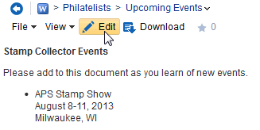

***Figure 19–30 Edit Action in Document Viewer for Microsoft Word File***

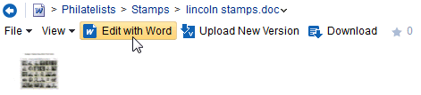

**Notes:**

If the file is already checked out by another user, the Document Viewer specifies the name of the user who has it checked out. See Section 8.8.4.1, "Opening a File Already Checked Out By Another User."

To edit a file in workflow, the file must be associated with a workflow that contains the step review the current revision or create new revisions *and* you must be an approver for the workflow. See the "Understanding Workflow Types" section in *Building Portals with Oracle WebCenter Portal*.

The file opens in the appropriate editor:

* + - * + Wiki documents, blog posts, and HTML files open in-place in the Rich Text Editor (RTE). For information about the RTE, see Section 8.7, "Using the Rich Text Editor (RTE)."
        + Microsoft Office (Word, Excel, PowerPoint) files may first display a confirmation prompt, then an authentication dialog. Use the same credentials used to log in to WebCenter Portal to open the file in-place in its corresponding application.

**Note:** The user name and password must contain only ASCII characters. A user name or password containing multi-byte characters cannot be successfully authenticated.

When the connected content repository is Content Server, you must access the WebCenter Portal through Oracle HTTP Server (OHS) to expose Content Server and the WebCenter Portal application under the same host and port to allow for full integration of Microsoft Office with WebCenter Portal. For information about setting up OHS as the front-end to WebCenter Portal, see the "Configuring Content Server" section in *Administering Oracle WebCenter Portal*.

Additionally, your system administrator must modify system properties and server configuration files, and set up a virtual host for your WebCenter Portal. These configuration requirements are described in the "Managing Microsoft Office Integration" chapter in *Administering Oracle WebCenter Portal*.

* + - 1. When the file opens, it is automatically checked out. In WebCenter Portal, click the

**Refresh** icon to show the **Checked Out** icon for the selected file (Figure 19–31).

***Figure 19–31 Checked Out Icon in WebCenter Portal***



* + - 1. Make required updates, then save and close the file. The modified file is automatically checked back in.

##### 19.8.4.1 Opening a File Already Checked Out By Another User

If the file that you attempt to open is already checked out by another user, the Document Viewer specifies the name of the user who has it checked out. (Figure 19–32).

***Figure 19–32 Document Viewer: File Checkout Out***

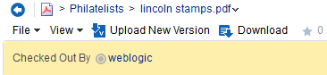

You can download the file to your local system to edit it, but you cannot upload the changed file to the content repository until it is checked in and made available again.

#### Uploading a New Version of an Existing File

If you have write permissions on a file, you can replace the file with a new version that you have saved on your local file system.

To upload new versions of multiple files at once, which allows you to also specify whether to create new versions of existing files or overwrite existing files, follow the steps in Section 8.5.1, "Uploading Files."

**Note:** WebCenter Portal does not support uploading a new wiki document or a new version of a wiki document from the file system. If you upload an HTML file, you cannot convert it to a wiki document due to differences in underlying metadata. For information about wiki documents in WebCenter Portal, see Chapter 17, "Working with Wikis."

To upload a new version of a single file:

* + - 1. On the **Documents** page or in the Document Explorer, Document Manager, or Folder Viewer on a page, click in the row of the file you want to replace.

Alternatively, you can upload a new version of an open file in the Document Viewer preview pane.

* + - 1. Depending on your view and permissions, perform one of the following actions:

**Note:** If you do not have write permission on the file, or if the file is already checked out by another user, then the **Upload New Version** action will not be available to you.

If you have write permissions on the file, and try to upload a new version at the same time it is being checked out by another user, an Information dialog notifies you that the file is checked out.

* + - * + On the **Documents** page or in the Document Explorer, Document Manager, or Folder Viewer on a page, click the **Checked Out** (padlock) icon in the file's row and choose **Upload New Version** (Figure 19–33), click the **File** menu, and select **Upload New Version**, or right-click to display the file's context menu and choose **Upload New Version**.

***Figure 19–33 Checked Out Icon: Upload New Version***



* + - * + In the Document Viewer preview pane, click the **Upload New Version** action (Figure 19–34).

***Figure 19–34 Document Viewer: Upload New Version***

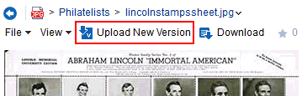

The Upload New Version pane opens (Figure 19–35).

***Figure 19–35 Upload New Version Pane***

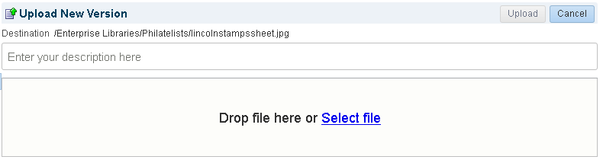

**Note:** If a file is associated with a content type profile, it will be uploaded using that content type profile. You cannot change a file's content type profile by uploading a new version. See Section 8.5.1.1, "Uploading a File with a Content Profile" for information about selecting a content type profile when a file is first uploaded.

* + - 1. Select the file(s) to upload in either of the following ways:
         * (In FireFox or Chrome browsers only) Select the file(s) in your local file system and drag them into the Upload New Version pane.
         * Click **Select file**, then navigate to and select the file(s) you want to upload.
      2. In the Upload Document pane, optionally, provide a description of the file in the

**Description** field.

* + - 1. Click **Upload**.

A new version of the file replaces the existing file. For information about viewing versions of a file, see Section 8.16, "Viewing and Deleting File Version History."

### Renaming a Folder or File

You can rename a folder or file as described in the following sections:

* + - Section 8.9.1, "Renaming a Folder or File Using a Menu"
    - Section 8.9.2, "Renaming a File and Revising Its Description Through Properties"

**Note:** To use Windows Explorer to rename folders and files in a portal when the back-end content repository is Content Server, see Section 10.4.2, "Working with Files Using Windows Explorer."

#### Renaming a Folder or File Using a Menu

To rename a folder or file:

* + - 1. On the **Documents** page or in the Document Explorer, Document Manager, or Folder Viewer on a page, click in the row of the folder or file you want to rename.
      2. Click the **File** menu, and select **Rename**, or right-click in the folder or file's row to display the context menu and choose **Rename**.

The Rename Folder or Rename Document dialog opens (Figure 19–36).

***Figure 19–36 Rename Document Dialog***

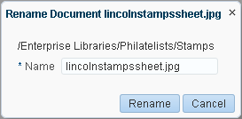

* + - 1. In the **Name** field, enter a new folder or file name.

**Note:** If WebCenter Portal is configured to use FrameworkFolders as the folder service, the following characters are not allowed in folder and file names:

? # & / \ * " | < > : ^

Letters, numbers, spaces, and periods (.) are allowed.

* + - 1. Click **Rename**.

#### Renaming a File and Revising Its Description Through Properties

To rename a file or revise its description through its properties, see Section 8.17.2, "Working with File Properties."

### Copying and Pasting Folders and Files

You can copy and paste folders and files in the following ways:

* + - Use menu actions as described in the steps below.
    - Drag and drop into a target folder while pressing the Ctrl key. You can even drag and drop into another Documents viewer on the same page as long as both viewers are connected to the same content repository.
    - Copy a file to your local file system, as described in Section 8.8.3, "Downloading a File."

**Notes:**

* + - * When you copy a file, only the latest version of the file is copied, not the version history. For more information on file history, see Section 8.16, "Viewing and Deleting File Version History."
      * Duplicate copies of files and folders (prefixed with "Copy of") are created when you "copy and paste", "cut and paste" , or "move and paste" to a location that already contains a file or folder with the same name. For example, if you copy or cut the file Events.docx and paste it to a folder containing that file, the new pasted version is named Copy of Events.docx. This happens when Oracle WebCenter Portal is configured to use Framework Folders as the folder service. If Folders_g is configured, files and folders are not duplicated if a matching copy is found at the target.

To copy one or more folders (including all of its subfolders and files) or files using menu actions:

1. On the **Documents** page or in the Document Explorer, Document Manager, or Folder Viewer on a page, click in the row of the folder(s) or file(s) you want to copy.

To select multiple folders or files, Ctrl-click in the rows.

1. Click the **File** menu, and select **Copy**, or right-click to display the context menu and choose **Copy**.
2. Navigate to the folder where you want to paste the copied folder(s) or file(s).

You can also navigate to a folder in another Documents viewer on the same or a different page as long as both viewers are connected to the same content repository.

1. Click the **File** menu, and select **Paste**, or right-click to display the folder's context menu and choose **Paste**. After pasting, the **Paste** action becomes inactive in the current folder. You can continue to paste the copied content to other folders as needed.

If you are copying into another Documents viewer, you may need to refresh the target folder if the **Paste** menu action is not active (see Section 8.13, "Refreshing Folder Contents").

The selected folder(s) and file(s) are copied to the current folder.

**Note:** If a folder or file is deleted at the source location before pasting, it will not be copied to the paste location.

### Moving Folders and Files

You can move folders and files in the following ways:

* + - Use the menu actions as described in the steps below.
    - Drag and drop into a target folder. You can even drag and drop into another Documents viewer on the same page as long as both viewers are connected to the same content repository.

**Note:** To use Windows Explorer to move folders and files in a portal when the back-end content repository is Content Server, see

Section 10.4.2, "Working with Files Using Windows Explorer."

To move one or more folders (including all of its subfolders and files) or files using menu actions:

1. On the **Documents** page or in the Document Explorer, Document Manager, or Folder Viewer on a page, click in the row of the folder(s) or file(s) you want to move.

To select multiple folders or files, Ctrl-click in the rows.

1. Click the **File** menu, and select **Cut**, or right-click to display the context menu and choose **Cut**.
2. Navigate to the folder where you want to move the folder(s) or file(s).

You can also navigate to a folder in another Documents viewer on the same or a different page as long as both viewers are connected to the same content repository

1. Click the **File** menu, and select **Paste**, or right-click to display the folder's context menu and choose **Paste**. After pasting, the **Paste** action becomes inactive in the current folder.

If you are moving folders or files into another Documents viewer, you may need to refresh the target folder if the **Paste** menu action is not active (see Section 8.13, "Refreshing Folder Contents").

The selected folder(s) and file(s) are moved to the current folder.

**Notes:**

* + If you do not paste the cut folder(s) or file(s), they are restored to the location where they were cut. If a folder or file is deleted at the source location before pasting, it will not be moved to the paste location.
  + Duplicate copies of files and folders (prefixed with "Copy of") are created when you "copy and paste", "cut and paste" , or "move and paste" to a location that already contains a file or folder with the same name. For example, if you copy or cut the folder Events and paste it to a destination containing that folder, the new pasted version is named Copy of Events. This happens when Oracle WebCenter Portal is configured to use Framework Folders as the folder service. If Folders_g is configured, files and folders are not duplicated if a matching copy is found at the target.

### Deleting Folders and Files

When you delete a folder, all the subfolders and files the folder contains are also deleted in the content repository. When you delete a folder, this action is not reflected in the Activity Stream in the Home portal.

**Notes:**

* + - The root folder cannot be deleted.
    - To use Windows Explorer to move folders and files in a portal when the back-end content repository is Content Server, see Section 10.4.2, "Working with Files Using Windows Explorer."

To delete one or more folders or files:

1. On the **Documents** page or in the Document Explorer, Document Manager, or Folder Viewer on a page, click in the row of the folder(s) or file(s) you want to delete.

To select multiple folders or files, Ctrl-click in the rows.

1. Click the **File** menu, and select **Delete**, or right-click to display the context menu and choose **Delete**.

The Delete dialog opens (Figure 19–37).

***Figure 19–37 Deleting a File***

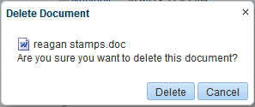

1. Click **Delete** to delete your selection from the content repository.

### Refreshing Folder Contents

Refreshing the contents of the current folder retrieves all changes made in the content repository since the last retrieval.

To refresh folder contents:

* + - On the **Documents** page or in a Document Explorer, Document Manager, or Folder Viewer, click the **View** menu, and select **Refresh Content**.
    - In the Document List Viewer, click the **Refresh** icon.

### Hiding and Showing Folders

To hide or show the folders in a listing of folders and files:

* + - On the **Documents** page or in a Document Explorer, Document Manager, or Folder Viewer, click the **View** menu, and select **Hide Folders**.

When folders are hidden, a check displays alongside the **Hide Folders** menu selection.

### Managing Tags on Files

Tags specify keywords related to the content of a file. Tags are useful for making a file more widely discoverable in search results.

**Note:** See Section 33.3.3, "Viewing Tags in Search Results" for information about searching on tags.

To work with the tags for a file:

1. Access tags by performing one of the following actions:
   * On the **Documents** page or in the Document Explorer, Document Manager, or Folder Viewer on a page, click the **View** menu, and select **Details**, or

right-click to display the file's context menu and choose **Details**.

* + In the Document Viewer preview pane, scroll to the bottom of the document and click the **Tags** tab (Figure 19–38).
  + In the Rich Text Editor, scroll to the bottom of the HTML document, wiki, or blog post, and click the **Tags** tab.

***Figure 19–38 Tags Pane***

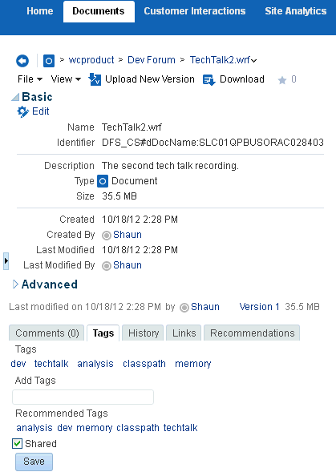

1. In the **Tags** pane, enter new tags, and edit or delete existing tags as your permissions allow, then click **Save**.

**See Also:** For information about tags in WebCenter Portal, see Chapter 33, "Working with Tags."

### Viewing and Deleting File Version History

If you edit and save a file, or upload a file with **Always create a new version** selected in the Upload dialog (Figure 19–39), WebCenter Portal creates a new version of the file if it already exists in the current folder. When a file has multiple versions, it has a version history.

***Figure 19–39 Upload Document Pane (in FireFox browser)***

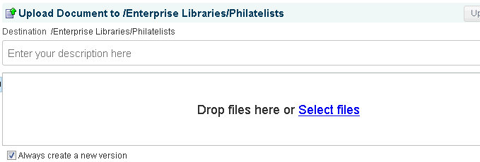

This section describes how to view a file's version history to track when a file was last revised, to determine which user revised it, and to delete a particular file version. For wiki documents and blog posts, you can also compare versions.

**Note:** To use the task pane available through Microsoft Office shared document management functionality to work with a Microsoft Word, Excel, or PowerPoint file's version history, see Section 8.16, "Viewing and Deleting File Version History."

To view or delete versions of a file:

1. Access the history by performing one of the following actions:
   * On the **Documents** page or in the Document Explorer, Document Manager, or Folder Viewer on a page, click the **View** menu, and select **Details**, or

right-click to display the file's context menu and choose **Details**.

* + In the Document Viewer preview pane, scroll to the bottom of the document and click the **History** tab (Figure 19–40).
  + In the Rich Text Editor, scroll to the bottom of the HTML document, wiki, or blog post, and click the **History** tab (Figure 19–40).

***Figure 19–40 History Pane***

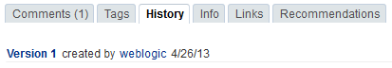

1. Select a version of the file to display a preview of that version in the preview pane.
2. To delete a particular version, select it in the History pane, then click **Delete**

(Figure 19–41).

**Note:** The **Delete** icon displays only if you have been granted delete permissions.

***Figure 19–41 Deleting a Version of a File***

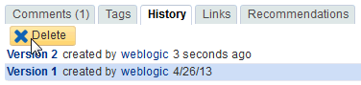

1. (For wiki documents and blog posts only) To compare a particular version with the current version of the file, select it in the History pane, then click **Compare** to open the Compare Versions dialog, showing the differences (Figure 19–42 and Figure 19–43).

***Figure 19–42 Comparing Older Version with Current Version (Wiki or Blog)***

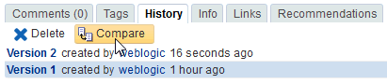

***Figure 19–43 Compare Versions Dialog (Wiki or Blog)***

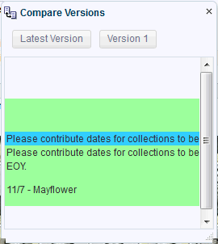

### Working with Folder and File Properties

Folder and file properties provide access to informational details. You can use file properties to perform activities such as rename a file, modify a file description, or change file metadata values.

Additionally, both folder and file properties provide read-only information about location, type, creation and modification dates, and the users who created or last modified the folder or file.

To access folder or file properties, refer to the steps in the following sections:

* + - Section 8.17.1, "Working with Folder Properties"
    - Section 8.17.2, "Working with File Properties"

#### Working with Folder Properties

To view folder properties:

* + - 1. On the **Documents** page or in the Document Explorer, Document Manager, or Folder Viewer on a page, click in the row of the folder.
      2. Click the **View** menu, and select **Details**, or right-click to display the folder's context menu and choose **Details**.

The Basic properties pane opens (Figure 19–44). Folder properties are not editable. To change the folder name, see Section 8.9, "Renaming a Folder or File."

***Figure 19–44 Folder Properties***

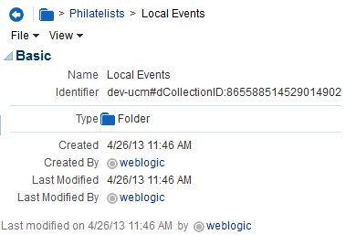

#### Working with File Properties

To view or modify file properties:

* + - 1. On the **Documents** page or in the Document Explorer, Document Manager, or Folder Viewer on a page, click in the row of the file.

Alternatively, you can view properties of an open file in the Document Viewer preview pane.

* + - 1. Depending on your view, perform one of the following actions:
         * On the **Documents** page or in the Document Explorer, Document Manager, or Folder Viewer on a page, click the **View** menu, and select **Details**, or

right-click to display the file's context menu and choose **Details**.

* + - * + In the Document Viewer preview pane:

If the file type supports an in-place preview of the file contents, scroll to the bottom of the preview and click the **Info** tab (Figure 19–45).

If the file type does not support a preview (for example, .mp3 music files, video files, or .ini files) or if you are using an Apple iOS device, the preview pane displays the file properties (see Figure 19–46) rather than a

preview of the file content.

***Figure 19–45 Document Viewer: File Properties in Tabbed Info Pane***

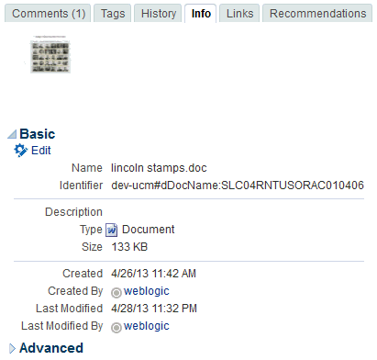

***Figure 19–46 Document Viewer: File Properties in Preview Pane***

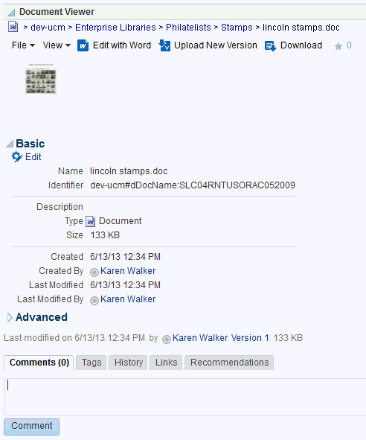

* + - 1. To modify the editable Basic properties, click **Edit** in the Basic properties area. In the Edit dialog (Figure 19–47), revise the file name and description as desired, then click **Save**.

**Note:** If WebCenter Portal is configured to use FrameworkFolders as the folder service, the following characters are not allowed in folder and file names:

? # & / \ * " | < > : ^

Letters, numbers, spaces, and periods (.) are allowed.

***Figure 19–47 Edit Dialog for Basic Properties***

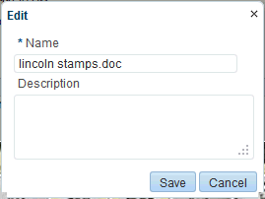

* + - 1. To modify the editable Advanced properties, click **Edit** in the Advanced properties area. In the Edit dialog (Figure 19–48), revise the property values as desired, then click **Save**.

**Note:** To enable **Edit** functionality on Advanced properties, *both* of the following two requirements must be met:

* + - * + You must access the WebCenter Portal application through Oracle HTTP Server (OHS) to expose Content Server and the WebCenter Portal application under the same host and port. For information about setting up OHS as the front-end to WebCenter Portal, see the "Configuring Content Server" section in *Administering Oracle WebCenter Portal*.
        + WebCenter Portal must be connected to a Content Server repository, with the webContextRoot parameter set to a Content Server host name. For information on setting webContextRoot, see the "Registering Content Repositories" section in *Administering Oracle WebCenter Portal*. To set webContextRoot through WLST, see "createJCRContentServerConnection" and "setJCRContentServerConnection" sections in *WebLogic Scripting Tool Command Reference*.

***Figure 19–48 Advanced Properties Edit Dialog***

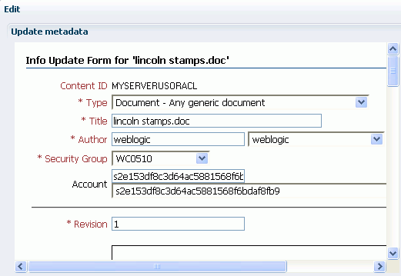

**Note:** Most advanced properties are unique to the content repository (such as Content Server) where the file is stored.

### Managing Document Links

Links provide a way to view, access, and associate related information by linking a file to a discussion, document, event, note, or URL. For example, you can create a link to associate a project plan document with a list of project issues. To create links, you must be granted the Links-Create Links permission.

**Note:** If you create a link using the **Select Resource** or **Add Resource** icons in the RTE (see Table 19–4, " Rich Text Editor Toolbar Icons and Controls on Rich Text Tab"), the resulting inline link is not added to the **Links** tab associated with the details of the linking HTML document, wiki, or blog post. If you require a link to appear on the **Links** tab, you must add it using the **Link to New** and **Link to Existing** menus on the **Links** tab, as described in the steps below, which also adds a corresponding link on the **Links** tab for the linked resource.

To work with the links for a file:

* + 1. On the **Documents** page or in the Document Explorer, Document Manager, or Folder Viewer on a page, click in the row of the file.

Alternatively, you can view the links of an open file in the Document Viewer preview pane.

* + 1. Depending on your view, perform one of the following actions:
       - On the **Documents** page or in the Document Explorer, Document Manager, or Folder Viewer on a page, click the **View** menu, and select **Details**, or

right-click to display the file's context menu and choose **Details**.

* + - * In the Document Viewer preview pane, scroll to the bottom of the document and click the **Links** tab (Figure 19–49).

***Figure 19–49 Links Pane***

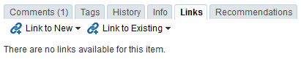

* + 1. On the **Links** tab, click **Link to New** and select the required item to create and link to discussion forum topics, events, or notes; upload and link to documents, or enter the URL of a web page to link to (Figure 19–50).

***Figure 19–50 Adding a Link to a New Discussion, Document, Event, Note, or URL***

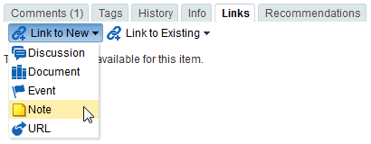

* + 1. Click **Link to Existing** and select the required item to link to an existing announcement, discussion forum topic, document, or event (Figure 19–51).

***Figure 19–51 Adding a Link to an Existing Announcement, Discussion, Document, or Event***

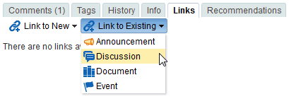

The links that you add are listed on the **Links** tab for the document, and a corresponding link to the document is listed on the **Links** tab for the linked resource.

***Figure 19–52 Link to Another Document***

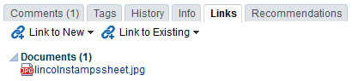

**See Also:** For more information about creating links in WebCenter Portal, see Chapter 32, "Linking Information in WebCenter Portal."

### Viewing Document Recommendations

**Note:** The Recommendations pane displays only if Activity Graph is configured. This is a system administrator task, described in the "Activity Graph Prerequisites" section in *Administering Oracle WebCenter Portal*.

The **Recommendations** pane provides suggestions of other documents you might want to view, based on the current document.

To work with the recommendations for a file:

* + 1. On the **Documents** page or in the Document Explorer, Document Manager, or Folder Viewer on a page, click in the row of the file.

Alternatively, you can view the links of an open file in the Document Viewer preview pane.

* + 1. Depending on your view, perform one of the following actions:
       - On the **Documents** page or in the Document Explorer, Document Manager, or Folder Viewer on a page, click the **View** menu, and select **Details**, or

right-click to display the file's context menu and choose **Details**.

* + - * In the Document Viewer preview pane, scroll to the bottom of the document and click the **Recommendations** tab (Figure 19–53).

***Figure 19–53 Recommendations Pane***

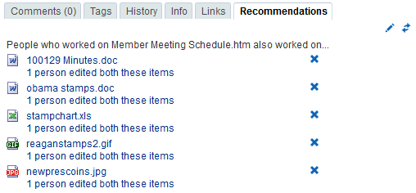

* + 1. Click the **Display Options** icon (Figure 19–54) to open the Display Options dialog (Figure 19–55), where you can select the items you want to show on the **Recommendations** tab.

***Figure 19–54 Recommendations Display Options Icon***

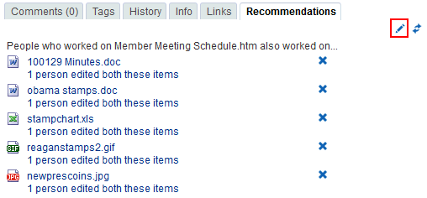

***Figure 19–55 Display Options for Recommendations***

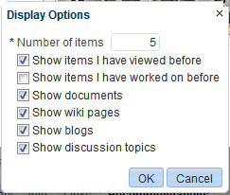

* + 1. In the Recommendations pane:
* Click the **Delete** icon to delete the associated recommendation.
* Click the link text for each recommendation to view that document.
* Click the **Refresh** icon to display the most recent recommendations.

**See Also:** For more information about working with recommendations, see Chapter 23, "Exploring Recommendations and Content."

### Openingor Saving PDFFiles

From the Document Viewer preview pane, you can open or save the PDF version of the currently open file to your local file system. This choice is available for any file type for which Content Server is configured to convert to PDF.

**Note:** To enable the conversion of wikis and blogs into PDF, your system administrator must configure the WebCenter Conversion component, as described in the "Enabling the Conversion of Wikis and Blogs into PDFs" section in *Administering Oracle WebCenter Portal*, and Oracle WebCenter Content settings for document conversion using IBR must be configured correctly.

To open or save a file in PDF:

* In the Document Viewer preview pane, click the **View** menu, and select:
  + **Open as PDF** to open the file in a new tab in your browser in Adobe Acrobat Reader's PDF Viewer plug-in.
  + **Download PDF** to open a browser dialog where you can save the file to your local file system as a PDF file.

### Sharing the URL for a Folder or File

With appropriate permissions (see Section 8.22, "Setting Security Options on a Folder or File"), users can directly access folders and files by clicking the URL, or entering it in a browser. You can retrieve and share the URL to a folder or file in several ways, as described in the following sections:

* Section 8.21.1, "Retrieving the URL for a Folder or File"
* Section 8.21.2, "Mailing the URL for a Folder or File"
* Section 8.21.3, "Publishing the URL for a File to Activity Streams"

#### Retrieving the URL for a Folder or File

Every folder and file that resides in a connected content repository can be accessed through a direct URL, which you can provide to other users. If they have permissions to access the folder or file, they can click the URL link to open the folder or file directly in a WebCenter Portal application, open the file in its default application, or save the file to their local file system.

To retrieve the URL for a folder or file:

* + - 1. Open the Get a Link dialog in any of the following ways:
         * On the **Documents** page or in the Document Explorer, Document Manager, or Folder Viewer on a page, click in the row of the folder or file, then click the **View** menu, and select **Get a Link**.
         * Right-click in the folder or file's row to display the context menu and choose

###### Get a Link.

* + - * + If you are already viewing a file in the Document Viewer preview pane, click the **View** menu, and select **Get a Link**.

The **Direct URL** provides a direct link to open the folder or file in WebCenter Portal application. For files, the **Download URL** provides a direct link to allow users to open the file in its default application, or choose to save the file to their local file system (Figure 19–56).

**Note: Download URL** is not available for folders.

***Figure 19–56 Direct and Download URLs in Get a Link Dialog***

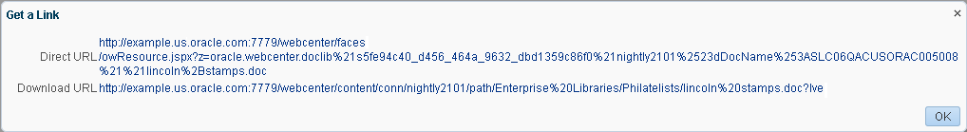

* + - 1. Drag your mouse pointer over the URL to select it, then press Ctrl-c to copy it so that you can paste it wherever you need it.

#### Mailing the URL for a Folder or File

From the Document Viewer preview pane, you can send a mail message to other users with the body of the message populated with the direct URL to the currently open folder or file. If the folder or file is in a portal, the direct URL to the portal is also included.

**Notes:**

* *When the FrameworkFolders folder service is enabled*, folders and files include parent information in their metadata. Therefore, users can access a folder or file only if they also have access to the parent folder. This means that you cannot share a folder or file from your personal document library (the **Documents** page in the Home portal) by only providing the URL, because other users do not have access to the parent folder for your personal documents. Instead, you can either copy the file to the Public folder, or share a personal file through Publisher, which stores shared items in the Public folder of your personal document library. See

Section 15.7.3, "Sharing Files Through Publisher."

* To enable others to manage the shared folder or file, you can modify the permissions, as described in Section 8.22, "Setting Security Options on a Folder or File."
* To use the task pane available through the Microsoft Office shared document management functionality to send a message to any user who has a mail address defined in WebCenter Portal, see Section 10.3.4.12, "Sending a Message."

To send the URL to folder or file in a mail message:

* + - 1. Open the folder or file in the Document Viewer preview pane in either of the following ways:
         * On the **Documents** page or in the Document Explorer, Document Manager, or Folder Viewer on a page, click in the row of the folder or file, then click the **View** menu, and select **Details**.
         * Right-click in the folder or file's row to display the context menu and choose

###### Details.

* + - 1. In Document Viewer preview pane, click the **File** menu, and select **Send Mail** to open the mail message in your default mail application.
      2. Modify the mail message as desired, and send it.

#### Publishing the URL for a File to Activity Streams

You can publish the URL for a file to the Activity Stream. Depending on whether you are sharing a personal file or a portal file, the shared file can appear in your connections' Activity Streams or in a portal's Activity Stream.

**Notes:**

* A portal's Activity Stream can be displayed in the portal, but portal members can also display a portal's activities in their own Activity Streams.
* *When the FrameworkFolders folder service is enabled*, folders and files include parent information in their metadata. Therefore, users can access a folder or file only if they also have access to the parent folder. This means that you cannot share a folder or file from your personal document library (the **Documents** page in the Home portal) by only providing the URL, because other users do not have access to the parent folder for your personal documents. Instead, you can either copy the file to the Public folder, or share a personal file through Publisher, which stores shared items in the Public folder of your personal document library. See

Section 15.7.3, "Sharing Files Through Publisher."

* To enable others to manage the shared folder or file, you can modify the permissions, as described in Section 8.22, "Setting Security Options on a Folder or File."

To share a file to Activity Streams:

* + - 1. Open the Share dialog (Figure 19–57) in any of the following ways:
         * On the **Documents** page or in the Document Explorer, Document Manager, or Folder Viewer on a page, click in the row of the file, then click the **File** menu, and select **Share**.
         * Right-click in the file's row to display the context menu and choose **Share**.
         * If you are already viewing a file in the Document Viewer preview pane, click the **File** menu, and select **Share**.

***Figure 19–57 Share Dialog***

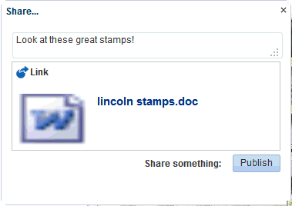

* + - 1. Optionally, enter a comment to appear with the URL.
      2. If you are sharing a personal file, select an option from the **Share with** menu.
         * Select **Everyone** to share the item with all of your connections. The shared file will appear in your connections' Activity Streams.
         * Select **Portals** to open the Select a Portal dialog (Figure 19–58) and select a portal. The shared file will appear in the selected portal's Activity Stream.

***Figure 19–58 Select a Portal Dialog***



From the **Show portals** menu:

Select **All** to show all of the portals to which you have access.

Select **Joined** to show all of the portals you have explicitly joined.

Select **Moderated** to show all of the portals for which you are a moderator.

Select **Public** to show all public portals.

Alternatively, enter the name of a portal in the **Search** field and execute the search. Results appear in the dialog.

Click a portal, and click **OK**.

* + - 1. Click **Publish**.

The URL to the file along with your comments, if any, are added to your Activity Stream and, as appropriate, your connections' Activity Streams or the portal's Activity Stream.

### Setting Security Options on a Folder or File

**Permissions:** To set security on a document in a portal, you must have Documents: Administration permission, granted by the portal manager.

For information about roles and permissions, see the "Understanding Permissions and Permission Models in a Portal" section in *Building Portals with Oracle WebCenter Portal*.

Security can set be on a folder or a file through inheritance from the parent folder, or by setting custom permissions. If set on a folder, the security is propagated to child files and folders that do not already have their own custom permissions defined. A child file or folder (at any depth) that already has custom permissions defined will retain that security definition.

**Note:** *When the FrameworkFolders folder service is enabled*:

* + - You can set security on a file, but not on a folder.
    - Folders and files include parent information in their metadata. Therefore, users can access a folder or file only if they also have access to the parent folder. This means that you cannot share a folder or file from your personal document library (the **Documents** page in the Home portal) by only changing the security options of the folder or file, because other users do not have access to the parent folder for your personal documents. Instead, you can either copy the file to the Public folder, or share a personal file through Publisher, which stores shared items in the Public folder of your personal document library. See

Section 15.7.3, "Sharing Files Through Publisher."

To set security options on a folder or file:

1. Verify that the system administrator has completed the prerequisite steps before setting security options on a folder or file, as described in the "Configuring Item

Level Security in WebCenter Portal Applications" section in *Administering Oracle WebCenter Portal*.

1. Open the Security Settings dialog (Figure 19–59) in any of the following ways:
   * On the **Documents** page or in the Document Explorer, Document Manager, or Folder Viewer on a page, click in the row of the folder or file, then click the **File** menu, and select **Security**.
   * Right-click in the folder or file's row to display the context menu and choose

###### Security.

* + If you are already viewing a file in the Document Viewer preview pane, click the **File** menu, and select **Security**.

***Figure 19–59 Security Settings Dialog***

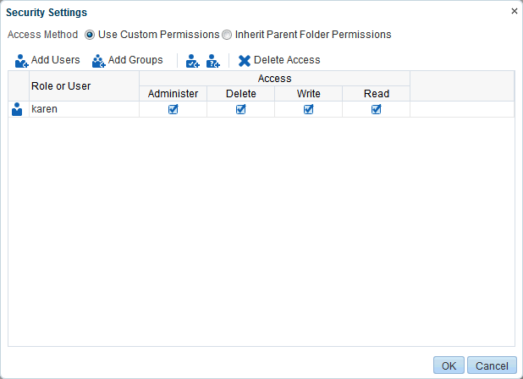

1. Select the **Access Method**:
   * To specify that the folder or file should inherit access settings from the parent folder, select **Inherit Parent Folder Permissions**, then click **OK** to save your changes and exit the dialog.
   * To set custom access on the current folder or file, select **Use Custom Permissions**, and continue with the next steps.
2. To grant access permissions to all authenticated users (that is, to users who are logged in to WebCenter Portal), click the **Add Authenticated Role for Logged in User Access** icon (Figure 19–60).

***Figure 19–60 Add Authenticated Role for Logged in User Access Icon***

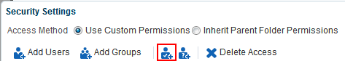

The role authenticated-role is added under **Role or User** with default **Read** access to the folder or file, and the option to grant **Administer**, **Delete**, and **Write** permissions (Figure 19–61).

***Figure 19–61 authenticated-role Default Security Settings***

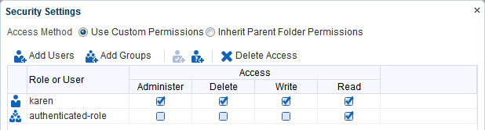

1. To grant access permissions to all public users (that is, users who have not logged in to WebCenter Portal), click the **Add Anonymous Role for Public Access** (Figure 19–62).

***Figure 19–62 Add Anonymous Role for: Access Icon***

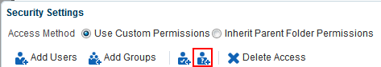

The role anonymous-role is added under **Role or User** with default **Read** access to the file (Figure 19–63).

***Figure 19–63 anonymous-role Default Security Settings***

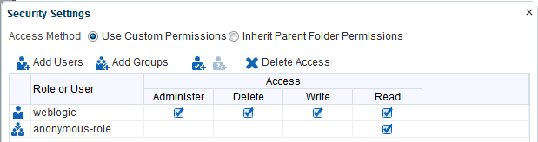

1. To grant access permissions to selected members of the portal, click **Add Users** or **Add Groups** to open the corresponding Search dialog where you can select users or groups to populate the list in the Security Settings dialog. For tips on searching for a user or group in the identity store, see the Searching for a User or Group in the Identity Store" section in *Building Portals with Oracle WebCenter Portal*.
2. For each user, group, or role, grant access by selecting one or more access privileges from the **Access** columns: **Administer**, **Delete**, **Write**, and **Read**.
3. Click **OK** to save your changes and close the Security Settings dialog.

### Subscribing toa File

To receive notifications about the activities on a file, you can subscribe to it. Whenever a user comments on, likes, updates, or deletes the file, you will be notified through your selected messaging channel.

**See Also:** For more information, see Section 10.2, "Establishing and Managing Your Messaging Channels and Filters."

To subscribe to a file:

1. On the **Documents** page or in the Document Explorer, Document Manager, or Folder Viewer on a page, click the file to open it in the Document Viewer preview pane.
2. From the **File** menu, select **Subscribe**.
3. If you no longer wish to monitor the activities on a file, click the **File** menu, and select **Unsubscribe**.

### Liking a File

For information on liking a file, see Section 15.2, "Liking Items."

### Adding a Folder or File to Your Favorites

For quick access to a folder or file (including wiki documents and blog posts), you can add it to your personal favorites.

**See Also:** For more information, see Chapter 4, "Managing Your Favorites."

To add a folder file to your personal WebCenter Portal favorites:

1. Open the folder or file in the Document Viewer preview pane in either of the following ways:
   * On the **Documents** page or in the Document Explorer, Document Manager, or Folder Viewer on a page, click in the row of the folder or file, then click the **View** menu, and select **Details**.
   * Right-click in the folder or file's row to display the context menu and choose

###### Details.

1. In Document Viewer preview pane, click the **File** menu, and select **Add To Favorites**.

### Searching for Documents

In addition to WebCenter Search, which searches a particular portal or across all portals (see Chapter 3, "Searching for Information"), Documents provides its own search engine for file searches. A Documents search saves time and increases the relevancy of results by narrowing the scope of a search to files.

In WebCenter Portal, Documents search searches within a specific portal root folder.

**Note:** When searching for content stored in the connected Content Server repository, full-text search must be enabled in Content Server through either of the following methods:

* + - OracleTextSearch (preferred), as described in the "Configuring OracleTextSearch for Content Server" section in *Installing and Configuring Oracle WebCenter Content*
    - DATABASE.FULLTEXT, as described in the "Configuring the Full-Text Features in the WebCenter Content Repository" section in *Installing and Configuring Oracle WebCenter Content*

The Oracle Secure Enterprise Search (SES) adapter does *not* need to be configured to use Documents search.

The document search feature is exposed in the Document Manager, Document Explorer, and Folder Viewer. It provides two levels of search: Basic and Advanced. To perform Basic and Advanced searches for files, refer to the following sections:

* Section 8.26.1, "Running a Basic Document Search"
* Section 8.26.2, "Running an Advanced Document Search"

#### Running a Basic Document Search

A basic document search searches the connected content repository for the specified file name. To include more search criteria, see Section 8.26.2, "Running an Advanced Document Search."

To perform a basic document search:

* + - 1. On the **Documents** page or in the Document Explorer, Document Manager, or Folder Viewer on a page, enter a full or partial file name in the **Filter** field (Figure 19–64).

**Tip:** Searching with wildcards (for example, * or %) is not supported due to its potential impact on performance.

***Figure 19–64 Filter Field***

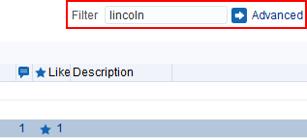

* + - 1. Press the Enter key, or click the **Search** icon.

The search results pane displays files matching the search string (Figure 19–65).

***Figure 19–65 Search Results Pane***

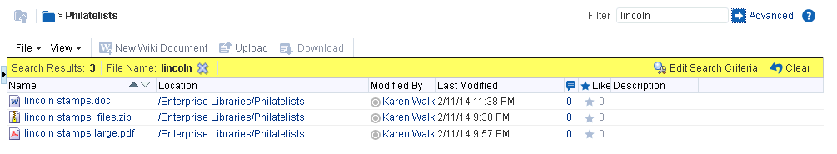

In the search results pane, the presence of the highlighted area indicates that you are looking at the results of a query, not the contents of a folder. Look in the **Location** column to determine where a file or folder is located. Alternatively, click the file name to open it from the Search Results pane.

* + - 1. In the Search Results pane:
         * Click the **Clear** action to clear the **Filter** field and return to the default folder display.
         * Click **Edit Search Criteria** action to open the Advanced Search dialog, where you can specify additional search criteria, as described in Section 8.26.2, "Running an Advanced Document Search."

#### Running an Advanced Document Search

You can specify more granular search options to search the connected content repository to generate results for a specified file name, keywords, folder, content type, dates, users, or properties that are defined for the selected content profile.

To perform an advanced document search:

* + - 1. Open the Advanced Search dialog in either of the following ways:
         * On the **Documents** page or in the Document Explorer, Document Manager, or Folder Viewer on a page, click **Advanced** next to the **Filter** field.
         * Click **Edit Search Criteria** in the highlighted toolbar area of the Search Results pane (Figure 19–65).

The **Advanced Search** dialog opens (Figure 19–66).

***Figure 19–66 Advanced Search Dialog***

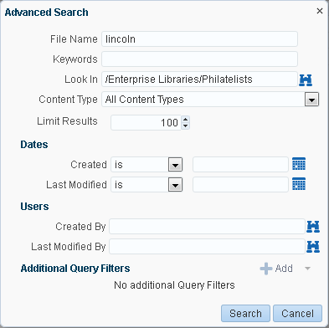

* + - 1. Enter search terms in one or more of the fields:
         * **File Name**: Enter a full or partial file name.

**Tip:** Searching with wildcards (for example, * or %) is not supported due to its potential impact on performance.

* + - * + **Keywords**: Enter words to search for in the content of the file or tags applied to the file.
        + **Look In**: Click the **Browse** icon to open a list of content repository folders, then drill down to the desired folder.
        + **Content Type**: Choose **All Content Types** to retrieve content items regardless of the content type. Or, choose from the list the name of a content type profile defined in the Content Server repository. A content type profile specifies the properties that define a specific type of content (for example, a press release, or a news flash, or an image). The content type **IDC:GlobalProfile** is the name of a default content profile defined in Content Server that can be applied if no other content profiles are defined.
        + **Limit Results**: Specify the maximum number of files to be returned by the search.
        + **Dates**: In the **Created** and/or **Last Modified** fields, select a modifier to search for files matching an exact date (**is**), a following date (**is after**), a preceding date (**is before**), or a date between two other dates (**is between**).

Selecting **is between** adds an additional date field for entering the end date (Figure 19–67). Enter a beginning date and an end date; the end date is *not* inclusive.

***Figure 19–67 Dates Search Fields***

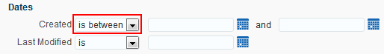

Click the **Select Date** icon to select a date in the correct format (mm/dd/yy), for example 11/18/11, or enter a date manually.

* + - * + **Users**: In the **Created By** and **Last Modified By** fields, enter a user name to search for files that the user created (uploaded) or last modified. Click the **Browse** icon to open the Search Users dialog where you can select from a list of users or search for a user name. For tips on searching for a user in the identity store, see the "Searching for a User or Group in the Identity Store" section in *Building Portals with Oracle WebCenter Portal*.

**Note:** In WebCenter Portal, when you search in a portal, the user selection list and the user search find user names for current members of the portal.

* + - * + **Additional Query Filters**: Not applicable when **Content Type** is set to **All Content Types**. For a selected content type profile (prefixed **IDC**), click the **Add** icon (Figure 19–68) to list all the properties that are defined for the selected profile. Select one or more properties to refine the query to find files with specific property settings.

***Figure 19–68 Additional Query Filters Search***

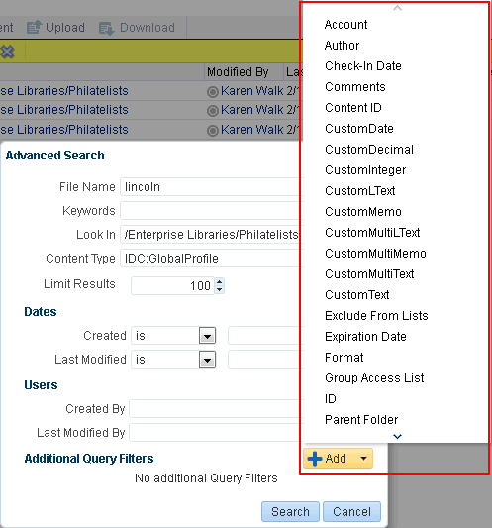

* + - 1. Click **Search** to execute the advanced search.

Files matching the search criteria display in the Search Results pane.

### Working with Workflow-Enabled Content

A workflow provides for review and approval of a file before it is released to the system. The workflow notifies approvers through mail messages when they have a file to review and approve.

If you have privileges to view the contents of a folder that is assigned a workflow, you can view the files while they are in a workflow, showing the pending changes.

To work with files in workflow, see the "Working with Workflow-Enabled Content" chapter in *Building Portals with Oracle WebCenter Portal*.

## Collaborating on Documents

This chapter describes different ways to collaborate on documents, both during the development of a document, or when a document is available to all users of a portal. This includes joint authoring, sharing, reviewing, approving, editing, and so on.

This chapter includes the following topics:

* + - Section 9.1, "Collaborating on Documents Using the Documents Page and Documents Viewers"
    - Section 9.2, "Collaborating on Documents through Workflows"
    - Section 9.3, "Collaborating on Documents Using Oracle AutoVue"

**Permissions:** To perform the tasks in this chapter, you need the portal-level permissions Customize Pages and Edit Content and Create Documents (which includes delete permissions on documents that you create), granted by the portal moderator. To delete documents that are not your own, you must have Delete Documents permission.

To set security on a document, you must have Documents: Administration permission, granted by the portal moderator.

**Note:** The **Documents** page in a portal is only shown with Content Server 11*g*. If the connected content repository is Content Server 10*g*, the **Documents** page will not be available; to use Documents functionality, you can create a page in a portal and add Documents viewers to the page.

### Collaborating on Documents Using the Documents Page and Documents Viewers

The Documents page and Documents viewers provide features for accessing, adding, and managing folders and files; configuring and viewing file and folder properties; and searching file and folder content in the connected content repositories.

The following features enable you to collaborate on documents:

* + - Viewing a document in-place. See Section 8.6.2, "Opening a File."
    - Tagging a document. See Section 8.15, "Managing Tags on Files."
    - Linking to supporting documents. See Section 8.18, "Managing Document Links."
    - Viewing recommendations for similar documents. See Section 8.19, "Viewing Document Recommendations."
    - Commenting on a document. See Section 15.4, "Commenting on Items."
    - Sharing the link to a document. See Section 8.21, "Sharing the URL for a Folder or File."
    - Subscribing to a document. See Section 8.23, "Subscribing to a File."
    - Liking a document. See Section 8.24, "Liking a File."
    - Adding a document to your list of favorites. See Section 8.25, "Adding a Folder or File to Your Favorites."
    - Adding wiki documents to WebCenter Portal, allowing multiple users to collaborate to create content that is relevant, useful, and up-to-date. See Chapter 17, "Working with Wikis."
    - Adding blogs to record experiences and opinions, and allowing multiple users to contribute through blog posts. See Chapter 18, "Working with Blogs."

### Collaborating on Documents through Workflows

While a document is being developed, it must typically be reviewed and approved by a number of people. To assist in managing this process, WebCenter Portal provides a built-in workflow capability to move a document through required approvals by assigned approvers. This capability is available when the connected content repository is Content Server.

For information about viewing and participating in document workflows, see the "Working with Workflow-Enabled Content" chapter in *Building Portals with Oracle WebCenter Portal*.

# Part V

## Getting Notified When Things Change

This chapter describes how to subscribe and unsubscribe to portals and application objects, how to specify how you are notified when they are changed, and how to manage your subscriptions.

This chapter includes the following topics:

* Section 10.1, "About Subscriptions and Notifications"
* Section 10.2, "Establishing and Managing Your Messaging Channels and Filters"
* Section 10.3, "Subscribing to the Application, to Portals, and to Objects"
* Section 10.4, "Viewing and Cancelling Your Subscriptions"

**Permissions:** The tasks described in this chapter are available to any WebCenter Portal user. However, your system administrator can enforce certain application defaults that prevent you from setting subscription and notification preferences for yourself. In such cases, you will be unable to perform some of the actions described in this chapter.

### About Subscriptions and Notifications

Subscriptions and Notifications allow you to receive timely notice of changes in WebCenter Portal—track changes that occur to your connections, your portal memberships, content in specific portals, and other application objects that are important to you. You can receive notifications through phone text, mail, or your Worklist.

Notifications provide an automated means of triggering notices across different messaging channels. Messages are triggered when the portals and application objects to which you have subscribed change.

Messaging channels can include phone text, mail, or Worklist (depending on how your system administrator has configured Notifications). For example, you can receive a mail message when a particular document changes, a text message when someone responds to a particular discussion topic, a Worklist alert when you receive an invitation to connect. All messages contain links that take you to the scene of the change.

You can select the objects that trigger a notice by subscribing to them. In WebCenter Portal, there are three levels of subscription:

* + - *Application*, which you can use to receive notices about changes to your portal memberships, Message Board, Connections, and Feedback

Such notifications occur only for application-level activities that involve you as the user.

* + - *Portal*, for changes to a subscribed feature, such as Events, Discussions, Announcements, Documents, and Blogs, that occur within the scope of a selected portal
    - *Object*, for changes to the application objects to which you have specifically subscribed, such as a particular document, wiki, blog, and so on

Table 22–1 describes the types of activities that can trigger a notification and indicates the level and location of the associated subscription (for more information, see Section 10.3, "Subscribing to the Application, to Portals, and to Objects").

**Note:** Owning an object, such as a document, wiki, or blog, does not automatically subscribe you to that object. You must explicitly subscribe to an object to receive subscription-related notifications about it, unless the system administrator has set and enforced company-wide subscription defaults. For more information about object-level subscriptions, see Section 10.3.3, "Setting Object-Level Subscriptions."

***Table 22–1 Activities that Can Trigger Notifications***

|  |  |  |
| --- | --- | --- |
| **Activity** | **Level** | **Where to Subscribe** |
| A user sends you an invitation to connect  **Note:** Out of the box, the option to send notifications for invitations to connect is enabled and is not end-user configurable. | Application | Preferences (for more information, see Section 10.3.1, "Setting  Application-Level Subscriptions") |
| Your portal role changes, for example from Participant  to Moderator | Application | Preferences |
| You are added as a member of a portal | Application | Preferences |
| Your portal membership is removed | Application | Preferences |
| A user posts a message to your Message Board | Application | Preferences |
| A user likes your Message Board post (messages explicitly set on a Message Board and not those added from Publisher to the Activity Stream) | Application | Preferences |
| A user comments on your Message Board post (messages explicitly set on a Message Board and not those added from Publisher to the Activity Stream) | Application | Preferences |
| A user posts feedback for you | Application | Preferences |
| An announcement is created | Portal | On the portal, for example, from the **Actions** menu on a portal in Browse portals (for more information, see Section 10.3.2, "Setting Portal-Level Subscriptions") |
| A new event is created | Portal | On the portal |
| An event is updated | Portal | On the portal |
| An event is deleted | Portal | On the portal |
| A new discussion topic is created | Portal | On the portal |
| A new discussion forum is created | Portal | On the portal |

***Table 22–1 (Cont.) Activities that Can Trigger Notifications***

|  |  |  |
| --- | --- | --- |
| **Activity** | **Level** | **Where to Subscribe** |
| A new document is created or uploaded | Portal | On the portal |
| A wiki document is created | Portal | On the portal |
| A new blog entry is posted | Portal | On the portal |
| A user replies to a discussion topic | Object | On the topic (for more information, see Section 10.3.3, "Setting  Object-Level Subscriptions") |
| A user comments on a discussion topic | Object | On the topic |
| A user deletes a discussion topic | Object | On the topic |
| A user comments on a document | Object | On the document |
| A user likes a document | Object | On the document |
| A user updates a document | Object | On the document |
| A user deletes a document | Object | On the document |
| A user comments on a wiki document | Object | On the wiki |
| A user likes a wiki document | Object | On the wiki |
| A user updates a wiki document | Object | On the blog entry |
| A user deletes a wiki document | Object | On the blog entry |
| A user comments on a blog entry | Object | On the blog entry |
| A user likes a blog entry | Object | On the blog entry |
| A user updates a blog entry | Object | On the blog entry |
| A user deletes a blog entry | Object | On the blog entry |

You can establish your preferred messaging channels through the **Messaging** page of your Preferences (for more information, see Section 10.2, "Establishing and Managing Your Messaging Channels and Filters"). Additionally, you can use messaging preferences to create filters for the types of notifications you want to receive.

Messaging configuration is available when your system administrator selects a BPEL server as the connection type for outbound notifications. If the system administrator selects a Mail server, the only available messaging channel is mail; consequently, you are neither required nor able to configure your own messaging channels when your system administrator selects a Mail server as the connection type for outbound notifications.

Default settings for application-level subscriptions are configurable by the system administrator. This means that your initial view of application-level Subscription Preferences is determined by these system administrator defaults. Application-level subscriptions appear on the **General Subscriptions** tab of the **Subscriptions** page in your Preferences (Figure 22–1).

***Figure 22–1 General Subscriptions Preferences***

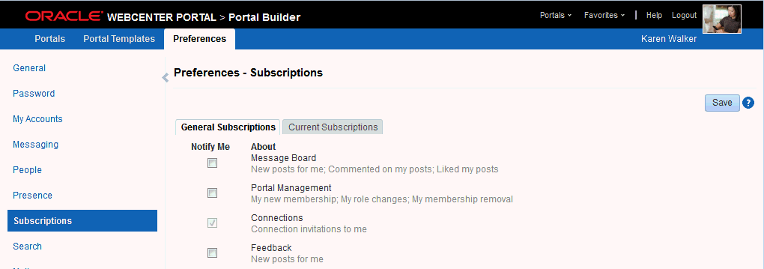

For each option on the **General Subscriptions** tab, the system administrator controls two settings:

* + - Whether the subscription is enabled for the feature
    - Whether users are allowed to change the default setting

These settings determine how and whether general subscription options appear on your view of the tab. Table 22–2 illustrates how administrator-level subscription settings affect the appearance of the **General Subscriptions** tab.

***Table 22–2 Effect of Administrator Defaults on Subscriptions Preferences***

|  |  |  |
| --- | --- | --- |
| **Subscription Enabled1** | **User Can Change Default** | **Option in Preferences** |
| True | True | Rendered normally, check box selected |
| False | True | Rendered normally, check box deselected |
| True | False | Grayed out, check box selected |
| False | False | Hidden, check box hidden |

1 Rather than enabling or disabling the entire subscription capability, the subscription-enabled attribute merely sets the initial state of the preference option. For example, if subscription-enabled="true", then the associated subscription option is selected by default in Portals Preferences. If subscription-enabled="false", then the associated subscription option is not selected by default in Preferences.

You can view and delete all of your subscriptions from one location: the **Current Subscriptions** tab on the **Subscriptions** page in Preferences (Figure 22–2).

***Figure 22–2 Current Subscriptions Preferences***

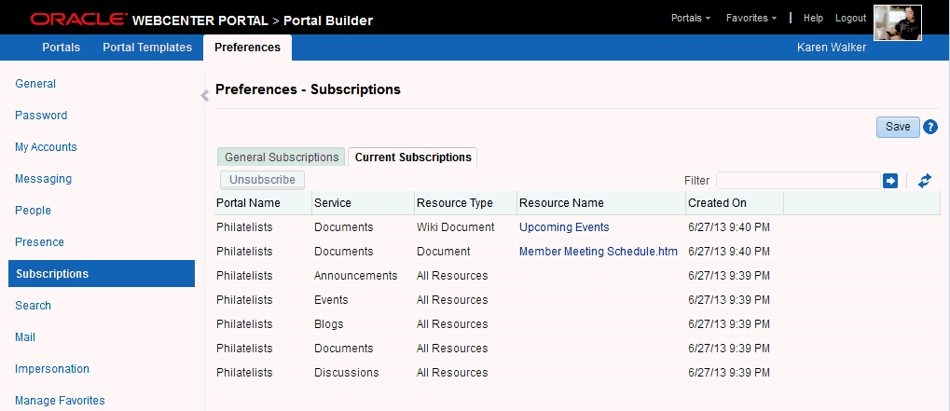

Use the **Subscriptions** page to view and manage all of your application-, portal-, and object-level subscriptions. For more information, see Section 10.4, "Viewing and Cancelling Your Subscriptions."

WebCenter Portal also provides Notifications viewers that can be added to a portal page. The Notifications viewers duplicate the features provided through Notifications preferences, with the added benefit of flexibility. That is, the Notifications viewers can be placed on any page. Additionally, the Subscription Preferences viewer changes scope according to where it is placed.

Two Notifications viewers are available:

* + - **Subscription Preferences**, which provides subscription options according to where its is placed:
      * A Subscription Preferences viewer on a Home portal page provides application-level subscription options (Figure 22–3).

***Figure 22–3 Subscription Preferences Viewer on a Home Portal Page***

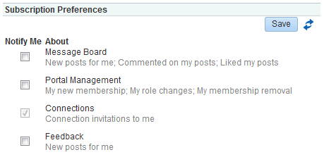

* + - * A Subscription Preferences viewer on a portal page provides portal-level subscription options (Figure 22–4).

***Figure 22–4 Subscription Preferences Viewer on a Portal Page***

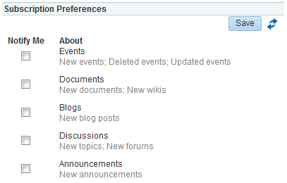

**See Also:**

* + - * + Section 10.3.1, "Setting Application-Level Subscriptions" and Section 10.4.1, "Viewing and Cancelling Application-Level Subscriptions."
        + Section 10.3.2, "Setting Portal-Level Subscriptions" and

Section 10.4.2, "Viewing and Cancelling Portal- and Object-Level Subscriptions."

* + - **Subscription Viewer**, which provides the same controls that are available on the

**Current Subscriptions** tab of the **Subscriptions** page in Preferences (Figure 22–5)

***Figure 22–5 Subscription Viewer***

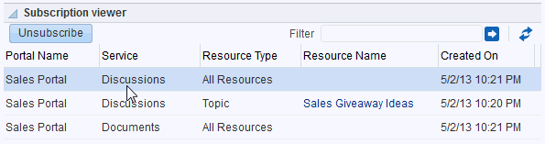

**See Also:** Section 10.4.2, "Viewing and Cancelling Portal- and Object-Level Subscriptions."

### Establishing and Managing Your Messaging Channels and Filters

Out of the box, your mail address is your default messaging channel, and, with no filters defined, a subscription is sufficient to trigger a notification, provided your system administrator has configured the external application associated with the Mail server connection to contain shared credentials and provided mail is selected as the messaging default.

After you have subscribed to an application object, no additional configuration is required to receive a notification through your mail when that object changes.

However, if you want to receive notifications over your phone, through your Worklist, or via an alternate mail address, a little configuration is required. First you must establish a messaging channel. Then you must define a messaging filter. The channel identifies the delivery medium and its associated address (user ID, mail, or phone number). The filter refines the types of notifications you receive and sets the conditions under which a notification is triggered.

This section steps you through the process of setting up your messaging channels and filters. It includes the following subsections:

* + - Section 10.2.1, "Accessing Messaging Configuration Settings"
    - Section 10.2.2, "Establishing a Messaging Channel"
    - Section 10.2.3, "Editing a Messaging Channel"
    - Section 10.2.4, "Deleting a Messaging Channel"
    - Section 10.2.5, "Creating and Applying Messaging Filters"
    - Section 10.2.6, "Editing Messaging Filters"
    - Section 10.2.7, "Deleting Messaging Filters"

#### Accessing Messaging Configuration Settings

The **Messaging** page in Preferences provides a **Manage Configuration** button for navigating to User Messaging Preferences.

To access messaging configuration settings:

* + - 1. Open the Preferences dialog, and click **Messaging** to bring the **Messaging** panel forward.
      2. Click the **Manage Configuration** button to open User Messaging Preferences login page.

**Note:** The **Manage Configuration** button is active only when a BPEL server is configured with Portal application. Because the BPEL server provides notification features, the **Manage Configuration** button may be active even when your system administrator elects to use a mail server in lieu of a BPEL server for Notifications.

* + - 1. Log in to the User Messaging Server (this is not required if single sign-on is implemented).

This opens the User Messaging Preferences panel (Figure 22–6).

***Figure 22–6 Messaging Panel in Preferences Dialog***

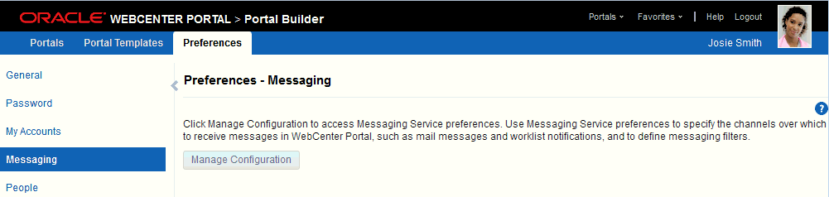

The **Messaging Channels** tab provides controls for creating and managing messaging channels and a view of all configured messaging channels, such as WORKLIST, EMAIL, and SMS. The EMAIL channel is always available. By default, it uses your email address from the LDAP identity store. If the WORKLIST driver is deployed by your system administrator, it is also automatically added for each user.

The **Messaging Filters** tab provides a means of defining the conditions under which you are notified and associating a messaging channel with a defined set of conditions.

For information about messaging configuration, see the following subsections:

* Section 10.2.2, "Establishing a Messaging Channel"
* Section 10.2.3, "Editing a Messaging Channel"
* Section 10.2.4, "Deleting a Messaging Channel"
* Section 10.2.5, "Creating and Applying Messaging Filters"
* Section 10.2.6, "Editing Messaging Filters"
* Section 10.2.7, "Deleting Messaging Filters"

**Note:** In environments where multiple BPEL connections are registered against the WebCenter Portal's Worklist component, the messaging preferences repository is shared by all. When you set messaging preferences for one connection, you set them for all.

#### Establishing a Messaging Channel

Establishing a messaging channel involves selecting the channel over which a notification is sent and providing the delivery address for that channel.

To establish a messaging channel:

* + - 1. Go to the User Messaging Preferences page as described in Section 10.2.1, "Accessing Messaging Configuration Settings."
      2. If necessary, click the **Messaging Channels** tab to bring it forward.
      3. Click the **Create** icon to open the Add Channel dialog (Figure 22–7).

***Figure 22–7 Create Icon and Add Channel Dialog***

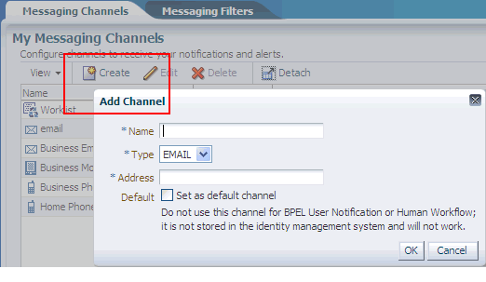

* + - 1. In the **Name** field, enter a display name for the channel. For example, enter MyPhone.
      2. From the **Type** list, select the channel over which to send notifications:

**Tip:** The presence of a channel is determined by your system administrator, who deploys them and makes them available.

* + - * + **EMAIL** to specify that notifications are sent to you through your mail
        + **SMS** to specify that notifications are sent as text messages to your phone
        + **WORKLIST** to specify that notifications are posted to your Worklist
      1. In the **Address** field, enter an address for the selected type:
         * For EMAIL, enter the address of the mail account to which to send notifications, for example, [my.name@example.com.](mailto:my.name@example.com)
         * For SMS, enter the phone number to which to send notifications in the format

<*country_code*><*area_code*><*number*>, for example, 14154444444.

* + - * + For WORKLIST, your user name is provided as a read-only value.
      1. For the **Default** check box:
         * Select to identify one or more channels as the default channel over which to send notifications.

Default channels are the channels over which are sent all notifications that do not meet any of your defined filtering conditions.

* + - * + Deselect to prevent selected channels from being used as defaults.
      1. Click **OK** to save your changes and exit the dialog.

To complete your configuration, see Section 10.2.5, "Creating and Applying Messaging Filters."

#### Editing a Messaging Channel

To revise messaging channel values:

* + - 1. Go to the User Messaging Preferences page as described in Section 10.2.1, "Accessing Messaging Configuration Settings."
      2. If necessary, click the **Messaging Channels** tab to bring it forward.
      3. Select the messaging channel you want to revise, and click the **Edit** icon to open the Modify Channel dialog.
      4. Change values as desired.
      5. Click **OK** to save your changes and exit the dialog.

#### Deletinga Messaging Channel

When you delete a messaging channel, any filters that rely on the deleted channel revert to the channel identified as the default. In the absence of a specifically identified default channel, the mail channel is used for sending notifications.

To delete a messaging channel:

* + - 1. Go to the User Messaging Preferences page as described in Section 10.2.1, "Accessing Messaging Configuration Settings."
      2. If necessary, click the **Messaging Channels** tab to bring it forward.
      3. Select the messaging channel you want to delete, and click the **Delete** icon.
      4. Click **OK** in the resulting Confirmation dialog.

#### Creating and Applying Messaging Filters

Messaging filters enable you to qualify the types of notifications you want to receive and weed out the notifications of no interest. Filters also provide a means of associating a selected messaging channel with a particular type of notification. For example, using messaging filters, you can specify that all notifications about document updates go to mail while all notifications about event changes go to your phone, provided your system administrator has configured Notifications to use multiple messaging channels.

Two important things to know about setting up messaging filters:

* Text values in your filtering conditions are case-sensitive. For example, messaging filters differentiate between *Document* and *document*.
* Create separate conditions for multiple terms. For example, for a Subject that contains *Monty gave feedback*, create three filtering conditions, one for each term.

To create and apply messaging filters:

* + - 1. Go to the User Messaging Preferences page as described in Section 10.2.1, "Accessing Messaging Configuration Settings."
      2. If necessary, click the **Messaging Filters** tab to bring it forward.
      3. Click the **Create** icon to open a filter-creation page.
      4. In the **Filter Name** field, enter a display name for the filter.
      5. Optionally, enter a filter description in the **Description** field.
      6. From the **Matching** list, select from:
         * **All of the following conditions** to require that all of the conditions you specify are met
         * **Any of the following conditions** to require that at least one of the conditions you specify is met
      7. From the first **Add Filter Condition** list, select from:
         * **Subject** to base a condition on words appearing in the message subject

It is likely that the most useful filter condition option is Subject. The subjects of notification messages are standardized and can therefore be anticipated.

This makes subjects ideal for setting up filtering conditions. See Table 22–4 for a list of standard notification message subjects and examples of filter conditions.

* + - * + **From** to base a condition on the message sender

All notification messages are sent from the same entity—as configured by your system administrator.

* + - * + **Date** to base a condition on when the message was generated

Date and Time options may be useful for ad hoc situations, for example, you want to ensure that any notifications about events delivered on the day of the event are sent right to your phone.

* + - * + **Time** to base a condition on the time the message was generated

**Note:** Of all the filter conditions available on the **Add Filter Condition** list, Subject, From, Date, and Time are the options that are relevant to and work with the types of messages generated by Notifications. The other options have no effect.

* + - 1. From the second **Add Filter Condition** list, select an operator for the condition.

**See Also:** Table 22–3 for an alphabetical list of operators that are relevant to the attributes Subject, From, Date, and Time.

* + - 1. Click the **Click to add new filter condition** icon.
      2. From the **Messaging Option** list, select from:
         * **Send No Messages** to omit notification for the defined filter conditions
         * **Send Messages to all Selected Channels** to send notification through all channels selected from the **Add Notification Channel** list
         * **Send to the First Available Channel** to send notification through the first open channel of all the selected channels
      3. From the **Add Notification Channel** list, select the channel over which to send the notification messages that meet your defined filter conditions, and then click the **Click to add channel to this filter** icon.

The **Add Notification Channel** list is populated with the channels that are defined on the **Messaging Channels** tab. You can add multiple channels in turn.

* + - 1. Click **OK** to save and apply the messaging filter.

**Tip:** If your defined filtering conditions do not match an incoming notification, the User Messaging Server will send notifications over all the channels you have identified as default channels.

Table 22–3 provides an alphabetical list of operators that are relevant to the attributes

Subject, From, Date, and Time and describes the values they require.

***Table 22–3 Operators relevant to Subject, From, Date, and Time***

**Operator Value1**

Between In the fields provided:

* + - * + For Date, enter a start date and end date between which to apply the filter
        + For Time, select a start time (hours and minutes)

**Attributes**

Date, Time

|  |  |  |
| --- | --- | --- |
|  | and end time between which to apply the filter |  |
| Contains | Enter a string that must be included in the message Subject or return address (From) | Subject, From |
|  | Separate multiple values with commas. |  |
| isEqual | Enter the literal value that must be used for the message Subject, Date, Time, or return address (From) | Subject, From, Date, Time |
| isGreaterThan | Enter the message delivery date beyond which to apply the filter | Date |
| isGreaterThanOrEqual | Enter the message delivery date on which to start applying the filter | Date |
| isLessThan | Enter the message delivery date before which to start applying the filter | Date |
| isLessThanOrEqual | Enter the message delivery date on which to stop applying the filter | Date |
| isNotEqual | Enter a literal value that must be ignored for the message Subject, Date, Time, or return address (From) | Subject, From, Date, Time |
| isWeekday | No value is required. This operator applies to messages sent on weekdays. | Date |
| isWeekend | No value is required. This operator applies to messages sent on weekends. | Date |
| NotContains | Enter a string that must be excluded from the message Subject or return address (From). | Subject, From |
|  | Separate multiple values with commas. |  |

1 String values are case sensitive. Multiple values in strings must be separated by a comma.

Table 22–4 provides a list of standard notification message subjects and examples of condition formulations.

**Tip:** Messaging filters are case-sensitive. For example, they differentiate between *Document* and *document*.

You must create a separate condition for each term. For example, when you filter for *Monty gave feedback*, create three conditions—one for each term.

***Table 22–4 Standard Notification Message Subjects***

|  |  |
| --- | --- |
| **Standardized Notification Subject** | **Example Filter Conditions** |
| *userName* has invited you to become a connection | * Subject Contains connection * Subject Contains Monty   You can set the condition action to route or ignore all messages concerning a named user for any subject that includes a user name. |
| *userName* posted message on your message board | * Subject Contains message * Subject Contains board |
| *userName* commented on your message board posting | Subject Contains commented |
| *userName* likes on your message board posting | Subject Contains likes |
| *userName* gave feedback to you | * Subject Contains gave * Subject Contains feedback |
| Portal Membership Change | Subject isEqual Portal Membership Change |
| *userName* created the *documentType documentName*  **Note:** For documentType, either Document or Wiki Document is returned. This means that all file types, except wikis, are identified in the subject as Document. | * Subject Contains Document * Subject Contains Wiki * Subject Contains java.txt * Subject Contains Monty |
| *userName* changed the *documentType documentName* | * Subject Contains changed * Subject Contains myFile.docx |
| *userName* deleted the *documentType documentName* | * Subject Contains deleted * Subject Contains document * Subject isNotEqual java.txt |
| *userName* posted a comment on the *documentType documentName* | * Subject Contains Monty * Subject Contains comment * Subject Contains movingforward.docx |
| *userName* likes the *documentType documentName* | * Subject Contains likes * Subject Contains movingforward.docx |
| *userName* created the blog post *blogName* | * Subject Contains kirk * Subject Contains tribbles |
| *userName* changed the blog post *blogName* | Subject NotContains tribbles |
| *userName* deleted the blog post *blogName* | * Subject Contains deleted * Subject Contains blog |
| *userName* posted a comment on the blog post *blogName* | * Subject Contains comment * Subject Contains blog |
| *userName* likes the blog post *blogName* | * Subject Contains like * Subject Contains blog |
| *userName* created the forum *forumName* | * Subject Contains Monty * Subject Contains created * Subject Contains forum |

***Table 22–4 (Cont.) Standard Notification Message Subjects***

|  |  |
| --- | --- |
| **Standardized Notification Subject** | **Example Filter Conditions** |
| *userName* created the discussion topic *topicName* | * Subject Contains Monty * Subject Contains topic   This example affects both *created* and *deleted* topics. Consider adding the verb, for example, *created* or *deleted*, in the filter condition when you want to make a distinction between the two types of actions.  Note, however, that the verb alone is not likely to have the effect you want. For example, if you set the filter condition, Subject Contains deleted, messages for all types of objects upon which a delete action is performed are handled by the filter. |
| *userName* replied to the discussion topic *topicName* | * Subject Contains replied * Subject Contains topic * Subject Contains NewTech |
| *userName* deleted the discussion topic *topicName* | * Subject Contains deleted * Subject Contains topic |
| *userName* posted a comment on the discussion topic  *topicName* | * Subject Contains comment * Subject Contains topic * Subject Contains NewTech |
| *userName* likes the discussion topic *topicName* | * Subject Contains likes * Subject Contains NewTech |
| *userName* created the event *eventName* | * Subject Contains Java * Subject Contains Summit |
| *userName* changed the event *eventName* | * Subject Contains Java * Subject Contains Summit * Subject Contains changed |
| *userName* deleted the event *eventName* | * Date isEqual 5/31/10 * Subject Contains event * Subject Contains Java * Subject Contains Summit   On the day of the event, all notifications concerning the Java Summit event are routed to a selected channel. You can omit the term *event*, and receive other related notifications, such as an announcement concerning Java Summit. |
| *userName* created the announcement *announcementName* | * Subject Contains created * Subject Contains announcement |
| *userName* changed the announcement  *announcementName* | * Subject Contains Monty * Subject Contains announcement |
| *userName* deleted the announcement *announcementName* | * Subject Contains announcement * Subject Contains myPortal |

#### Editing Messaging Filters

To edit a messaging filter:

* + - 1. Go to the User Messaging Preferences page as described in Section 10.2.1, "Accessing Messaging Configuration Settings."
      2. If necessary, click the **Messaging Filters** tab to bring it forward.
      3. Select the filter condition to edit, and click the **Edit** icon.
      4. Make your changes.
      5. Click **OK** to save and apply your changes.

#### Deleting Messaging Filters

To delete a messaging filter:

* + - 1. Go to the User Messaging Preferences page as described in Section 10.2.1, "Accessing Messaging Configuration Settings."
      2. If necessary, click the **Messaging Filters** tab to bring it forward.
      3. Select the filter condition to delete, and click the **Delete** icon.
      4. Click **OK** in the resulting Confirmation dialog.

**Note:** You can remove a filtering condition without deleting the entire filter. Follow the steps in Section 10.2.6, "Editing Messaging Filters," and click the **Delete** icon next to the condition to remove.

### Subscribing tothe Application, to Portals, and to Objects

Where you perform a subscription varies according to the level at which the subscription is applied as well as the type of object being subscribed to. For example:

* + - Application-level subscriptions are made through your personal preferences.
    - Portal-level subscriptions are made on the portal's right-click menu on the **Portals**

page.

* + - Object-level subscriptions are made on the object itself.

This section steps you through these subscription scenarios. It includes the following subsections:

* + - Section 10.3.1, "Setting Application-Level Subscriptions"
    - Section 10.3.2, "Setting Portal-Level Subscriptions"
    - Section 10.3.3, "Setting Object-Level Subscriptions"

#### Setting Application-Level Subscriptions

Set application-level subscriptions on the **Subscriptions** panel in the Preferences dialog (Figure 22–8).

***Figure 22–8 General Subscriptions Preferences***



You can use subscription preferences to specify whether to receive notifications from People Connections for activities related to Connections, Feedback, and Message Board. Additionally, you can use subscriptions preferences to subscribe to portal management activities, such as changes to any of your portal memberships or roles.

Application-level subscriptions are affected by the defaults set by your system administrator. In your view of Preferences, some subscription options may appear but be unavailable, while others may be hidden completely. For more information, see Section 10.1, "About Subscriptions and Notifications."

To set application-level subscriptions:

* + - 1. Click **Preferences**, click **Subscriptions** to open the **Subscriptions** page, and, if necessary, click the **General Subscriptions** tab to bring it forward.
      2. Select the check box next to an option for which to receive notifications through mail or other selected channels.

**See Also:** Section 10.2, "Establishing and Managing Your Messaging Channels and Filters."

Select from:

* + - * + **Message Board** to receive notification when other users post messages to your Message Board, like your posts, and comment on your posts
        + **Portal Management** to receive notification when you are added or removed as a member or your role changes
        + **Connections** to receive notification when another user invites you to connect
        + **Feedback** to receive notification when other users leave feedback for you Deselect the check box next to the options for which to omit notifications.
      1. Click **Save** to apply your changes.

**See Also:** Section 10.4.1, "Viewing and Cancelling Application-Level Subscriptions."

#### Setting Portal-Level Subscriptions

You can use portal-level subscriptions to trigger notification messages whenever any of the following actions occur within the scope of the subscribed portal:

* An announcement is created
* An event is created, updated, or deleted
* A discussion forum or topic is created
* A document is created or uploaded
* A wiki document is created
* A blog entry is posted To subscribe to a portal:
  + - 1. Open the Subscribe dialog in either of the following ways:
         * From the **Portals** menu, select **Browse Portals** to display the **Portals** page in the Home portal. Locate the portal to which you want to subscribe, then right-click the portal icon or name, and select **Contact**, then **Subscribe** (Figure 22–9).

***Figure 22–9 Subscribe Options in Portal Actions Menu: Portal Browser***



* + - * + When viewing a portal, click the **Actions** menu, and select **Contact**, then

###### Subscribe.

***Figure 22–10 Subscribe Option in Portal Actions Menu: Viewing Portal***



**Note:** The location of the **Actions** menu is dependent on the page template in use. For example, it may be an icon in the menu bar in a top navigation template.

* + - 1. In the Subscribe dialog, select one or more of the following options:

**Note:** An option appears in this dialog only when the associated feature has been provided in the portal. For example, if the portal moderator has not enabled discussions in the portal, the **Discussions** option does not appear in this dialog.

* + - * + **Events**, to receive notice whenever an event is created, updated, or deleted in this portal
        + **Documents**, to receive notice whenever a document is created or uploaded in this portal

**Tip:** To see a more detailed level of notifications regarding a specific document, such as when it is updated, subscribe to the document at the object level. For more information, see Section 10.3.3.1, "Subscribing to a File, Wiki, or Blog Entry."

* + - * + **Blogs**, to receive notice whenever a blog entry is posted in this portal

**Tip:** To see a more detailed level of notifications regarding a specific blog entry, such as when it is edited, liked, or commented on, subscribe to the blog entry at the object level. For more information, see Section 10.3.3.1, "Subscribing to a File, Wiki, or Blog Entry."

* + - * + **Discussions**, to receive notice whenever a discussion topic is created in this portal

**Tip:** To see a more detailed level of notifications regarding a specific discussion topic, such as when it is edited, liked, or commented on, subscribe to the topic at the object level. For more information, see Section 10.3.3.2, "Subscribing to a Discussion Topic."

* + - * + **Announcements**, to receive notice whenever an announcement is created in this portal
      1. Click **Save** to save your settings and exit the dialog.

After you have subscribed to a portal, the subscription is reflected on the **Current Subscriptions** tab on the **Subscriptions** page of Preferences. From that tab you can view all of your portal- and object-level subscriptions. For more information, see Section 10.4.2, "Viewing and Cancelling Portal- and Object-Level Subscriptions."

#### Setting Object-Level Subscriptions

You can use object-level subscriptions to trigger notification messages for actions performed on a selected document, wiki, blog entry, or discussion topic. This section describes how to subscribe to each. It includes the following subsections:

* Section 10.3.3.1, "Subscribing to a File, Wiki, or Blog Entry"
* Section 10.3.3.2, "Subscribing to a Discussion Topic"

##### Subscribing to a File, Wiki, or Blog Entry

When you subscribe to a file, wiki, or blog entry, you are notified through your selected messaging channel whenever a user takes action on the object. Depending on the object, you are notified upon different actions:

* For files, you are notified when a user revises or deletes the file, or likes or comments on it.
* For wikis, you are notified when a user performs a major edit on, deletes, likes, or comments on the selected wiki.

**Tip:** Users can identify a wiki document edit as major, in which case notification is sent. If the edit is not marked as major, no notification is sent.

* For blog entries, you are notified when a user edits, likes, comments on, or deletes the selected blog entry

**See Also:** Section 10.2, "Establishing and Managing Your Messaging Channels and Filters."

To subscribe to a file, wiki, or blog entry:

1. Open the file, wiki, or blog entry.
2. From the **File** menu, select **Subscribe**.

**See Also:** Section 10.4.2, "Viewing and Cancelling Portal- and Object-Level Subscriptions."

##### Subscribing to a Discussion Topic

When you subscribe to a discussion topic, you are notified through your selected messaging channel whenever a user, edits, deletes, likes, or comments on the selected discussion topic.

**See Also:** Section 10.2, "Establishing and Managing Your Messaging Channels and Filters."

To subscribe to a discussion topic:

1. Go to the discussion topic you want to subscribe to.
2. Click the **Subscribe** link at the top of the topic (Figure 22–11).

***Figure 22–11 Subscribe Link on a Discussion Topic***

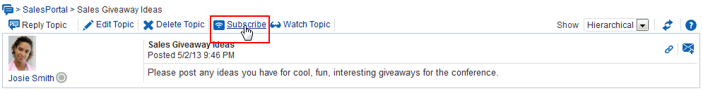

**See Also:** Section 10.4.2, "Viewing and Cancelling Portal- and Object-Level Subscriptions."

### Viewing and Cancelling Your Subscriptions

Where you view and cancel your current subscriptions depends on the level of the subscription:

* + - In addition to making application-level subscriptions, you can view and cancel application-level subscriptions on the **General Subscriptions** tab on the **Subscriptions** page in Preferences.
    - View and cancel portal- and object-level subscriptions on the **Current Subscriptions** tab on the **Subscriptions** page in Preferences.

**Tip:** The settings available on the **Current Subscriptions** tab are also provided through the Subscriptions Viewer. For more information, see Section 10.1, "About Subscriptions and Notifications."

This section provides information about how to view and cancel your application-level subscriptions and how to view and cancel your portal- and object-level subscriptions. It includes the following subsections:

* + - Section 10.4.1, "Viewing and Cancelling Application-Level Subscriptions"
    - Section 10.4.2, "Viewing and Cancelling Portal- and Object-Level Subscriptions"

#### Viewing and Cancelling Application-Level Subscriptions

View and cancel application-level subscriptions through Preferences or through the Subscription Preferences viewer (for more information, see Section 10.1, "About Subscriptions and Notifications").

To view or cancel application-level subscriptions:

* + - 1. Click **Preferences**, click **Subscriptions** to open the **Subscriptions** page, and, if necessary, click the **General Subscriptions** tab to bring it forward.

Here you can readily view and change your current application-level subscriptions.

* + - 1. To cancel a subscription, deselect its check box.

#### Viewing and Cancelling Portal- and Object-Level Subscriptions

Both portal- and object-level subscriptions are listed in Preferences on the **Subscriptions** page. Use the controls on the **Current Subscriptions** tab to adjust your view of these subscriptions and to cancel (or unsubscribe from) a portal- or object-level subscription.

**Tip:** Portal- and object-level subscriptions can be cancelled through the same action you took to create the subscription. At the portal- and object-levels, subscription options toggle between subscribed and unsubscribed. Follow the steps outlined in Section 10.3.2, "Setting Portal-Level Subscriptions" and Section 10.3.3, "Setting Object-Level Subscriptions," but select to unsubscribe instead.

**Tip:** The settings available on the **Current Subscriptions** tab are also provided in the Subscriptions Viewer. For more information, see Section 10.1, "About Subscriptions and Notifications."

To view and cancel portal- and object-level subscriptions:

* + - 1. Click **Preferences**, then click **Subscriptions** to open the **Subscriptions** page, and, if necessary, click the **Current Subscriptions** tab to bring it forward.
      2. Use the **View** menu to control the display order of columns and to hide or show individual columns.
      3. To cancel or unsubscribe from a portal- or object-level subscription, select the subscription, and click **Unsubscribe**.
      4. In the resulting Unsubscribe Notification Subscription dialog, click **Unsubscribe**. The selected subscription no longer appears on the list of subscriptions.
      5. Click **Save** to save your changes.

## Tracking Portal Activities

This chapter describes how to work with Activity Stream and Recent Activities to track and report on activities in WebCenter Portal. Tracking and reporting assist you in keeping up with the latest portal activities.

This chapter includes the following topics:

* Section 11.1, "Comparison of Activity Stream and Recent Activities"
* Section 11.2, "About the Activity Stream"
* Section 11.3, "Setting Activity Stream Preferences"
* Section 11.4, "Working with the Activity Stream"
* Section 11.5, "About Recent Activities"
* Section 11.6, "Working with Recent Activities"

**Permissions:** To perform the tasks in this chapter, you need the application-level permission People Connections: Update People Connections Data.

### Comparison of Activity Stream and Recent Activities

Activity Stream and Recent Activities both track and report on activities in WebCenter Portal, enabling you to easily keep up with what is going on. However, there are two main differences between them. First, Activity Stream tracks a broader range of activities. For example, Recent Activities tracks the Documents (including wikis and blogs), Announcements, Discussions, and Page activities. Activity Stream tracks these activities as well as People Connections. Second, Recent Activities reports activities regardless of who performs the action. Activity Stream reports activities performed by a user's connections. There is a third, small difference—Activity Stream includes information about who performed the activity, whereas Recent Activities does not.

### About the Activity Stream

In WebCenter Portal, Activity Stream provides a streaming view of the activities of your connections, actions taken in portals, and business activities. For example, Activity Stream can note when you or a connection posts feedback, uploads a document, or creates a discussion forum. Additionally, it streams messages and attachments entered through Publisher.

**See Also:** For information about Publisher, see Chapter 15, "Liking, Commenting On, and Sharing Items in WebCenter Portal."

Through Activity Stream Preferences, you can select to show connection and portal activities. (However, your system administrator can disable users from overriding application-level settings.)

In addition to streaming messages, your Activity Stream can provide access to file attachments and web links added through Publisher. Supported mime types can be fully previewed in the Activity Stream. Unsupported mime types are rendered as links, which you can use to access the file.

Activity Stream previews files through either a native web format or through Oracle WebCenter Content slide rendition. The previewer used depends on the mime type of the file to be previewed.

The mime types that use the native web format include the following:

* + - image
    - htm
    - text

The mime types that use Oracle WebCenter Content slide rendition include the following:

* + - pdf
    - powerpoint
    - powerpnt
    - pptx

**Note:** PDF file previews are available only if your system administrator configured WebCenter Portal to preview PDFs.

The mime types shown in the previous lists are the only mime types that are previewed. Other mime types appear as links. The mime types docx and xlsx are *not* previewed in Activity Stream. Your administer can configure Activity Stream to omit file previews.

Users can share a streamed activity and its attachments using a **Share** feature, available on each streamed item.

**See Also:** For information about sharing, see Section 11.4.7, "Sharing Files and other Objects Through an Activity Stream Item."

Table 24–1 lists and describes the types of activities that are reported through Activity Stream.

**Note:** Delete activities do not appear *per se* in the Activity Stream, but references to objects, such as *Joe Smith created the document file.xml*, are removed from the stream when such objects are deleted.

***Table 24–1 Activities Tracked by Activity Stream***

|  |  |  |  |
| --- | --- | --- | --- |
| **Tools/Service** | **Tracked Activities** | **Scope** | **Activities Shared or Private** |
| Announcements | * Create announcement * Edit announcement | * portal | * Shared with other portal members |
| Blogs | * Create blog * Update blog | * portal * Home portal | * Activities on portal blogs are shared with other portal members. * Activities on Home portal blogs are shared with the blogger's connections. |
| Connections | * Invite to connect * Connection invite accepted | * Home portal | * Shared with invitor and invitee's connections |
| Discussions | * Create forum * Create topic * Reply to topic | * portal | * Shared with other portal members |
| Documents | * Create document * Edit document * Add tag * Remove tag | * portal * Home portal | * Activities on portal documents are shared with other portal members. * Activities on Home portal documents are private to user. |
| Feedback | * Leave feedback * Receive feedback | * Home portal | * Shared with whomever is permitted to view such activities (for more information, see this section and Section 14.1, "About Feedback." |
| Lists | * Create a list | * portal | * Shared with other portal members |
| Message Board | * Leave message * Receive message | * Home portal | * Shared with whomever is permitted to view such activities (for more information, see this section and Section 14.7, "Setting Message Preferences." |
| Pages | * Create page * Edit page * Add tag * Remove tag | * portal * Home portal | * Activities on portal pages are shared with other portal members. * Activities on Home portal pages are private to user. |
| Profiles | * Update photo * Update profile * Update personal status | * Home portal | * Shared with whomever is permitted to view such activities (for more information, see this section and Section 6.4, "Setting Profile Preferences." |

***Table 24–1 (Cont.) Activities Tracked by Activity Stream***

|  |  |  |  |
| --- | --- | --- | --- |
| **Tools/Service** | **Tracked Activities** | **Scope** | **Activities Shared or Private** |
| Portal Events | * Create an event * Edit an Event | * portal | * Shared with other portal members |
| Portals Management | * Create portal * Change portal membership * Join portal * Post comment * Like item * Update portal configuration * Enable portal tool or service * Disable portal tool or service * Change custom portal attribute * Change portal role permissions * Change portal role assignment | * portal | * Shared with other portal members |
| Tagging | * Add tag * Remove tag | * portal * Home portal | * Activities in a portal are shared with all portal members. * Activities in a Home portal are shared with whomever is permitted to view such activities (for more information, see Section 11.3, "Setting Activity Stream Preferences"). |

Use Activity Stream Preferences to specify who can view your Activity Stream and the types of activities to show. For more information about Preferences relating to Activity Stream, see Section 11.3, "Setting Activity Stream Preferences."

Your system administrator can hide or show various controls on Activity Stream viewers and limit the types of activities and the specific portals that are tracked.

WebCenter Portal provides the following Activity Stream viewers:

* + - **Activity Stream** for viewing application activities and the activities of your connections and for providing access to the attachments added through the **Share** link (Figure 24–1)

***Figure 24–1 Activity Stream Viewer***

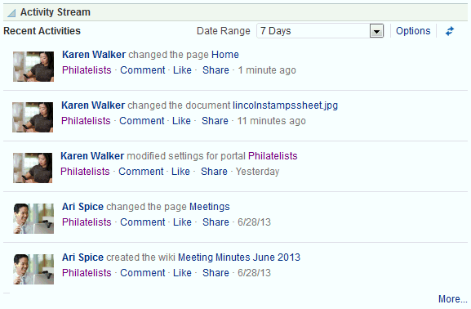

This full view of Activity Stream functionality includes options for liking and commenting on listed activities and for sharing different types of objects, such as images, URLs, documents, and the like. Activity Stream also provides a means of hiding the activities and posts of a given user. You can use Activity Stream Options to show those users you have hidden.

The **Activities** page in the Home portal combines an instance of Publisher with the Activity Stream viewer.

**See Also:** For information about Publisher, see Section 15.7.1, "About Publisher."

* + - **Activity Stream - Quick View** provides a summary view of application activities and the activities of your connections (Figure 24–2).

***Figure 24–2 Activity Stream - Quick View***

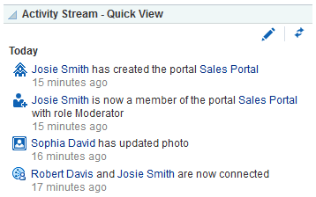

Unlike the full view of Activity Stream, Activity Stream - Quick View does not display **Like**, **Comment**, and **Share** links. The Activity Stream - Quick View also combines similar activities into one entry. For example, if a user posts two documents, you see one entry that lists both documents; if a user posts two messages, you see one entry that says the user "posted messages," but only the most recent message is shown.

A hierarchy of configuration settings control what you can do with your view of the Activity Stream. Your system administrator sets application-wide values on the **Administration** page. You can set your own personal values through People Connections Preferences. Your system administrator can set values on a given viewer instance, which affect all users' views of the viewer instance (application customization). You can set values on a given viewer instance, which affect only your view of the Activity Stream viewer (user customization).

**Tip:** If you adjust a setting through Preferences that does not seem to affect the behavior of a viewer as you expected, it might be because settings on the viewer instance override Preferences settings.

The Activity Stream viewer provides an **Options** link for accessing configuration settings for a given instance (Figure 24–3).

***Figure 24–3 Options Link for Activity Stream Options***

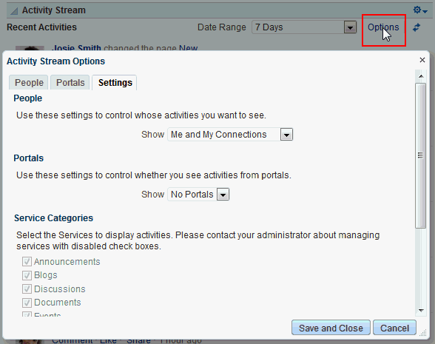

The Activity Stream - Quick View provides access to its own configuration settings through a pencil icon (**Change the source, filter, and display options**) (Figure 24–4).

***Figure 24–4 Pencil Icon and Resulting Configure Dialog***

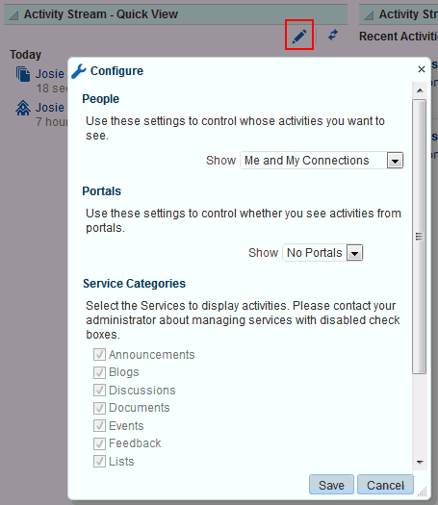

Use these controls to adjust an individual viewer instance with the same kinds of settings that are provided for all of your views of Activity Stream through Activity Stream Preferences (for more information, see Section 11.3, "Setting Activity Stream Preferences" and Section 11.4, "Working with the Activity Stream").

Clicking an object in Activity Stream opens the object. For example, clicking the name of a newly created document in Activity Stream opens the document (see

Section 8.6.2, "Opening a File" for more information about file preview in the Document Viewer). Clicking a user name in an Activity Stream opens a user profile pop-up. Clicking an attachment, such as a file or a URL, navigates you to that attachment.

**See Also:** You can attach an object to a message streamed from Publisher to the Activity Stream. For more information, see Chapter 15, "Liking, Commenting On, and Sharing Items in WebCenter Portal."

### Setting Activity StreamPreferences

Use Activity Stream Preferences to specify who can view your Activity Stream; the users, categories, and portals for which to track activities; and the activities to show in an Activity Stream view.

**See Also:** For information about the types of activities that Activity Stream tracks, see Table 24–1, " Activities Tracked by Activity Stream".

To set Activity Stream preferences:

1. Click **Preferences**.
2. Click **People** to display People Connections preferences.
3. If necessary, click the **Activity Stream** tab to bring it forward (Figure 24–5).

***Figure 24–5 Activity Stream Preferences***

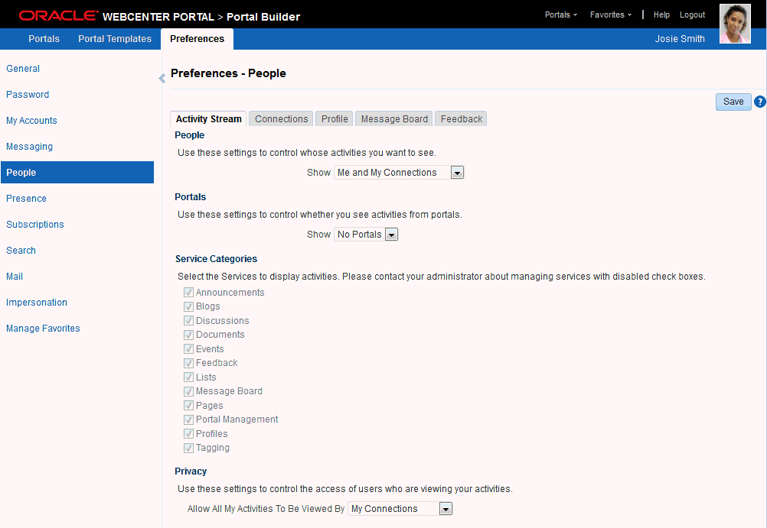

1. Under **People**, specify whose activities to show in your view of the Activity Stream:

**Tip:** This setting relates only to the activities that stream from People Connections. Such activities include making connections, posting Feedback and Messages, adjusting your Profile, and so on.

From the Show list, select one of the following options:

* + **Only Me**—Show only your own activities in your view of the Activity Stream.
  + **Me and My Connections**—Show only your activities and the activities of your connections in your view of the Activity Stream.
  + **No Personal**—Do not show any user activities in your view of the Activity Stream, including your own.
  + **Selected Connection Lists**—Show the activities of only those users on the selected connections lists in your view of the Activity Stream.

When you select this option, all available connections lists appear below it. Select one or more connections lists to limit the display of activities to the users on those lists.

**Note:** Use this option only after you have created one or more connections lists (for more information, see Section 11.7, "Creating and Managing Groups of Contacts").

1. Under **Portals**, select to show activities from:
   * **All Portals**—Stream activities from all available portals.

**Note:** When **All Portals** and **Selected Connection Lists** (from step 4) are selected, the activity stream shows the selected users personal activities and the activities in the portals of which the selected users are members. For example, the activity stream displays an entry when the user creates a portal (personal activity) and displays an entry when an announcement or document is created in a portal of which the user is a member (portal activity).

* + **My Portals**—Stream activities from the portals of which you are a member.
  + **No Portals**—Do not stream any activities from portals other the Home portal.

1. Under **Service Categories**, select the category for which to track activities.

Select a check box to track the activity of a particular category; deselect a check box to ignore the activity of a particular category.

**Tip:** Selecting **No Portals** in the previous step affects the outcome of your category selection: despite their selection here, categories publish no activities to your view of the Activity Stream.

1. Under **Privacy**, identify the types of users who can see your view of the Activity Stream:
   * **Everyone**—All users, whether they are logged in, can see your view of the Activity Stream.
   * **Authenticated Users**—All users who are logged in can see your view of the Activity Stream.
   * **My Connections**—The people to whom you are connected can see your view of the Activity Stream.
   * **Myself**—Only you can see your view of the Activity Stream.
2. Click **Save** to save your changes.

### Working withthe Activity Stream

You can perform user customizations on an Activity Stream viewer that affect only your view of the viewer. Activity Stream viewers provide user customization controls for determining whose activities and what activities are streamed.

Your system administrator can perform application customizations on an Activity Steam viewer that affect everyone's view of the viewer. For example, Activity Stream your system administrator can enable or disable the display of links for liking, sharing, and commenting on individual Activity Stream items. Therefore, some of the actions described in this section might not be available, depending on such customizations.

This section provides information about controlling whose activities and what activities are shown in a given viewer instance, as well as how to like and comment on a streamed item, and how to share a file or URL with other users through the Activity Stream.

This section includes the following subsections:

* + - Section 11.4.1, "Selecting the People to Stream in an Activity Stream Instance"
    - Section 11.4.2, "Selecting the Portals to Stream in an Activity Stream Viewer"
    - Section 11.4.3, "Selecting the Categories to Stream in an Activity Stream Viewer"
    - Section 11.4.4, "Hiding and Showing the Activities of a Selected User"
    - Section 11.4.5, "Hiding and Showing the Activities of a Selected Portal"
    - Section 11.4.6, "Liking and Commenting On Activity Stream Items"
    - Section 11.4.7, "Sharing Files and other Objects Through an Activity Stream Item"

#### Selecting the People to Streamin an Activity StreamInstance

Use the **Options** link in an Activity Stream viewer to specify the people from whom to stream activities in your view of the Activity Stream. Use the pencil icon in an Activity Stream - Quick View to perform the same operation.

To select the people from whom to stream activities in your view of an Activity Stream viewer:

* + - 1. Go to an Activity Stream viewer or Activity Stream - Quick View.
      2. In an Activity Stream viewer, click **Options**.

In an Activity Stream - Quick View, click the **Change the source, filter, and display options** icon (pencil).

* + - 1. For Activity Stream only: in the resulting dialog, click the **Settings** tab to bring it forward.
      2. Under **People**, select the people from whom to stream activities:
         * **Only Me**—Show only your own activities in your view of the Activity Stream.
         * **Me and My Connections**—Show only your activities and the activities of your connections in your view of the Activity Stream.
         * **No Personal**—Do not show any user activities in your view of the Activity Stream, including your own.
         * **Selected Connection Lists**—Show the activities of only those users on the selected connections lists in your view of the Activity Stream.

When you select this option, all available connections lists appear below it. Select one or more connections lists to limit the display of activities to the users on those lists.

**Note:** Use this option only after you have created one or more connections lists (for more information, see Section 11.7, "Creating and Managing Groups of Contacts").

* + - 1. Click **Save** to save your changes and exit the dialog.

#### Selecting the Portals to Streamin an Activity StreamViewer

Use the **Options** link in an Activity Stream viewer to select the portals from which to stream activities. Use the pencil icon in an Activity Stream - Quick View to perform the same operation.

To select the portals from which to stream activities in an Activity Stream viewer instance:

* + - 1. Go to an instance of an Activity Stream viewer or Activity Stream - Quick View.
      2. In an Activity Stream viewer, click **Options**.

In an Activity Stream - Quick View, click the **Change the source, filter, and display options** icon (pencil).

* + - 1. For Activity Stream only: in the resulting dialog, click the **Settings** tab to bring it forward.
      2. Under **Portals**, select to show activities from all available portals in your view of the Activity Stream (**All Portals**), or omit the display of any portal activities (**No Portals**).

**Tip:** Selecting **No Portals** affects the outcome of your category selection (see Section 11.4.3, "Selecting the Categories to Stream in an Activity Stream Viewer"): despite their selection, categories publish no activities to your view of the Activity Stream.

* + - 1. Click **Save** to save your changes and exit the dialog.

#### Selecting the Categories to Streamin an Activity StreamViewer

Use the **Options** link on an Activity Stream viewer to select the categories from which to stream activities. Use the pencil icon on an Activity Stream - Quick View to perform the same operation.

To select the categories from whom to stream activities in an Activity Stream viewer:

* + - 1. Go to an Activity Stream viewer or Activity Stream - Quick View.
      2. In an Activity Stream viewer, click **Options**.

In an Activity Stream - Quick View, click the **Change the source, filter, and display options** icon (pencil).

* + - 1. For Activity Stream only: in the resulting dialog, click the **Settings** tab to bring it forward.
      2. Under **Service Categories**, select the categories for which to track activities.

Select a check box to track the activity of a particular category; deselect a check box to ignore the activity of a particular category.

**Tip:** Selecting **No Portals** (as described in Section 11.4.2, "Selecting the Portals to Stream in an Activity Stream Viewer") affects the outcome of your category selection: despite their selection here, categories publish no activities to your view of the Activity Stream.

* + - 1. Click **Save** to save your changes and exit the dialog.

### Hiding and Showing the Activities of a Selected User

Some of your connections might post activities with a frequency that is more of a distraction than a help. In this case, or for any other reason, you can select to hide the activities streamed from selected users in your view of the Activity Stream (or from the **Activities** page in the Home portal).

You can easily reverse this action by showing one or more hidden users through the

**Options** link on the affected Activity Stream viewer.

This section describes how to hide or show the activities of individual users in an Activity Stream viewer instance. It includes the following subsections:

* Section 11.4.4.1, "Hiding the Activities of a Selected User"
* Section 11.4.4.2, "Showing the Activities of a Hidden User"

#### Hiding the Activities of a Selected User

To hide the activities streaming from a selected user in an Activity Stream viewer instance:

1. Go to an instance of an Activity Stream viewer.
2. Open the **Hide** menu next to the user you want to hide, and select the relevant user name (Figure 24–6).

***Figure 24–6 The Hide Option in the Activity Stream***

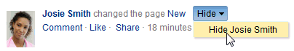

1. Click **OK** in the confirmation dialog.

The page refreshes, and the viewer no longer shows activities from the selected user.

**See Also:** For information about showing a hidden user, see Section 11.4.4.2, "Showing the Activities of a Hidden User."

#### Showing the Activities of a Hidden User

To reinstate the streaming of activities from a hidden user:

1. Go to an instance of an Activity Stream viewer where a user's activities are hidden.
2. Click **Options**.
3. In the resulting dialog, click the **People** tab to bring it forward.
4. Next to the person whose activities you want to show, click **Show** (Figure 24–7).

***Figure 24–7 The Options Link and the Show Button***

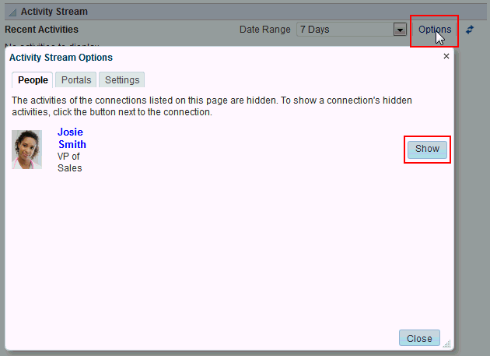

### Hiding and Showing the Activities of a Selected Portal

If there is a portal that streams activities that are not currently of interest to you, you can hide that portal's activities from a selected instance of the Activity Stream viewer (or from the **Activities** page in the Home portal).

You can easily reverse this action by showing one or more hidden portals through the

**Options** link on the affected Activity Stream viewer.

To hide the activities streaming from a particular portal, the affected Activity Stream viewer instance must be configured to show **All Portals** or **My Portals** (for more information, see Section 11.3, "Setting Activity Stream Preferences" and Section 11.4.2, "Selecting the Portals to Stream in an Activity Stream Viewer").

**Tip:** Whether the activities streaming from portal are shown can be determined at the application level, in personal Preferences, and on an individual viewer instance by you or by your system administrator. If you find you cannot hide or show activities streaming from portals, it is likely that at one of these levels, the facility to see such activities has been blocked.

This section describes how to hide the activities streaming from a particular portal and how to show those hidden activities. It includes the following subsections:

* + - * Section 11.4.5.1, "Hiding the Activities of a Selected Portal"
      * Section 11.4.5.2, "Showing the Activities of a Hidden Portal"

#### Hiding the Activities of a Selected Portal

To hide the activities streaming from a selected portal in an Activity Stream viewer instance:

**Note:** Your Preference settings may prevent any portal activities from streaming. For information about Activity Stream Preferences, see Section 11.3, "Setting Activity Stream Preferences."

1. Go to an instance of an Activity Stream viewer.
2. Open the **Hide** menu next to an activity that has streamed from the portal you want to hide, and select the relevant portal name (Figure 24–8).

***Figure 24–8 Selecting to Hide a Portal***

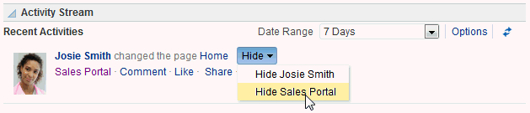

1. Click **Yes** in the confirmation dialog.

The page refreshes, and the viewer no longer shows activities from the selected portal.

**See Also:** For information about showing a hidden portal, see Section 11.4.5.2, "Showing the Activities of a Hidden Portal."

#### Showing the Activities of a Hidden Portal

To reinstate the streaming of activities from a hidden portal:

1. Go to an instance of an Activity Stream viewer where a portal's activities are hidden.
2. Click **Options**.
3. In the resulting dialog, click the **Portals** tab to bring it forward.
4. Next to the portal whose activities you want to show, click **Show** (Figure 24–9).

***Figure 24–9 The Options Link and the Show Button in Activity Stream Options Dialog***

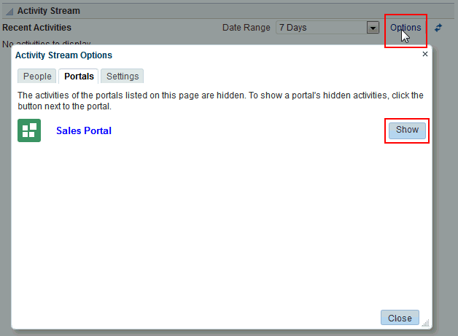

### About Recent Activities

Recent Activities track changes in WebCenter Portal providing a quick and easy way to view any additions or changes to a particular area of WebCenter Portal. Tracked changes include additions and revisions to pages, documents, discussion forums, lists (Portals only), and events. (Figure 24–11).

***Figure 24–11 The Recent Activities Viewer***

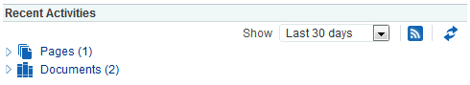

Recent activities can track the following information:

* + - Documents added
    - Announcements created
    - Discussion forums created
    - Pages created or modified
    - List definitions created or modified

By default, the Recent Activity list displays 25 recent activities for a given feature. If more than 25 activities have occurred, the Recent Activity list displays the 25 most recent. Your system administrator can change the default value, so your limit might be more or less than 25.

The level of information provided in the Recent Activity list depends on the context in which the list is placed. In a portal page, the Recent Activity list summarizes changes

occurring in that portal. In your Home portal, your system administrator must set the Recent Activities viewer properties to specify a portal. The Recent Activity list summarizes changes occurring in the specified portal.

You can use the Recent Activity list as an access point to new and revised content. The Recent Activity list displays new and revised content as links, which you can click to go directly to the content.

**Note:** You can track recent activities through your favorite RSS reader. For more information, see Chapter 27, "Monitoring RSS Feeds."

### Working with Recent Activities

You can personalize your view of recent activities, access a changed item, and refresh your view to update the viewer with the latest changes. This section tells you how. It contains the following subsections:

* + - Section 11.6.1, "Personalizing the Recent Activities Viewer"
    - Section 11.6.2, "Accessing Recently Acted-On Items"
    - Section 11.6.3, "Refreshing the Recent Activities Viewer"

#### Personalizing the Recent Activities Viewer

The Recent Activities viewer provides a way to specify the range of days for showing changes and additions to WebCenter Portal. These date-range options appear on the **Date Range** menu in the Recent Activities viewer toolbar (Figure 24–12).

***Figure 24–12 Date-Range Options on the Recent Activity Toolbar***

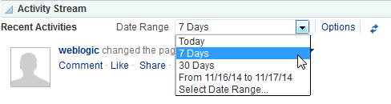

Select an option from the **Date Range** menu to view recent activities occurring within the selected range. The range you select is applicable only to that viewer instance. If you have more than one Recent Activities viewer instance on the page, you can show activities from a different time range in each.

**Tip:** Ensure that your Preferences reflect your own local time zone. To access your time zone preference in the Portal application, click the **Preferences** link at the top of WebCenter Portal, and then select **General**. For more information, see Section 5.3, "Setting Date and Time Preferences."

The default options on the **Date Range** menu include:

* + - * **Today**—Shows all activities that have taken place between 12:00AM (2400 hours) and now.
      * **7 days**—Shows all activities that have taken place in the last 7 days.
      * **30 days**—Shows all activities that have taken place in the last 30 days.
      * **From date to date**—Shows all activities that have taken place within a range you specify.
      * **Select Date Range**—Click to select a date range to use with the date-to-date option.

**Note:** These options are described according to their default meanings. In some instances, an advanced user can provide alternative definitions for them.

#### Accessing Recently Acted-On Items

The Recent Activities viewer groups the different activities it reports on into nodes that are named for each feature (for example, Pages and Documents; shown in

Figure 24–13).

***Figure 24–13 Feature Nodes in the Recent Activities Viewer***

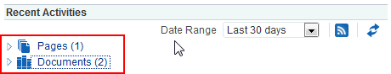

Expand a node, and access the changed item directly by clicking its link (Figure 24–14).

***Figure 24–14 Recent Discussion Link in the Recent Activities Viewer***

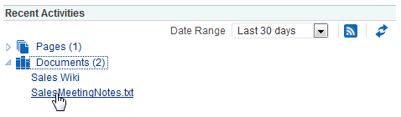

The targets of linked items open on dynamically-generated pages, or in Portal application, on dynamically-generated, top-level tabs. Link targets appear according to their parent feature. For example, click a Discussions link to access a forum or a specific topic under a forum; click a Lists link to access an updated list of lists or a specific updated list; click an event to display event details; and so on.

#### Refreshing the Recent Activities Viewer

If you prefer not to wait for an automatic refresh of the Recent Activities viewer, you have the option of refreshing the data yourself by clicking the Refresh icon

(Figure 24–15).

***Figure 24–15 The Refresh Icon on a Recent Activities Viewer***

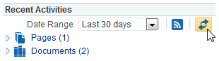

The viewer updates and indicates the number of recently-changed items by increasing the value displayed in parenthesis next to each affected feature.